DEVELOPMENT OF URBAN VILLAGES
IN DELHI (1986-2001 AD)

JUNE, 1986

CITY PLANNING WING
DELHI DEVELOPMENT AUTHORITY

DEVELOPMENT OF URBAN VILLAGES
IN DELHI (1986-2001 AD)

JUNE, 1986
CITY PLANNING WING
DELHI DEVELOPMENT AUTHORITY

PREFACE

All the settlements were initially rural. However, most of them have been converted into urban due to interaction of different forces of agglomeration, urbanization, industrialization and migration. Conversion of the settlements from rural to urban is directly proportional to the increase in urban functions, and problems in a particular centre. In Delhi, most of the urban villages engulfed within urban areas have become slum pockets. Before 1931, there were only 25 urban villages they increased to 47 in 1951, 88 in 1971 and 111 in 1981. The number of urban villages is expected to increase to 164 by the end of the century and about 200 by 2010 A.D.
Delhi had 369 villages in 1981 of which 111 villages were urban and 258 were rural villages. This position is likely to change by the end of the century when there will be 164 urban and 205 rural villages. In 1981, the 258 rural villages consisted of two large urban centres viz. Narela and Najafgarh, 27 census towns, 15 growth centres, 33 growth points, 147 basic village, 17 deserted settlements and 17 are being engulfed in extended urban limits of Delhi. Details of these 258 rural villages have been given separately in the Project Report for “Integrated Development of Urban and Rural Villages” by DDA/Delhi Administration. This Project report was prepared by a working group appointed by the Lt. Governor, Delhi, in Sept. 1984, under the chairmanship of Development Commissioner, Delhi, with senior officers of Delhi Administration, M.C.D., Water Supply & Sewage Disposal Undertaking, D.E.S.U. & D.D.A. as members and Director, City Planning, D.D.A., as Member Secretary.
In 1980, a Project Report for the “Urban Villages: Delhi, 1980-85” was prepared by the Urban Village Cell, City Planning Wing, DDA and was submitted to the Delhi Administration & Ministry of Urban Development. The Project Report covered the development of 111 urban villages at a total cost of Rs.23 crore with a break –up of Rs.20.5 crore as a grant from the Central Government and Rs.2.5 crore from the Village Development Cess. Summary of the project report has been given in Appendix- 1.

This project report was approved by the Ministry of Urban Development vide their letter No.N-11014/182 DDVI of 24.6.81 (Appendix No. II) for the development of 96 urban villages (111 total urban villages minus 10 villages falling in slum areas at that time, 2 deserted villages, 2 falling cantonment area and one viz. Mangla Puri was rehabilitated near villages Palam) at a total estimated cost Rs. 2067.33 lakh with a break –up of Rs. 1817.33 lakhs as grant and Rs. 250 lakh as village development cess. The order of the government specified the details regarding services to be provided, and the community halls to be constructed in various villages.
During the 6th Five Year Plan period, i.e. 1980-85, a total expenditure of Rs. 2031.22 lakh was incurred on the development of urban villages. In spite of this, expenditure, development works in terms of laying of water lines, sewer lines, electric lines, storm water drains and construction of roads & community halls were not completed as envisaged in the above mention Project Report. Therefore, further action is required to complete the development work.
Now a Project Report for “Development of Urban villages” has been prepared incorporating the following six components:-
Evolution of strategies for “Development of different types of villages.
Policies on important subjects, viz. extent of commercialization, industrialisation, sanction of building plans, collection of development charges, concept of “Lal dora” sale of properties, etc.
Completion of development works in 96 urban villages including their extensions.
Completion of development works in 10 urban villages including their extensions which were in slum areas but now are being transferred to main wings of DDA in general category.
Development of additional 53 urban villages including their extension which are likely to be urbanized by the end of the century.
Construction of tenements for landless labour.

With the above components, the Project Report has been prepared and put up for approval to the Delhi Administration & the Ministry of Urban Development. Total cost of the project is Rs. 40 crore with break-up of Rs. 33 crore as grant and Rs.5 crore as village development cess. This does not include the cost of construction of tenements for landless labours. It is proposed to complete the entire development of the village, falling in the third and fourth categories, in the 7th Five Year Plan and simultaneously start development of villages, falling in the fifth category, which shall be completed in the 8th Five Year Plan. A separate Project Report for the “Construction of 15000 Tenements for Landless Labour” at total cost of Rs.20 crore has been prepared and submitted to Delhi Administration for approval.
The Project Report for Development of Urban Villages has been prepared in five parts as per details given below:-
1. Urban villages; characteristics and strategies for development.
2. Policies for various components of the subject.
3. Development works already completed upto 1985.
4. Development works to be undertaken in the 7th and the 8th Five Year Plans .
5. Various informative appendices.

The Project, if approved and implemented, will benefit 6 lakh people who are living in sub- standards conditions. The project is not only meant for improving the life of 6 lakh people but also for formulation of strategies for the development of different types of villages, like village with excessive industrialisation, villages with excessive commercialization, villages in the midst of fruit and vegetable market, a very small village surrounded by a proposed truck terminal etc., and policies about extent of commercialization and industrialization in urban villages sanction of building plans, concept of lal dora, use of large properties of more than 500 sq. mtr., and collection of development charges, etc.

Apart from the development that has taken places in the existing 106 urban villages, it is estimated that Rs. 18 crore will be required to complete the development works in these villages. Further, for the 53 villages which are likely to be urbanized by 2001, the cost of development is estimated to be Rs.26.75 crores. The total estimated amount of Rs. 44.75 crores for the development of urban villages will be spent in the 7th FIVE YEAR PLAN (Rs.30 crores ) and in the 8th Five Year Plan (Rs.14.75 crores).
Informative appendices have been added at the end report. Acknowledgements are due to the entire staff of Urban Village Cell who have worked for the preparation of report and especially to Mr. H.S. Sikka, Deputy Director, Mr. Bhardwaj, Senior Research Officer and Mr. U.D. Pande, Asst. Director, City Planning Wing.

(R.G. GUPTA)
Director
City Planning and
Traffic and Transportation Planning
Delhi Development Authority New Delhi

June, 1986

CONTENTS
PAGE
Preface 4
Contents 8
List of Maps and Table 10
Appendices 11

- URBAN VILLAGES : CHARACTERISTICS 13
AND STRATEGIES FOR DEVELOPMENT.
  - Introduction 13
  - Number of Urban villages as per legal 14
definition
  - Classification of villages 16
  - Names, Population and Location of 17
111 urban villages

- POLICY FRAME WORK FOR PLANNING OF 23
URBAN VILLAGES

  - Permission for Industrial use in urban village. 23
  - Permission for Industrial use in urban village 24
  - Use of large properties exceeding an area of 26
500 sq. mt.
  - Sanction of Building Plan 28
  - Permission for sale of transfer of plots. 30
  - Concept of Lal Dora 31
  - Development Charges and premium. 33

- DEVELOPMENT OF URBAN VILLAGES UPTO 1985 36

  - General 36
  - Socio Economic Conditions of Urban villages. 36
  - Strategies for development of typical urban 41
villages.

  - Development carried out up to 1980. 69
  - First Project Report for development of 69
urban villages, carried out during Sixth
Five Year Plan.
  - Fiscal Position of Development works 70
in urban villages up to 1985.

- DEVELOPMENT WORKS IN 7TH AND 8TH 71
FIVE YEAR PLANS

  - Amount required to complete the development 71
works in 106 villages.
  - Amount required to develop additional 73
53 villages which are likely to be urbanized
by 2001.

APPENDICES

LIST OF MAPS
MAP PAGE
- Location of urban villages 14

- Villages proposed for urbanization 15
- Development plan of Hasanpur 44
- Development plan of Garhi Piran 46
- Development plan of Bharola and Pipal Thala 49
6.a Development plan of Todapur 52
6.b Development plan of Dusghra 53
7. Development plan of Karkar Dooman 56
8. Development plan of Jwala Heri 58
9. Development plan of Humayunpur 61
10. Development plan of Basai Darapur 63
11. Development plan of Peetampura and extension . 65

LIST OF TABLES

TABLE PAGE
- List of Urban Villages 18
- Properties exceeding 500 sq.mt. in Area 26
- Release and expenditure of funds for 70
development of Urban villages in Delhi-1985

LIST OF APPENDICES
APPENDIX PAGE
- Project Report for Development of Urban 76
Villages in Delhi (1980-85)
- Scheme for Development of Urban Villages 80
of Delhi. Govt. of India Order No.
N-110014/1/82-DDVI dated 24.6.1983
- List of Urban Village located in Development 83
Area of DDA
- Policy regarding Grant of Industrial license 86
to Household Industries.
- Copy of Resolution No. 1458 of the Standing 92
Committee meeting of Corporation held on
1.4.1965 (Regarding interpretation of Building
Bye- law No. 25(2)(1-4)(e) setbacks)
V.A. City Area Policy 95
V.B Building Activities in Urban Villages 99
VI. List of plots measuring Villages 101
VII Concept of Lal – Dora as defined by Delhi 104
Administration (Delhi)
VIII Levy of Development Charges 111
IX Standards of Community Facilities adopted in 113
Regularized Unauthorized colonies as adopted
by Technical Committee And high Powered
Implementation Body.
X Sample Industrialized and Commercialized Villages 114

- Position of Socio-economic condition 115
in 52 villages being proposed for
urbanization

- List of Village being proposed for urbanization 123
- Percentage of structures which have come up 125
as village extension as on December 1984
- Development charges for urban villages 128
- Land Use analysis of Urban villages 131

- Estimates of expenditure for 53 additional 140
Villages by the turn of the century (based
on 1983 price level).

- URBAN VILLAGES: CHARACTERISTICS AND STRATEGIES FOR DEVELOPMENT

  - Introduction

The entire civilization was in rural settlements before the development process started. Gradually, needs and requirements of human beings increased and rural settlements started acquiring urban character. Most of the rural settlements have already changed and merged into urban areas with changed characteristics in terms off pucca houses, pucca roads, availability of infrastructure etc. Such changed villages called urban villages while the others remained the rural villages.

In Delhi in 1981, there were 369 settlements consisting of 111 urban and 258 rural villages. Since more than one decade, urban villages are becoming slum pockets which has necessitated the development in terms of laying of infrastructure, construction of roads and making available public and semi public buildings and parks, etc. Similarly it is also necessary to formulate strategies for the development of different types of villages .

1.1.2 Following are the three methods for the planning and development of urban villages.

Curative method,
Preventive method
Development method.

The entire system of physical planning and development may be compared to man’s health Is. In curative method, the disease has to be cured, may be the method of surgery or medicine . In preventive method, due care and sufficient measures should be taken to prevent disease, and in the development method develop the system to such an extent that the body gains resistance to face the attacks of germs, bacteria’s and climate. Application of these three methods in planning of urban villages has been given in the next page.

Curative Method:- In this method Comprehensive survey of the area should be conducted of pockets which are beyond repairs should be earmarked. Improvements and development be carried out after demolishing structures, and vacant pockets should be used for community facilities to the possible extent. This method is very difficult to implement because of the resistance offered by the public residing in the area.

Preventive Method :- For the preventive method of development zoning regulations, building bye- laws, land acquisition act, Urban Land Ceiling and regulations Act. P.P. Act, charging of heavy damages, unauthorised constructions as a cognizable offence, collection of development charges as arrears of land revenue, Municipal Act, etc. should be applied to stop illegal and unauthorised construction.

Development Method :- For development method, supply of residential, commercial, and community facility space should match the demand from time to time for different sections of the society . Proposals in the “Project Report” are largely based on the second and the third method.

  - Number of Urban Villages as per Legal Definition

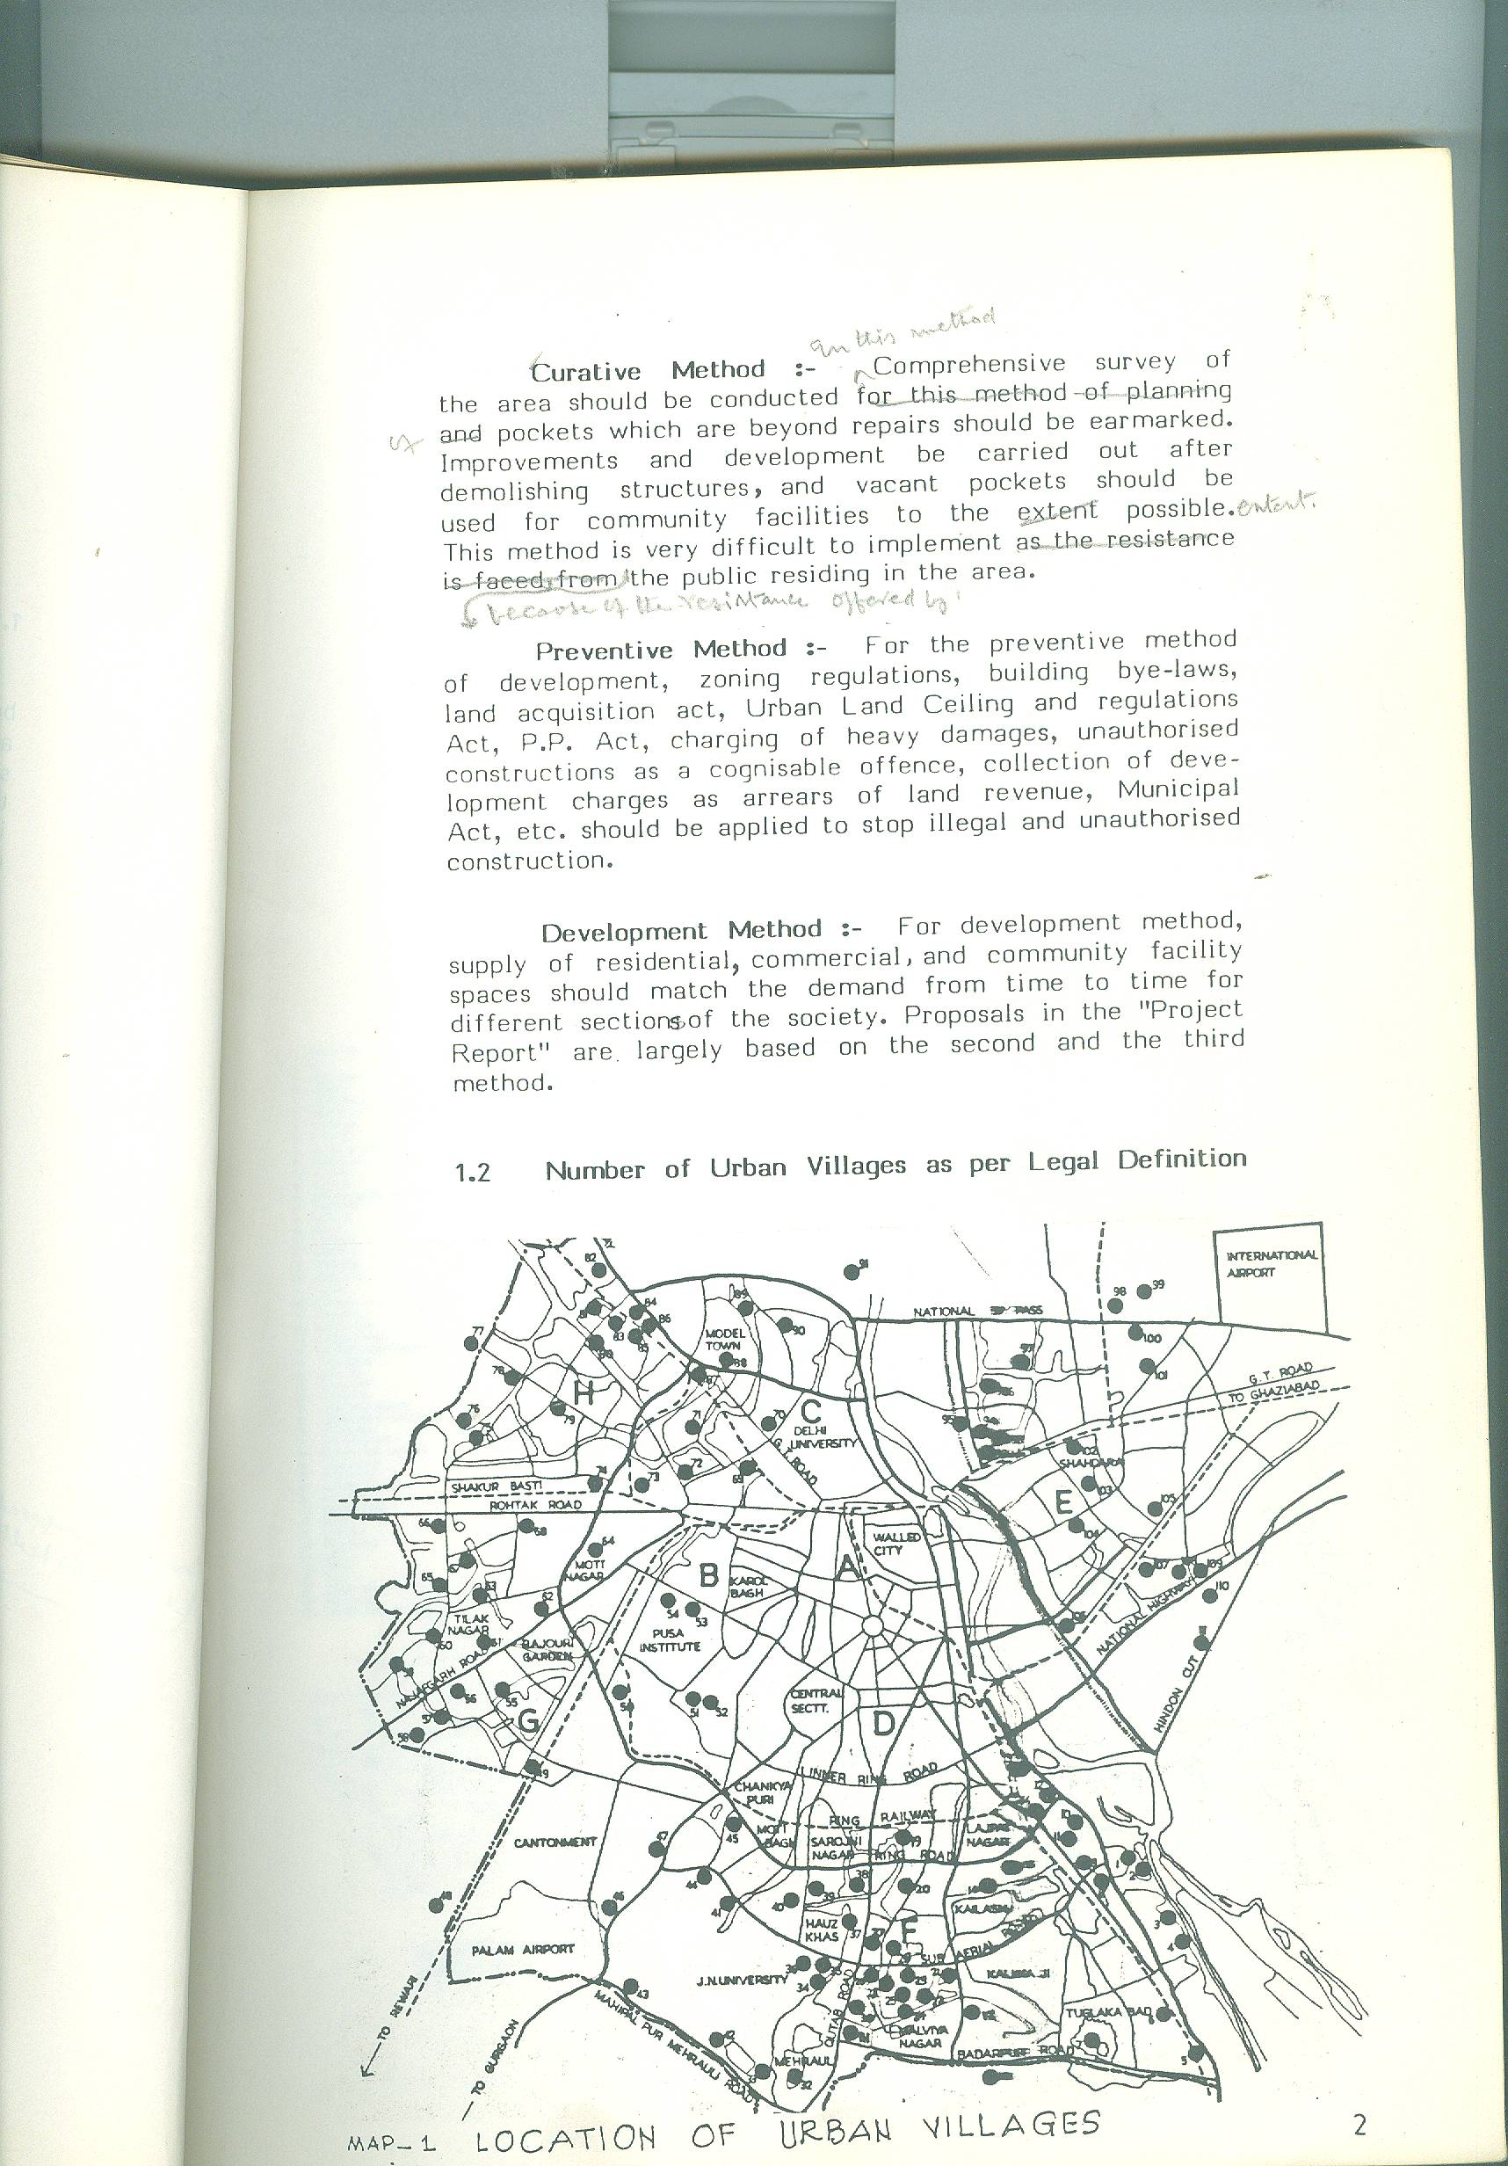

Legally any rural settlement ceases to exist and gets converted into urban village as soon as it is declared under Clause (a) of Section 507 of Delhi Municipal Corporation Act, 1957. Under this Section, so far 114 have been declared as urban villages with a break-up of 19 under notification No. 24 dated 13.6.63 of Delhi Gazettee, 71 vide notification No. 41 dated 3.6.66 and 24 vide notification No. TCO/82/47 dated 26.2.82. Out of these 114 villages viz. Beholpur Khadar is repeated twice in the list. The total number of urban villages, therefore, as per these notification is 106. If five Nazul villages, viz. Arakpur Bagh Mochi, Todapur, Dasghara, Nangli Razapur, Jhilmil Tahirpur are added to this list, the total number of urban villages will be 111. (location shown in map no.1).

Now, the Delhi Administration and the MCD should notify the balance number of 53 villages which are likely to come in the purview of urbanization by the turn of the century, and declare them as urban villages so that they can be properly developed. Action in this regard has already been initiated. (These additional villages have been shown in map No.2, Gazette given in appendix)

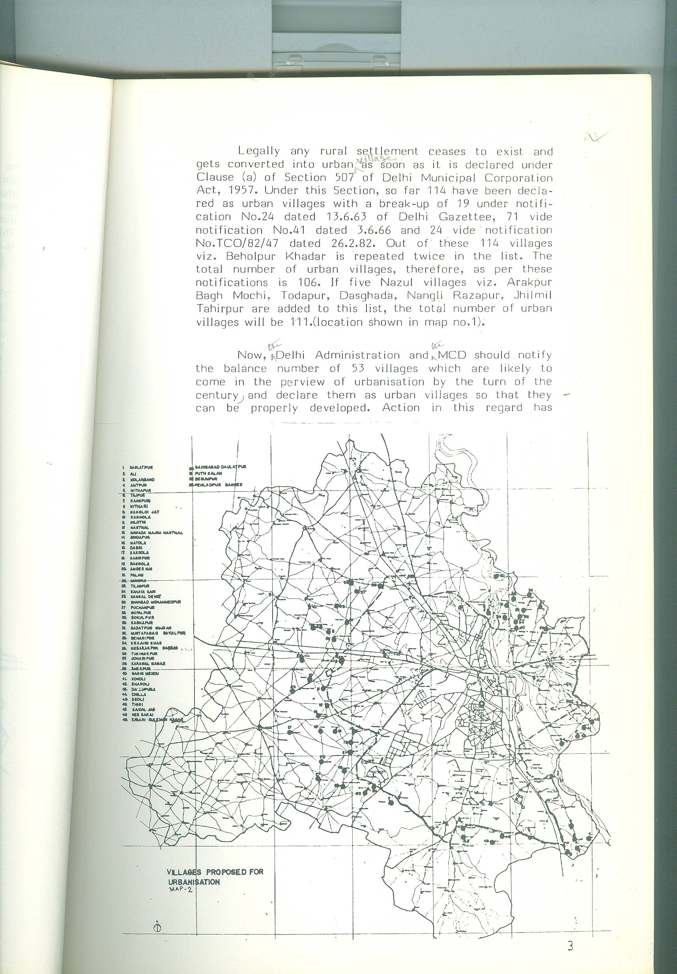

1.3 Classification of villages

Urban villages can be classified in many ways based on various criteria. Some of them have been given under :

Land ownership:

Land use as given in Delhi Master Plan,

Land use as existing on the site,

Within urban limits of Delhi or outside,

Urban or rural.

Jurisdiction- wise i.e. DDA, MCD and Cantt. Board. Planning division wise viz. (A) (Walled City and adjoining areas), (B) (Karol Bagh & Naraina etc.), (C) (Civil lines area), (D) (New Delhi area), (E) (Trans Yamuna Area), (F) (South Delhi), (G) (West Delhi) and
(H) North West Delhi.

Population wise i.e. upto 500, 501-1000, 1001-2000: 2001-5000, 5001-10000 and more than 10000, etc.

All the above classifications are useful and have been used while formulating policies and strategies for these villages. The Urban Villages of Delhi have been classified as under :

Villages on Government Land :

Das Garha, Todapur, Saraj Kale Khan, Nangli Raza, Mehram Nagar, Bagh Mochi, and Jharera.

Village in Trans Yamuna Area:

Gazipur, Hasanpur, Mandavali–Fazalpur, Shakarpur Khas, Seelampur, Usmanpur, Mauzpur, Gamri, Karkardooma, Jhilmil, Naya Gaon, Khureji Khas, Ghardi, Chauhan Banger, Babarpur, Gonda, Chilla, Patparganj, Kotla, Khichripur, Shahdara, Kaithwara and Kondli (Some of these villages are outside the Urban limits specified in the Master Plan of Delhi but are likely to be declared as Urban Villages).

Located within Rohini :

Naharpur, Razapur, Mangolpur Kalan, Mangolpurkhurd and Badli.

Surrounding by DDA Schemes :

There are 46 villages viz. – Sheikh Sarai, Wazipur, Tatarpur, Asalatpur, Possangipur, Nangli Jalib, Jwala Heri, Nangloi-Syed, Garhi Piran, Madipur, Munirka, Vasant Gaon, Pritampura, Shalimar, Khayala-Haiderpur, Shahipur, Bodella, Zamroodpur, Begampur, Ber Sarai, Katwaria Sarai, Tikhand, Tamoor Nagar, Khizrabad, Kilokari, Pipal-thala, Bharola, Naraina, Shahpur Jat, Mahammadpur, Kishan Garh, Masodpur, Samepur, Madanpur Khadar Madangir, Keshopur, Shakarpur (West), Hamayunpur, Garhi Jharia Maria, Nangal Raya, Okhla, Jaga Bai, Mahipalpur and Basai Darapur, connected with the schemes prepared by the DDA, Their plans cannot be dealt with in isolation, and have to be integrated with the planned schemes.

Independent Villages with reference to DDA’s Schemes:

There are 28 villages, which do not come under the purview of various schemes of DDA. These villages are: Masjid Moth, Hauz Khas, Kalu Sarai, Hari Nagar Ashram, Azadpur, Rampura, Mahipalpur, Dhakka, Malikpur Chawni, Rajpur Chawni, Shadipur, Tihar, Chaukanandi, Chirag Delhi, Jia Sarai, Kotla Mubarakpur, Mehrauli Lado Sarai, Adhchini, Tughlakabad, Jasola, Badarapur, Dheerpur, Yusuf Sarai, Hauz Rani, Sadhora Kalan, Hastasal and Bahlopur Khadar.
1.4 Names, Population and Location of 111 Urban Villages.

The following table gives the list of existing 111 urban villages along with the population which existed during the year 1981.

Table 1. List of Urban Villages

SOUTH DELHI

Sl. No. | Name of Village | Total Population
Sl. No. | Name of Village | Population |  | Families
1 | 2 | 3 |  | 4
1. | Kilokri | 2455 |  | 545
2. | Behlopur Khaddar | 239 |  | 53
3. | Kotla Mubarakpur | 3322 |  | 768
4. | Tamur Nagar | 1911 |  | 43
5. | Khizrabad | 1177 |  | 261
6. | Saraijuliana | 2405 |  | 540
7. | Joga Bai | 1186 |  | 261
8. | Okhla | 3667 |  | 815
9. | Garhi Jharia Maria | 9646 |  | 2144
10. | Zamrundpur | 3346 |  | 768
11. | Masjid Moth | 5688 |  | 1264
12. | Shahpur Jat | 5248 |  | 1166
13. | Humayun Pur | 4370 |  | 971
14. | Hauz Khas | 936 |  | 208
15. | Yusuf Sarai | 1543 |  | 343
16. | Mohammad Pur | 5220 |  | 1166
17. | Masihgarh | 578 |  | 122
18. | Jasola | 899 |  | 200
19. | Madan Pur Khaddar | 3189 |  | 709
20. | Tekhand | 2406 |  | 644
21. | Khirki | 1212 |  | 270
22. | Shekh Sarai | 2136 |  | 479
23. | Begam Pur | 1576 |  | 350
24. | Sarai Shahji | 1068 |  | 237
25. | Hauz Rani | 5863 |  | 1303
26. | Adh- Chini | 1747 |  | 388
27. | Kalusarai | 827 |  | 184
28. | Ber Sarai | 11995 |  | 443
29. | Chirag Delhi | 7104 |  | 1578
30. | Katwaria Sarai | 2583 |  | 574
31. | Munirka | 5150 |  | 1145
32. | Basant Gaon | 2171 |  | 482
33. | Lado Sarai | 3144 |  | 699
34. | Madangir | 1285 |  | 285
35. | Badarpur
36. | Hari Nagar (Ashram) | 4396 |  | 977
37. | Kherara | 2622 |  | 583
38. | Arakpur Beghmochi (Nazul) | 1168 |  | 260
39. | Mahrauli | 14424 |  | 3205
40. | Kishangarh | 1232 |  | 294
41. | Khanpur (Part) | 1987 |  | 441
42. | Tughlakahabad | 4883 |  | 1085
43. | Jia Sarai | 784 |  | 174
44. | Masud Pur | 729 |  | 162
45. | Mahipal Pur | 5150 |  | 1144
NORTH DELHI
46. | Dhaka | 3162 | 703
47. | Dhirpur | 2280 | 507
48. | Malikpur Chhawni | 2493 | 554
49. | Rajpur Chhawni | 2514 | 559
50. | Azadpur | 4419 | 982
51. | Bharola | 658 | 146
52. | Peepal Thala | 2610 | 580
53. | Nimri | 2625 | 538
54. | Rampura | 8427 | 1873
55. | Wazirpur | 4244 | 943
56. | Shakur Pur | 3758 | 835
57. | Sadora Kalan | 3261 | 724
58. | Nihar Pur | 1530 | 340
59. | Rithala | 4047 | 900
60. | Mangol Pur Khurd | 593 | 131
61. | Haider Pur | 3427 | 761
62. | Wazira Bad | 1191 | 265
63. | Pitampura | 1366 | 303
64. | Mangolpur Kalan | 2264 | 503
65. | Basti Shalimar | 1254 | 299
66. | Sahi Pur | 534 | 118
67. | Samaypur | 3003 | 667
68. | Badli | 5334 | 1185
WEST DELHI
69. | Kham Pur | 1030 | 299
70. | Shadi Pur | 4290 | 953
71. | Naraina | 9657 | 2146
72. | Basai Dara Pur | 13870 | 3082
73. | Tatar Pur | 2014 | 447
74. | Chaukhandi | 880 | 196
75. | Khayala | 1131 | 251
76. | Tihar | 5616 | 1248
77. | Nangal Raya | 10295 | 2288
78. | Asalat Pur | 980 | 218
79. | Posangipur | 714 | 159
80. | Nangli Jalib | 1565 | 348
81. | Bodella | 1053 | 230
82. | Kasho Pur | 821 | 182
83. | Madi Pur | 6236 | 1386
84. | Dasghara | 1650 | 376
85. | Toda Pur | 1003 | 223
86. | Jwala Heri
87. | Gahri Piran | 674 | 150
EAST DELHI |  | 1607 | 357
88. | Ghonda | 1524 | 339
89. | Nangloisyed | 640 | 142
90. | Kaithwara | 1524 | 339
91. | Mauzpur | 2740 | 609
92. | Jhilmil | 1351 | 300
93. | Karkar Duman | 1472 | 327
94. | Shahdara | 7052 | 1567
95. | Ghonda | 2242 | 498
96. | Seelam Pur | 5794 | 1288
97. | Khureji Khas | 2812 | 625
98. | Mandavali Fazalpur | 1135 | 252
99. | Gazipur | 984 | 219
100. | Kachi Pur | 984 | 219
101. | Hasan Pur | 501 | 111
102. | Shakar pur | 606 | 135
103. | Saboli | 666 | 148
104. | Usmanpur | 1612 | 358
105. | Mandoli Kachhi | 4200 | 933
106. | Ghondaneemka Bangar | 1739 | 386
107. | Kotla | 233 | 52
108. | Khichri Pur | 984 | 219
DELHI CANTT
109. | Mangla Puri | 682 | 152
110. | Mahram Nagar | 2518 | 600
111. | Jharera | 1464 | 325
TOTAL POPULATION |  | 247840 | 56324

SOURCE:-DDA Records

- POLICY FRAMEWORK FOR PLANNING OF URBAN VILLAGES.

The policy framework for planning of urban villages has been evolved after careful and comprehensive consideration of various components and factors of development of urban villages, keeping in view their contextual relationship with urban areas of Delhi. The details of following important aspects are given in this chapter.

Permission for commercial use in an urban village.

Permission for industrial use in an urban village.

Use of large properties of more than 500 sq. mtr.

Sanction of building plans

Sale of plots
Concept of Lal Dora
Collection of development charges

  - Permission for commercial use in an urban village

- Any commercial use within Lal Dora of an urban village shall be regularized if it is in existence prior to Feb. 1977, and the structure fits in the approved layout plan.

- Any commercial use, within a Lal Dora, of urban village shall be regularized if it exists even after Feb. 1977 after the receipt of development charges at the rate to be decided by the authority, and it fits in the approved layout plan.

- Any commercial use outside the Lal Dora of the village, but within the boundary of the approved layout plan can also be regularized if it existed prior to Feb.1977, and is fitted in the layout plan, after receipt of development charges at double the rate of development charges for residential use.

- Any commercial use in an urban village outside the Lal Dora, but within the boundary of the approved plan which has up after Feb. 1977 shall not be regularized.

- Fitting of structures in the layout plan will be considered with reference to the following components:-

Parking,

Road widths,

Environmental problems.

2.2 Permission for industrial use in an urban village.
To formulate a policy on the subject of granting permission for industrial use in an urban village, following survey was done.
A detailed comprehensive socio-economic and environmental pollution survey of village Peera Garhi (a typical village in West Delhi).
Land use analysis of 46 urban villages (refer table 2).
Socio – economic surveys of 52 urban villages (Details given in chapter 3 of the report).
Policy regarding industrialization in rural villages formulated in the Project Report for the “Integrated Development of Urban and Rural Villages” prepared by DDA and Admn. In June1985.
Different types of industries in urban villages have been divided into 3 categories :
- Household and small industries .
- Light and service industries
- Noxious , nuisance, hazardous and obnoxious industries.
2.2.1 Household and Small Industries.
DDA vide its resolution No. 78 dated 21.8.79 (appendix No. IV) approved a list of 69 household industries to be permitted in residential use zone with the following use zone with the following conditions.
Industries should be run by the owner of the premises.
Floor area for industrial use should not be more than 30 sq. mtr.
Number of workers should not exceed 4.

Power Load should not exceed 1 kw with single phase and 2 kw with 3 phase.
Household industrial units should type not be considered for alternate allotment.
Loan should be given to such type of units so that they can run on regular basis.
It is proposed that household industries should be permitted in urban villages with above conditions within or outside Lal Dora within the approved boundary of the urban village.
It is also proposed to collect development charges equivalent to development charges of residential use or @ Rs. 135/- per sq. mtr. (whichever is more) from house hold industrial units if situated within Lal Dora of the Urban Village, and @ Rs. 270 per sq. mtr. or double the charges for residential unit, if outside the Lal Dorn (Which- ever is more).
2.2.2 Light and Service Industries.
A list of 132 industries has been taken from the Draft Master Plan-2001, Delhi and is given in Appendix No.-IV. These industries with the restriction of 10 workers at a time and power not exceeding 5 H.P. should be permitted in industrial estates to be developed either on the periphery of that villages or in some other suitable location.
Plots or built-up sheds, in these industrial estates, should be allotted only to the industrial units to be shifted from the urban villages on pre- determined price. On this pattern, DDA is getting request from the industries at present functioning at Village Khayala in West Delhi.
2.2.3 Noxious, hazardous and obnoxious industries.
At no cost, these industries shall be permitted in urban villages but shall be shifted to DDA’s development industrial estates. In the draft Plan of Delhi-2001, an area of 1553 hect. has been marked for light and service industries, and 265 hect. for extensive non- confirming industries to be shifted from urban villages, part of which can be used for the purpose of shifting non-confirming industries from villages.

  - Use of large Properties exceeding an area of 500 Sq.mtr. or more
2.3.1 Survey of Properties
A survey regarding number and size of large properties of more than 500 sq.mtr. was conducted in 82 urban villages, falling in the jurisdiction of DDA, by City Planning Wing, sometimes in Dec., 1984 (refer appendix VI). Results are as under
Table 2
Properties exceeding 500 sqm.in area
Number of large properties of more than 500 sq. mtr. | Number of Village
- | 25
1-5 | 31
5-10 | 10
10-20 | 6
More than 20 | 10
Total 687 | 82

2.3.2 Proposed Use
It is proposed to allow the use of these properties on the following norms :-
Land use as shown in the approved plan of the village.
Clearance from Urban Land Ceiling Act and regulations.
Number of dwelling units on a plot less than of 4000 sq. mtr. will be determined as per Govt. Notification No. K-120146/6/75- UD dated 11.12.75 and as given on the next page.

Plot Size | No. of dwelling units
Not exceeding 600 sq. yds. (about 500 sq. mtr.) | One dwelling unit on each floor.
Above 600 sq. yds. (about 500 sq. mts.) and not exceeding 1800 sq. yds.(about 1500 sq. mts.) | Two dwelling units on each floor, whether attached or detached .
Above 1800 sq. yds. (1500 sq.mts.) and not exceeding 2700 sq. yds. (2250 sq. mts.) | Three dwelling units on each floor, whether attached or detached.
Above 2700 sq.yds. (about sq.yds. (about 2250 sq. mts.) and not exceeding 3600 sq. yds. (about 3000 sq.mts.) | Four dwelling units on each floor, whether attached or detached.
Above 3600 sq. yds. (about 3000sq. mts.) and not exceeding 4500 sq.yds. (about 3750 sq.mts.) | Five dwelling units on each floor, whether attached or detached .
Above 4500 sq. yds. (about 3750 sq. mts.) | Six dwelling units on each floor, whether attached or detached .

No. of dwelling units for larger plots of 4000 sq. mt. and above
Group Housing based on following norms of density ground coverage and F.A.R. will be permitted.
Density | Ground Coverage | F.A.R.

100 33.1/3 150
125 33.1/3 150
150 35 150
200 35 175
Minimum size of a dwelling unit – 18 sq. mtr.
Maximum size of a dwelling unit – 180 sq. mtr
Height, not exceeding four storey, in case of group housing lease hold system, will be applicable .

  - Sanction of Building Plans

2. 4.1 Decision Taken so far.

- Copy of resolution No. 1458 dated 1.4.65 of the Standing Committee of the Municipal Corporation of Delhi has been placed as appendix No. V, it is with regard to interpretation of setbacks in urban villages. It states that setbacks as proposed in the building bye-laws shall not be applicable to built-up abadis of villages falling within 1981 urbanisable limit of the Master Plan of Delhi, but City Area Policy will be applicable to all such urban villages.

- City Area Policy as prepared by MCD in 1967, has been placed at appendix No. VA. Important points of this policy, as applicable to urban villages are as under:

- No building activity on plots up to 42 sq. mtr. is permissible as per ‘City Area Policy’. But now the policy, which was approved about 20 years back, cannot be made applicable to urban villages and to unauthorized regularized colonies, where DDA and MCD have regularized structures on plots up to 21 sq. mtr. Even otherwise, the DDA have also planned and developed 45 resettlement colonies with 2 lakh plots of 21 sq.mtr. size. As such, this part of policy of the City Area will not be suitable to urban villages and has been deleted.

- Plots with an area of more than 42 square mts.

For these plots, no front or rear setbacks have been specified except parts of the plots required for widening of the road to 9 meter in case of a trafficable road and 5 meter otherwise have to be left.

Rear set back shall be 1.5 meter minimum or 3 meter average, provided the light and air plane is maintained by the builder in his own plot.

Where the structure of ground floor is in existence with certain setbacks as per sanctioned plan, no further setbacks will be required on the floors above the ground floor provided the front and rear light and air planes are maintained, and coverage on various floors are according to building bye-laws or as per earlier sanctioned plan.

Back to back plots, where buildings are in existence on all the three sides with a open court yard in the centre, rear air plane will not be insisted upon for construction of first floor provided the area of the plot is not more than 167 square meter.

In all the cases right of ways of roads shall be maintained.

In Building Repairs

The City Area Policy has provisions with regard to repairs in the buildings also. It is proposed that the same provisions may be adopted in case of urban villages except with the addition that nominal fee based on per sq. mtr. may be charged.

- DDA resolution No.604 dated 16.8.67; resolution No. 2012 dated 18.6.68 and resolution No. 80 dated 29.4.69.

These three resolutions have been placed as appendix No. VB. Gist of these three resolutions has been given under:

Building plants should not be sanctioned till development plans of the urban villages are approved from the competent authority.

No. building activity be allowed in areas earmarked for community facilities, parks, playground, open spaces and roads.

In one of the resolutions, it was also resolved that no development charges be levied while sanctioning of building plans in residential plots provided they are situated within the Lal Dora of the village.

2.4.2. Proposals regarding sanction of building plans in urban villages.

After studying various decisions taken so far and the experiences of the last two decades, it is proposed to sanction building plans in urban villages on the following system.

Item Within Lal Dora Outside Lal Dora but
within Boundary of
Plan.

- Land Use As per approved Plan As per approved Plan
- Land Policy Free hold Lease hold
iii) Development Nil As in case of
charges unauthorized colonies
for residential and
commercial use.

iv) Area required for After payment Free of charge
widening of road of compensation
and public & semi
public buildings.

v) Building bye-laws No bye-laws except Building bye-laws
for plots up to the following inc. notification
1.0 acre - FAR – 150 11.12.75 as given
- Number of storeyes-2 in main para 5 of
this chapter.
No. of storeyes
not exceeding

- For plots more Not applicable Zoning regulations
Than 1.0 acre of group housing
shall be applicable.

vi) Building fee No fee As in case of
normal colonies

vii) Repairs of old As given in the As given in the
structures City area policy City Area Policy
in appendix No.VA in Appendix VA

2.5 Permission for Sale and Transfer of Plots.
Procedure for the sale/transfer of plots notified under Section 6 of Land Acquisition Act 1894 is laid down under Section 5(1) of ‘Delhi Lands Restriction on Transfer Act 1972’, Application for sale/transfer in urbanised villages should be sent to the competent authority appointed under the said Act. Such applications must be decided within a period of 30 days otherwise the permission shall be deemed to have been given. The Competent Authority should refer the matter to DDA with regard to land use and also take advise on the proposed sale/transfer.
DDA has prepared development plans of most of the urban villages, and the balance will be completed within a period of a year or two. It is also made clear that there is no intension to acquire built-up properties of urban villages except those required for public & semi- public buildings, parks, playground, open spaces and widening of roads. It is also true that large number of properties have changed hands under the cover of ‘Power of Attorney’. As such, it is desirable to permit sale/transfer of properties which are not required for any of the community facilities/services in an urban village.
2.5.2 Guidelines for permission for sale of plots in urban villages.
Permission may be granted for properties which stand regularized in the approved plan of the village.
Before granting permission, full development charges which at present are Rs.135 per sq. mtr. in case of residential and Rs.270 per sq. mtr. In case of commercial use should be charges from the beneficiaries which are in villages extensions. No development charges will be charged from the properties which are in Lal Dora.
Transferee will give an undertaking that he or she will abide by the terms and conditions of regularization imposed on them by the DDA, or MCD.
For the property, on Government land, though regularized, premium will be charged as per the details given earlier in this chapter.
An undertaking will be given by the transferee that amount of ground rent will be paid annually to the DDA.
Portion required for public and semi-public buildings, parks & playgrounds and road widening shall be surrendered to the govt. without waiting for compensation etc.
2.6 Concept of Lal Dora

Following three documents have been studied to get the clear understanding of the concept of Lal Dora:

- Memorandum from Secretary, Revenue, Delhi Admn., Delhi of 11.7.83 (appendix VII).

- Further clarifications about Lal Dora and consolidation of holdings – a note put up by Delhi Admn. To Executive Councilor (appendix VII).

- Recommendations made by the Group in the report of “Mini Master Plan for integrated development of urban and rural villages”.

Outlines of three have been given under:-

‘Lal Dora’ is the Abadi Deh as determined by the settlement of 1908-09 and such Abadi Deh has given only one Khasra number in the revenue record. This portion of land is not assessed to land revenue and the same cannot be revised till another settlement takes place.

There is no term like ‘Extended Lal Dora’ in any of the provisions of the revenue law. The concept of ‘Extended Abadi’ is, however, found in the provisions of ‘Consolidation of holding law’ which envisages that the ‘Extended Abadi’ shall be used for the common purpose and common need of the villagers. It is also clarified that the area within ‘Extended Abadi’, commonly known as ‘Phirni’ cannot be assessed to land revenue and subjected to all restrictions of sanction of building plans, and also imposed in the ‘Delhi Land Reform Act.’

In the year 1959, Delhi Municipal Corporation passed a resolution permitting the setting-up of cottage industries within Lal Dora and allowing power connections up to 20 H.T. Due to misuse in many respects, this permission was stopped in the year 1981 and ‘Extended Abadi’ was permitted only for residential use. It was clarified that concessions covered by MCD, resolution of 1959 will continue, as it is, in the Lal Dora Old Abadi Area.

However, in the case of ‘Extended Abadi (Phirni)’ electric and water connections for domestic use were permissible, and power up to 3 H.P. was also continued for setting up to traditional/village cottage industries but only to original residents of the village.

Power connections not exceeding 20 H.P. may be given to the residents of the villages subject to the prior approval of the administrator of Delhi in terms of provisions of section 23 of Delhi Land Reforms Act 1954.

No transferee shall have the right to transfer by sale or by gift or by any other mode of transfer any land for which power and water connections were granted; otherwise under the provisions of Delhi Land Reform Act 1954 the supply of the electricity and water shall be discontinued by the concerned authorities.

No Power connection, licence, permission, or relaxation shall be given in relation to any industry emitting obnoxious smell and otherwise hazardous to the health.

2.6.1 The report prepared by ‘Working Group’ on the Subject of ‘integrated development of urban and rural villages’ recommended very strongly that system of Lal Dora should be abolished from Union Territory of Delhi, and building bye- laws should be applicable to all the settlements whether urban or rural. It means that there should be no building activity in any urban or rural villages without getting the plans sanctioned from a competent authority i.e. DDA or MCD.
2.6.2 Proposals
Recommendations as made by the working Group given in Para 6 of 2.6.1 are proposed in case of urban villages also.
2.7. Development Charges and Premium.

2.7.1 Proposals for charging of Development Charges.

Within Lal Dora of Urban Outside Lal Dora but within the
Village approved boundary of urban village
No development charges should be charges from residential or commercial use situated in Lal Dora of any of the urban villages. | - No development charges to be charged if the structure is of residential use and is prior to the date of notification of the land Acquisition Act as well as before Feb. 1977 in case of commercial use and June 1977 in case of residential use.
 | - Development charges will be charged from the structures if they are after the date of notification under Section 4 of the Land Acquisition Act but before Feb.1977 in case of commercial use and June 1977 in case of residential use; at the rate of Rs. 135 per sq.mtr. in case of residential use and Rs. 270 per sq. mtr. In case of commercial use; provided these structures are fitted in the approved layout plan of the urban villages.
 | - Development charges will be charged from the structures if they are after the date of notification of Section 4 of Land Acquisition Act as well as after Feb. 1977 in case of commercial use and June 1977 in case of residential use but fitted in the layout plan at the rate of Rs. 270 per sq. mtr. in case of residential use and @ Rs. 540 per sq. mtr. in case of commercial use.
2.7.2. Payment of Premium
In this connection, a Group was constituted by the Ministry of Urban Development vide notification No. J- 13036/8/82/DD- IIB dated 29th May,1982 for analyzing cases on Government land. The Group recommended for recovery of premium from the properties on acquired land in the following manner:
In case of built up plots measuring upto 200 sq. yds., the premium may be recovered on predetermined rates prescribed under the scheme of Large Scale Acquisition, Development and Disposal of Land as on 16.2.77, less the element of development cost included in the said predetermined rates, plus the present development cost of unauthorized colony.
In the case of built up plots exceeding 200 sq. yds., the recovery may be made on predetermined market value, prescribed by the Government as on 16.2.77, less the element of development cost included in it, plus the present development cost of the unauthorized colony.
In the case of commercial structures, the premium may be recovered on pre-determined market rates for commercial structures, prescribed by the Government as on 16.2.77, less the element of development cost included in the said pre-determined market rates, plus the present development cost of the unauthorized commercial area.
Vacant plots/areas in unauthorized colonies, situated on Govt./acquired land, should not be allowed to be encroached upon and built-up on. Efforts should be made to utilize and dispose them off/under the scheme for ‘Large Scale Acquisition, Development and Disposal of Land in Delhi’.

- DEVELOPMENT OF URBAN VILLAGES UPTO 1985

3.1 General

Development of any area includes leveling, dressing, laying of internal, peripheral and trunk infrastructure like water lines, sewer lines, electric lines and storm water drains, construction of roads, development of sites for parks, playgrounds, open spaces and for public & semi- public buildings for health, education, social security, social justice, employment, housing, shopping centres, facilities etc.

For the development of any urban villages, normally Master Plan standards with regard to utilities, services, public & semi public facilities are followed. However, in most of the cases, it is not possible to earmark sites for various community facilities as per standards, and as such the norms for the provision of community facilities have been reduced and brought to the standards approved and adopted in case of unauthorized regularized colonies as per details given in Appendix No. IX. Provision of potable water has been made at the rate of 60 gallon per day per capita and discharge of sewage at the rate of 50 gallon per day per capita. It was not possible to adopt road widths as per norms laid down in the Master Plan, as such, most of the cases, existing road widths have been followed with a condition that no road or street should have less than 5 mtr. R/W.

Before going into details of development carried out in Urban villages during different periods, it is necessary to spell out socio-economic conditions prevailing in 1985 in these urban villages.

With the help of these surveys, the amount of work carried out upto the 6th Five Year Plan, and to be carried over in the 7th Five Year Plan, has been estimated. Details of these surveys have been given in paragraph No. 3.2.

3.2. Socio-economic conditions of urban villages
Socio-economic Planning Unit of City Planning Wing of the DDA conducted surveys of selected 52 villages out of 111. Total population of these 52 villages in 1985 was 1,39,103 consisting of 15,974 persons belonging to Scheduled Castes & Scheduled Tribes and the remaining belonging to various other castes. These 52 villages have different sizes. 14 villages have population of less than 1,000; 17 have population between 1,000 to 2,000; and 21 villages have population of more than 2,000.

These surveys have been described in the following two parts :

- General results

- Specific results.

General Results: - Running of the general results has been given below (For details refer Appendix).

There are 20538 properties/structures in these 52 villages.

There are 22138 households having a total population of 1,39,103 out of which 15,974 persons i.e. 11.48 % belong to Scheduled Castes & Scheduled Tribes.

Area of these 52 villages is 551.5 hect. with an average of 10.6 hect. per villages.

Position of utilities and services:

Tap water supply is available in 84.6% Of village.

Sewage disposal facility is available in 78.9% villages.

Electricity is available in all the villages.

Position with regard to public and semi-facilities .

60 primary schools in 49 villages.

9 middle schools in 7 villages.

15 higher secondary schools in 15 villages.

It shows that primary schools are available in almost all the villages. However, for middle and higher secondary education, the villagers have to depend upon adjoining colonies. It is observed that most of the school buildings are smaller in size and have sub- standard environment .

There are 62 chopals, barat ghars or community halls in 41 villages. 80% of the villages have the facility of chopals/community halls /barat ghars.

Only 27% of the villages have medical facilities. In 12 villages there are 14 dispensaries.

Position of parks, playgrounds and open spaces:

Out of 52 villages, there are parks in 31 villages. According to surveys only 60% of the villages have parks, playground and open spaces and the balance 40% lack in this type of facility . As per the plans prepared in early 1960’s sizeable plots of lands were proposed for parks and playground on the periphery of each villages. Now, in many cases, these spaces have been used for group housing purposes.

Position of sanitation and hygine:

Public lavatories exist in 33 villages and in four these were under construction. About 63.4% of the villages have the facility of public toilets. It has also been experienced that maintenance of public toilets has been a big problem . So in future, system of “pour flush latrines” should be followed.

In brief, most of the villages have facilities of potable water, sewage disposal and electricity, chopal/community hall/barat ghar. However, villages are deficient in terms of medical facilities, public lavatories, hygienic conditions and maintenance of services.

Specific Results:- The villages which have been surveyed have been divided into following 7 categories:

- Villages with excessive industrial growth.
- Villages with excessive commercial growth.
- Villages with substantial Scheduled Caste and Scheduled Tribe population.
- Very small villages
- Villages on rocky land
- Village with suitable development.
- Other general villages.

These 7 categories have been explained in brief and details are given in various appendices.

- Villages with Excess Industrial Growth (Appendix No. X):
Basai Darapur, Basti Shalimar Bagh, Haiderpur, Garhi Peeran, Dhirpur, Wazirpur, Khayala and Rampura villages fall in this category.
As per survey, total population of these villages is 55,798. There are 3120 small and big industrial units operating in these villages. From the survey analysis following factors were found responsible for excessive industrial growth in these villages:

Suitable locations of the villages along main routes,

Availability of cheap, skilled and semi – skilled labour,

Availability of cheap rented accommodation in and around villages,

Proximity to the thickly populated areas,

Securing municipal licences etc., with ease.

The strategies for development of such villages have been spelt out in this part of the Project Report.

- Villages with Excessive Commercial Growth Appendix No. X):-

There are eight villages falling in this category.
Pitampur Shiva Market
Munirka Kartar Market, Rama Market &
Pratap Market
Khanpur Markets along Mehrauli Badarpur
Road and Deoli Road.
Wazirpur Unauthorized market adjacent
To Deep Cinema
Jwalaheri Market opposite DDA Local
Shopping Centre site.
Possangipur A new market has come up
Around the village
Masjid Moth Lila Singh Market
Pipal Thala and Market adjacent to new
Bharola Subzi Mandi on G.T. Karnal Road

With the acquisition of agricultural land, villagers started searching the alternative means of livelihood for their survival. Those who possessed large plots constructed informal markets unauthorizedly and let out them on very high rent. This was done partly due to the shortage of organised markets in the developed colonies of the DDA, especially, for building materials and eatables. The process continued for some time resulting in the building of big or small unauthorized markets around most of the villages. Such unauthorized markets are responsible for sabotaging some of the commercial shopping centres of DDA. Jwalaheri, Wazirpur, Munirka and Khanpur and are the typical examples of this phenomenon.

Following are the factors which have been responsible for the development of unauthorized markets around villages.

With the release of building activity in a number of residential schemes of the DDA, the demand for building material was badly felt. Building material, being available in the remote areas, proved to be very costly. Hence, the private entrepreneurs developed shops for building materials like bricks, sand, timber, sanitary goods, cement etc. near the construction sites.

Acute shortage of planned and developed commercial markets compelled the residents of colonies to construct temporary shops for fruits, vegetables, eatables, general merchandise, grocery and pan, bidi, cigarettes, etc.

Construction of temporary unauthorized shops does not involve much finances. Piece-meal development within and outside the urban villages also encouraged informal shopping activity.

Strategies for development of such type of markets are given in this part of the Project Report. It is proposed to provide infrastructure to the following extent in such type of villages.

Open areas to the extent available.,

Development of parking sites, if available,

Construction of public convenience at suitable points,

Loading and unloading facilities,

Adequate arrangements for solid waste disposal.

- Villages with substantial Scheduled Caste and Scheduled Tribes Population:-

There are three villages in this category viz. Arakpur Baghmochi, Masihgarh and Karkardoma having a total population of 2846. These villages should be developed like other except that there should be more educational and health facilities.

- Three Very Small Villages :-
Out of 52 villages there are three small villages viz. Kachipur, (Population 200 ) Hasanpur (Population 177) and Kotla (Population 321). These villages are so small that it is worth considering their shifting to suitable sites. In the first chapter of the Report, suitable alternative strategies for development of villages Hasanpur (near the integrated freight complex) have been evolved after conducting studies.
- Villages Situated On Rocky Land :- Six villages viz. Vasant Gaon (population 2573), Dasgarha (Population 2240), Kishangarh (Population 1231), Masoodpur (Population 1389), Tekhand (Population 1650) and Tughlakabad (3688) are situated on Aravali ranges which form part of the southern ridge. Growth of these villages should be restricted to the extent possible so that the ridge is not affected much.

- Villages with Suitable Development :-
Most of the urban villages in Delhi are changing their character and are becoming industrial or commercial slums. Still, there are some villages, which have adequate and suitable developments. In this category come Shahpur Jat, Hauz Khas, Katwaria Sarai, Hamayunpur and some other villages.
- Other Villages :- Out of 52 villages, there are 18 villages which fall in the general category.

  - Strategies for Development of Typical Urban Villages :
Based on experiences of the last two decades, strategies for the development of 10 typical villages have been formulated (paragraphs 3.3.1 to 3.3.10). Following pertinent questions arise while formulating the strategies.
Whether an urban Villages should be developed first and then the adjoining areas or vice-versa.
Whether the villages should be developed simultaneously along with the adjoining areas.
There should be clear cut decision about sources of funds, the beneficiaries or the Government or both.
Whether the development should be carried out by the method of positive development or only regulatory controls should be applied.
Whether planning should commence at the top i.e. the growth centre or at the bottom, i.e. the basic villages or simultaneously at both the levels.
Whether development of all the villages should be taken up simultaneously or only some villages should be development at a particular stage considering the limitations of financial resources.
Whether urban villages should be development by public agencies or private sector. private sector be encouraged for the development process of the urban villages.
Proposed Strategies for development of typical villages.
    - HASAN PUR (MAP NO. 3.)
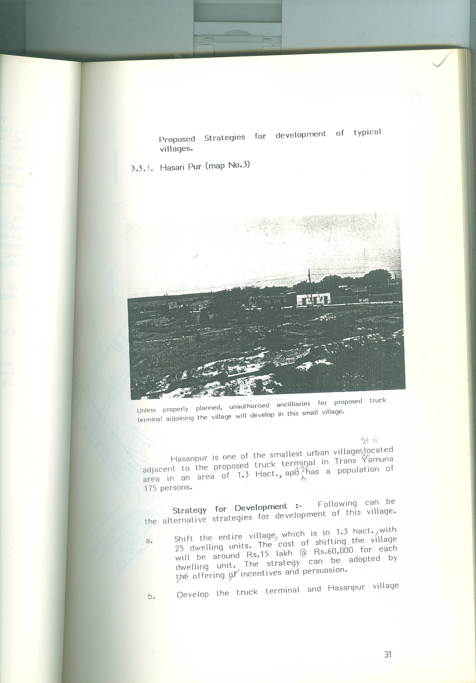
Unless properly planned, unauthorized ancillaries for proposed truck terminal adjoining the village will develop in this small villages.

Hasanpur is one of the smallest urban villages. It is located adjacent to the proposed truck terminal in Trans Yamuna area in an area of 1.3 Hact. It has a population of 175 persons.
Strategy for Development :- Following can be the alternative strategies for development of this villages.
- Shift the entire village, which is in 1.3 hact,,with 25 dwelling units. The cost of shifting the villages will be around Rs. 15 lakh @ Rs. 60,000 for each dwelling unit. The strategy can be adopted by offering of incentives and persuasion.

- Develop the truck terminal and Hasanpur village simultaneously by providing a thick green buffer between the two and restoring back the character of the village.

- Develop the truck terminal as per plan and leave the villages as it is. In this case, gradually the entire villages will be converted into ancillary activities of truck terminal. This strategy is not desirable from the planning and the environmental point of view.
Strategy mentioned at Sl. (a) is the best from planning point of view. But from public point of view strategy No.(b) is better. This is one of the smallest settlement and should be developed as per strategy a or b as 25 dwelling units have to be constructed for rehabilitation of villagers. Investment of Rs. 15 lakh is not very high in comparison to the achievements which will be made in terms of improvements in the life of 25 families, and planning a better truck terminal served by major roads on all the four sides.

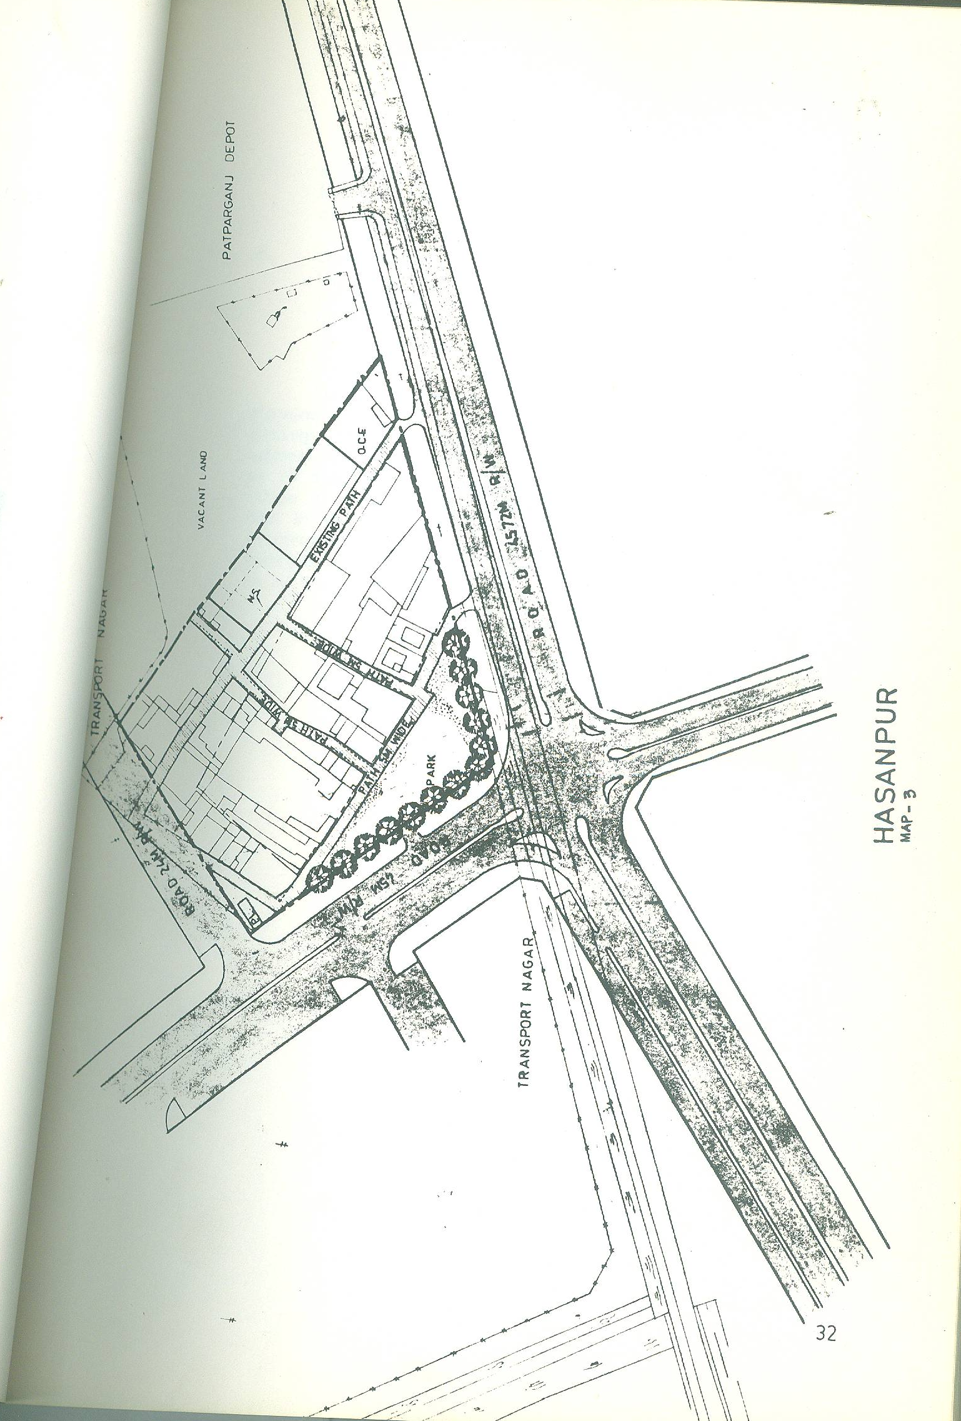

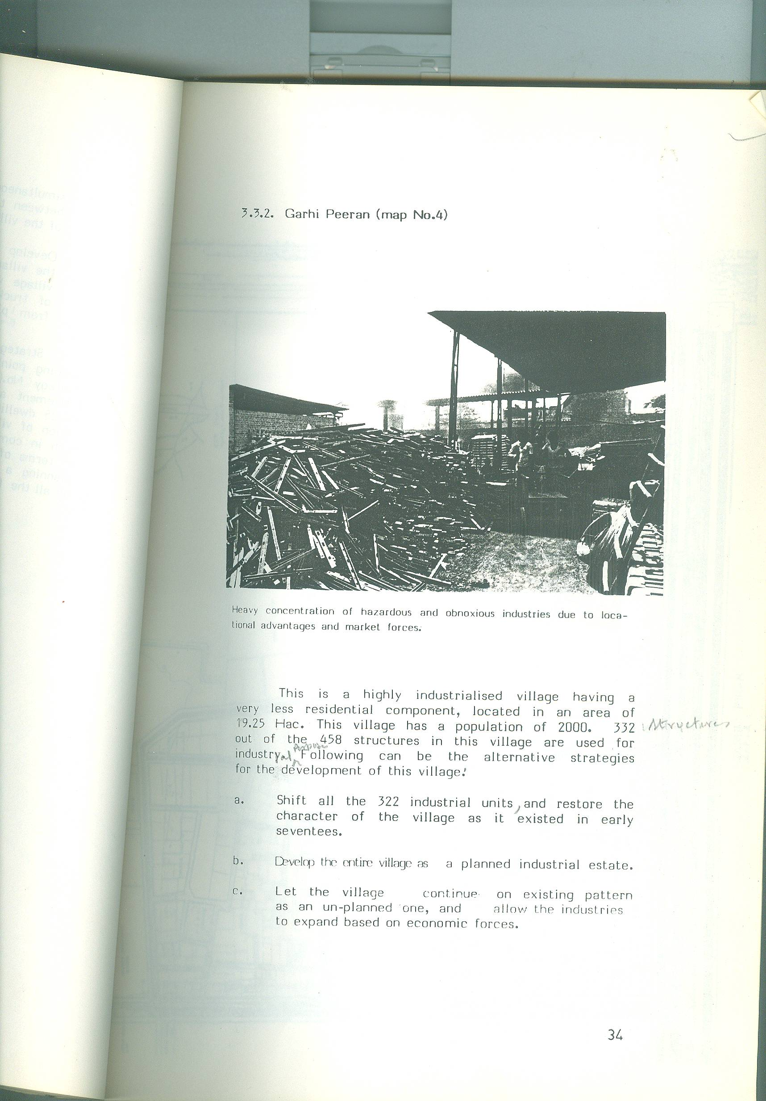
3.3.2. GARHI PEERAN (MAP NO. 4)

Heavy concentration of hazardous and obnoxious industries due to locational advantages and market forces.

This is a highly industrialized village having a very less residential component, located in an area of 19.25 Hac. This villages has a population of 2000. 332 structures out of the 458 structures in this villages are used for industrial purpose. Following can be the alternative strategies for the development of this villages.
- Shift all the 322 industrial units, and restore the character of the villages as it existed in early seventies.

- Develop the entire village as a planned industrial estate.

- Let the villages continue on existing pattern as an un- planned one, and allow the industries to expand based on economic forces.

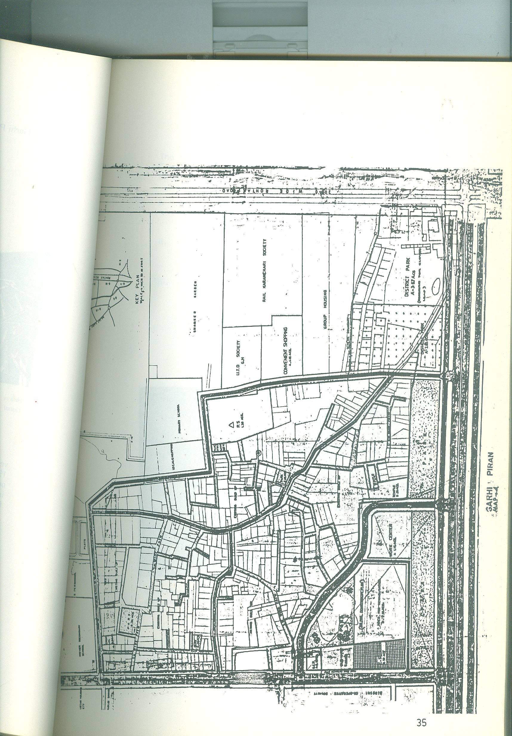
MAP. GARHI PIRAN MAP.

All the 3 strategies have merits and demerits. The last strategy is the worst and should not be adopted. From planning point of view, a strategy should be evolved by combining the merits of a & b, as given under :

- All the household and other light industries upto 4 workers and 1 H.P electric load should be permitted in the village.

- Noxious nuisance, hazardous and obnoxious industries should be shifted in planned industrial area of DDA.

- Remaining industries not falling in the above two categories should be rehabilitated after developing a pocket of about 5 hect. on the periphery or at a suitable location to accommodate all such units. One of the alternative locations can be Mangol Puri industrial area.

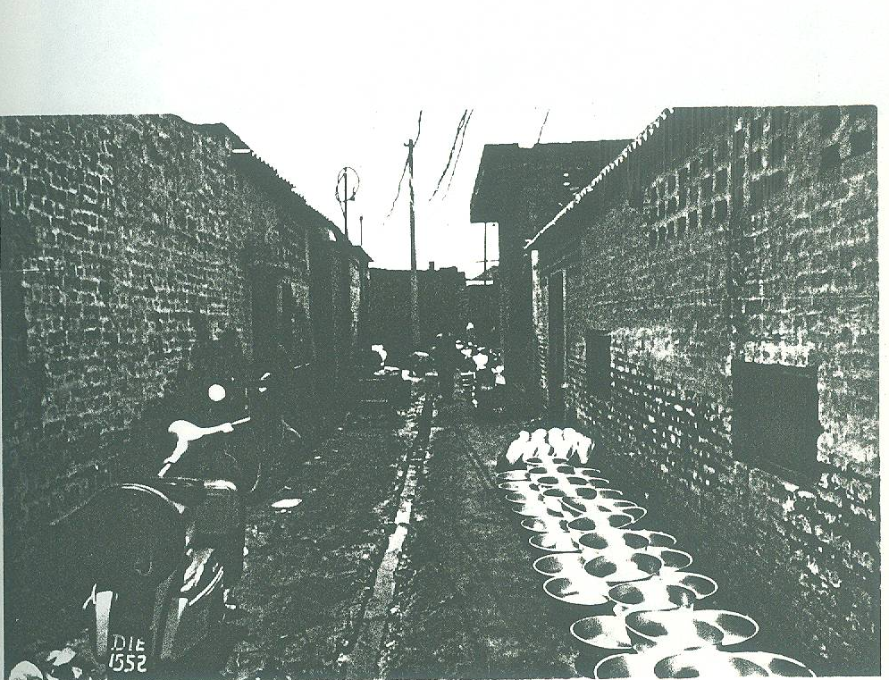
If not planned, industries will pollute not only the village but also surrounding
areas as there is no system for treating the industrial effluent.

    - PEEPALTHALA AND BHOORALA (MAP NO. 5)

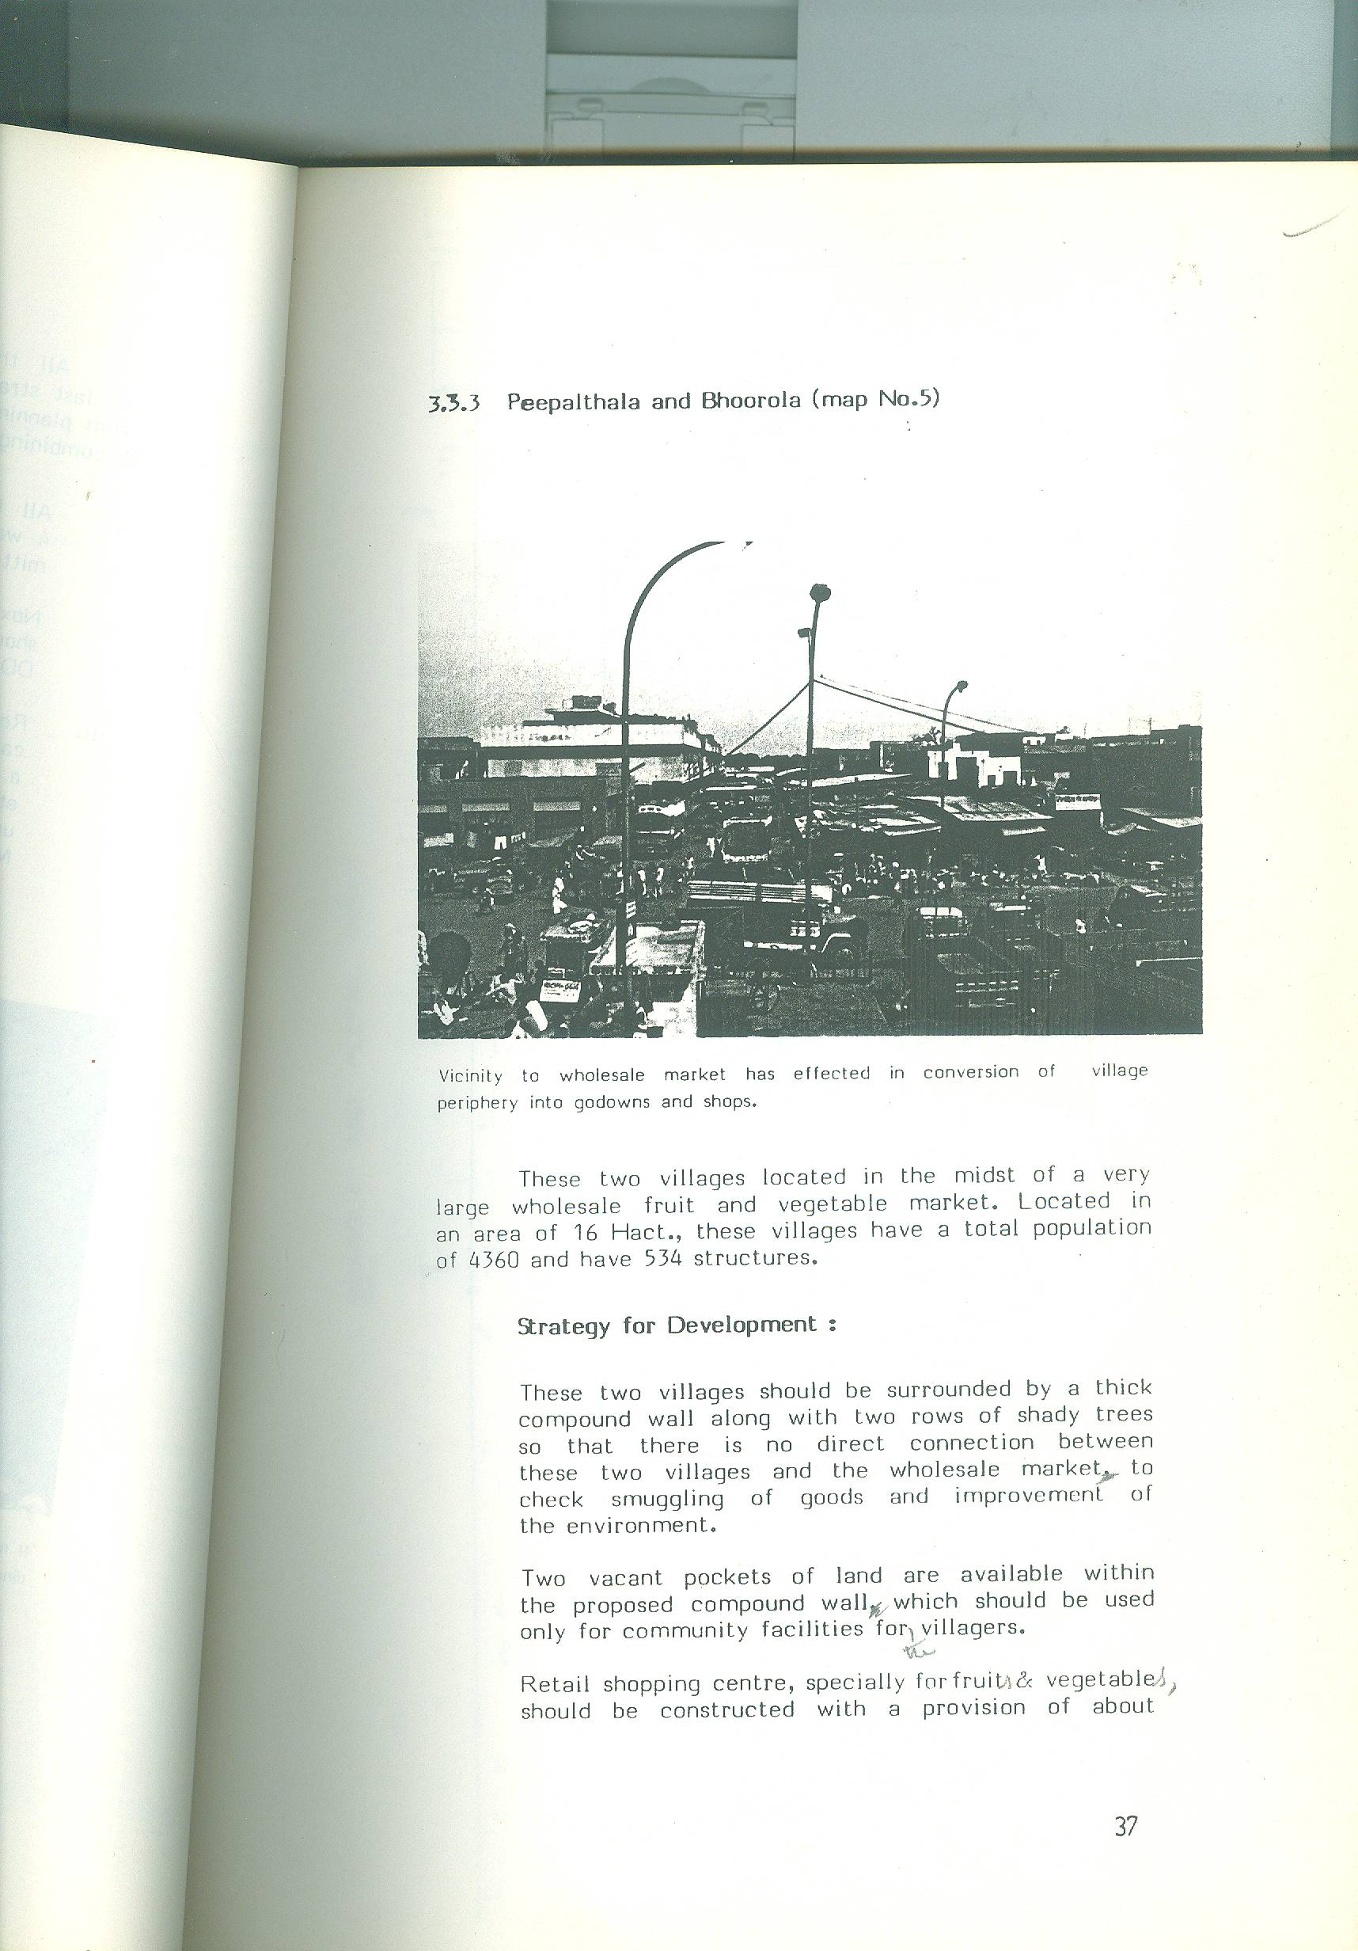
Vicinity to wholesale market has effected in conversion of villages periphery into god owns and shop.
These two villages located in the midst of a very large wholesale fruit and vegetable market. Located in an area of 16 Hact., these villages have a total population of 4360 and have 534 structures.
Strategy for Development :
These two villages should be surrounded by a thick compound wall along with two rows of shady trees so that there is no direct connection between these two villages and the wholesale market to check smuggling of goods and improvement of the environment.
Two vacant pockets of land are available within the proposed compound wall which should be used only for community facilities for the villagers.
Retail shopping centre specially for fruits & vegetables should be constructed with a provision of about 200 shops . These shops, may be allotted to villagers, who are the residents of these villages which have to be demolished for planned development of the villages and fruit & vegetable market.

Map BHAROLA AND PEEPAL THALA
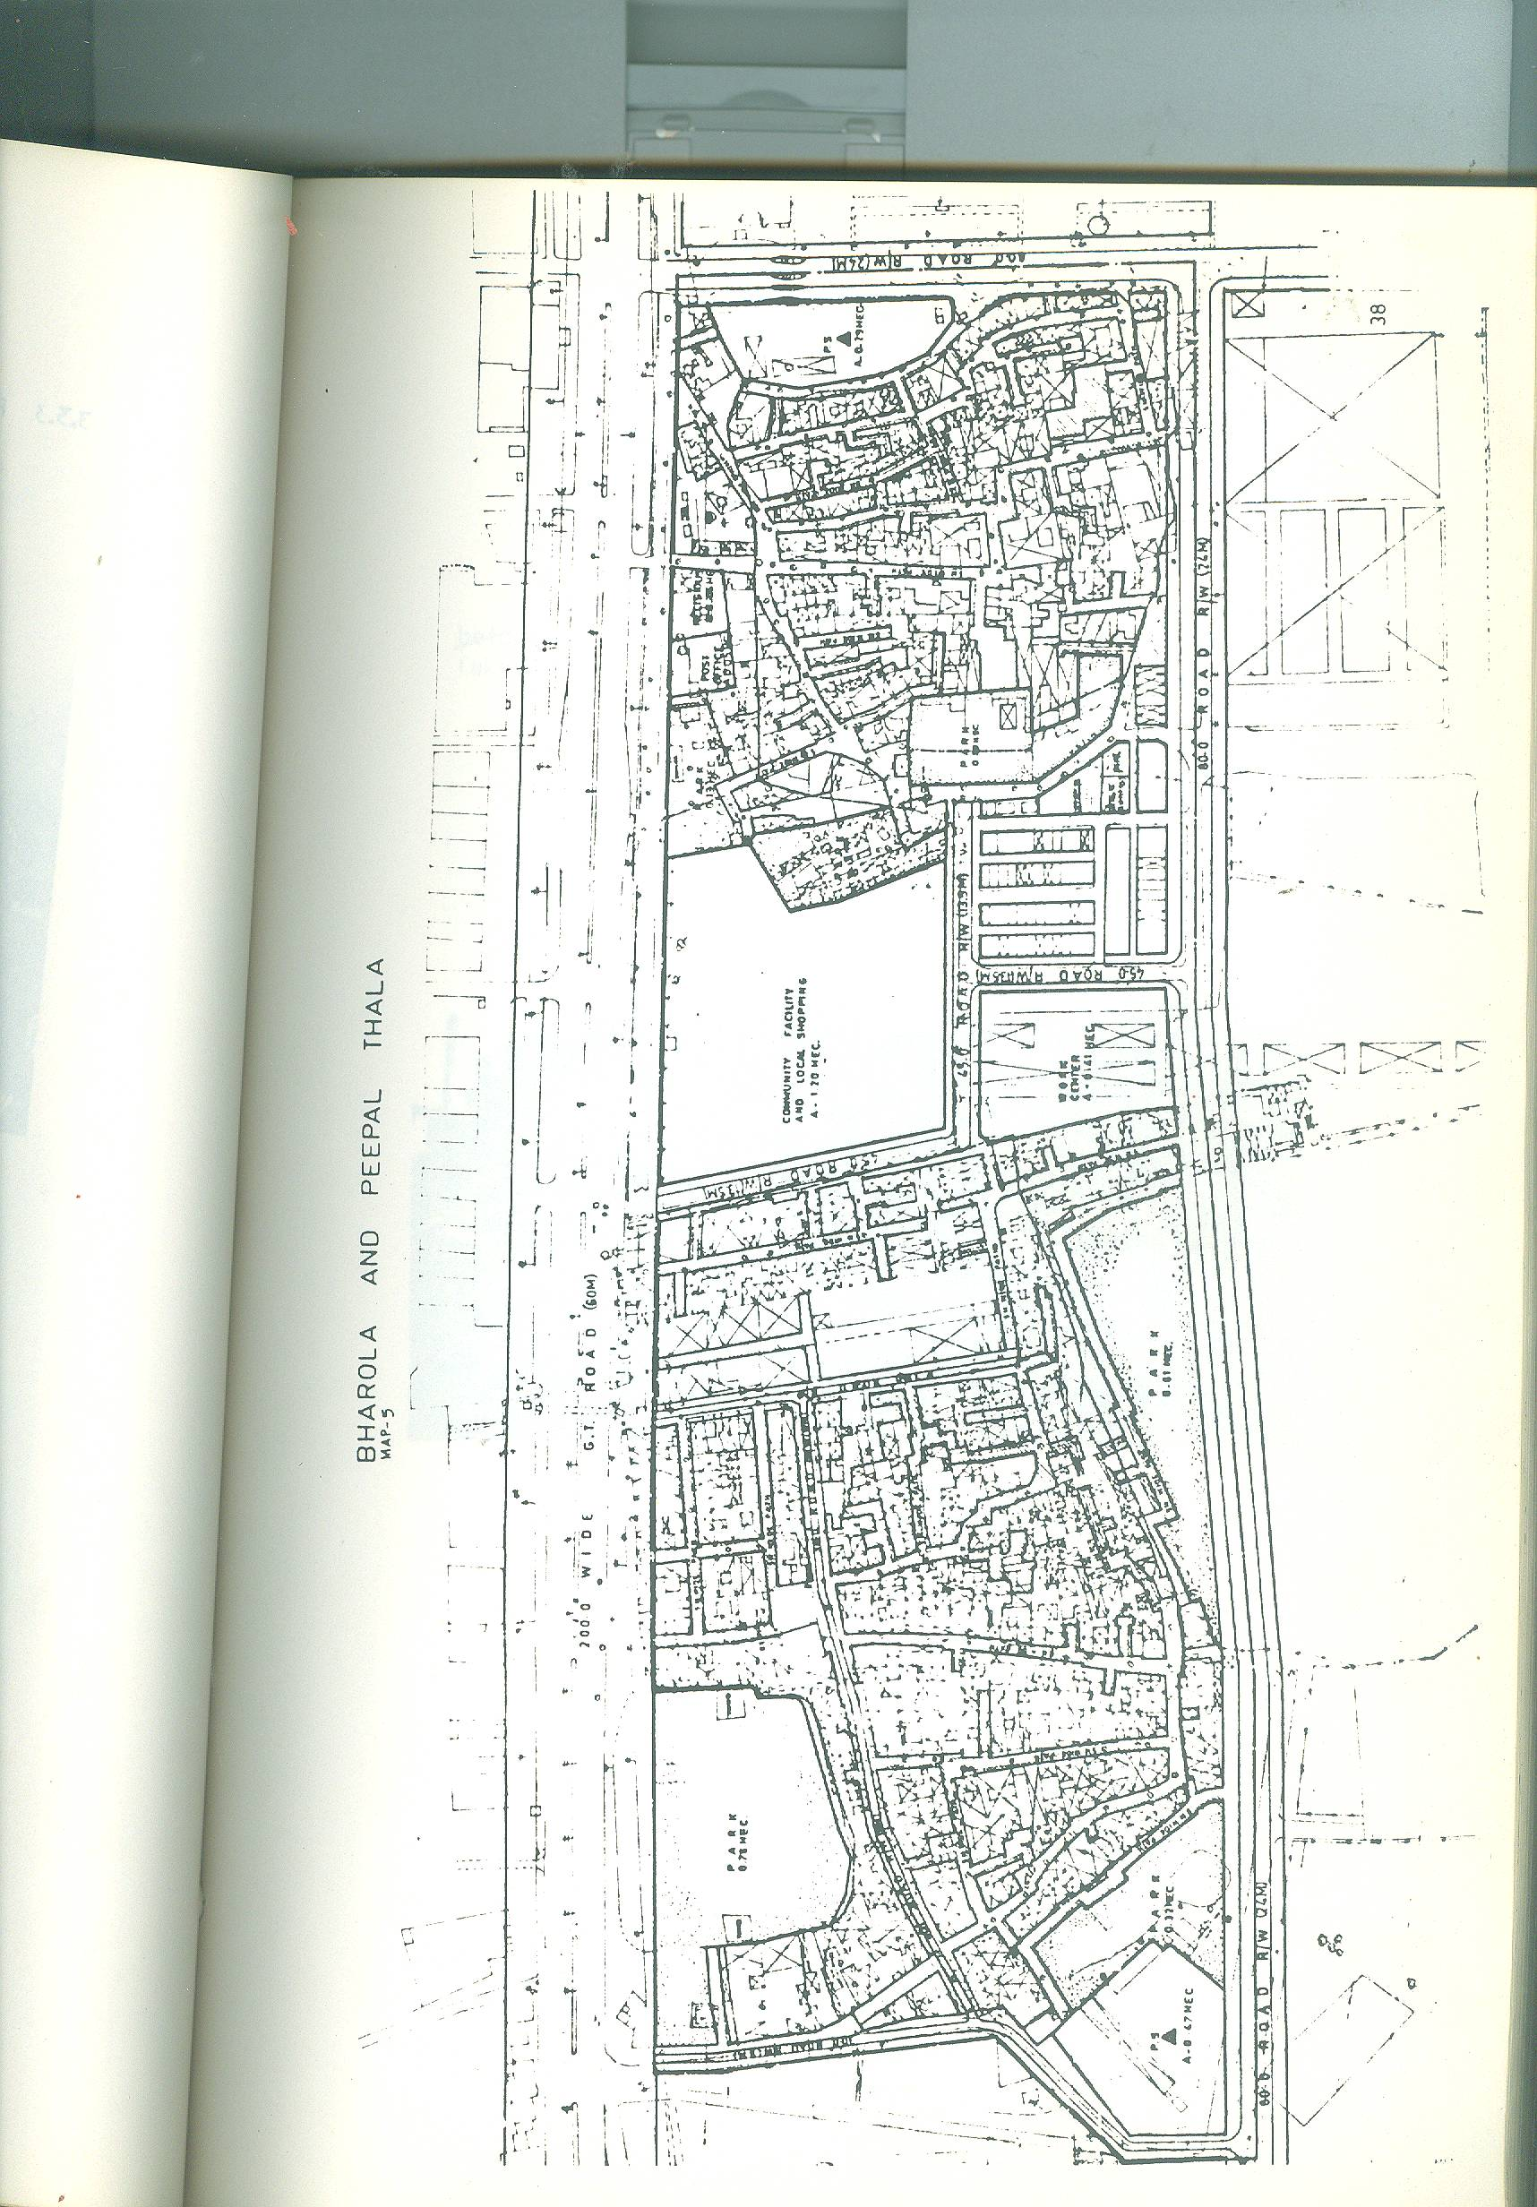

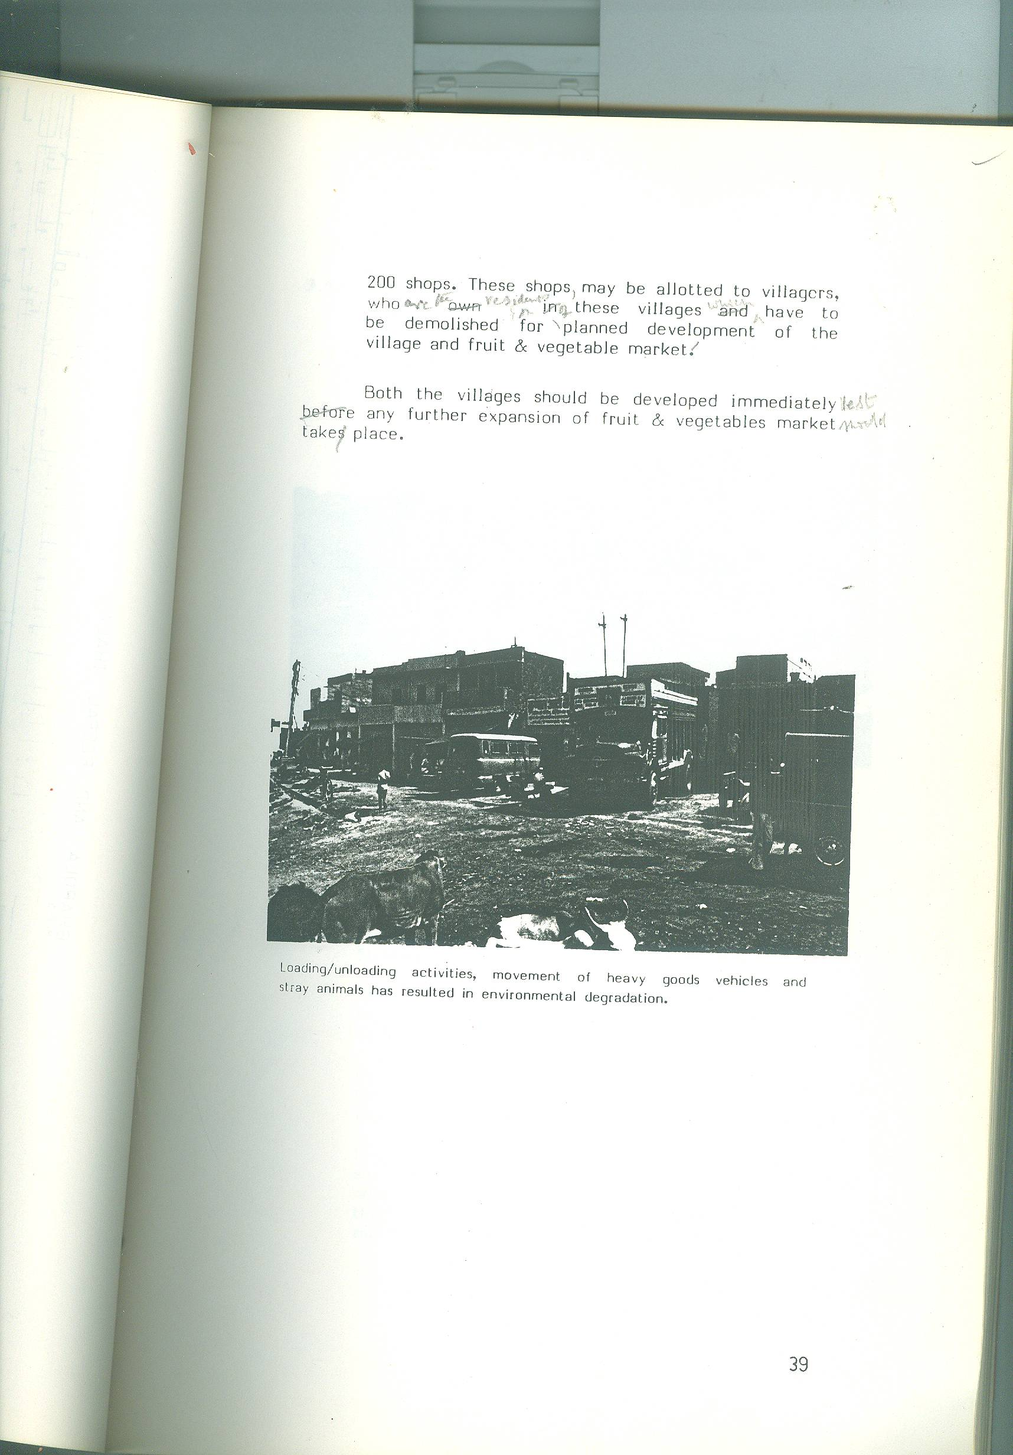
Both the villages should be development immediately lest any further expansion of fruit and vegetables market should take place.

Loading/unloading activities, movement of heavy goods vehicles and stray animals has resulted in environmental degradation.

    - TODARPUR AND DUSGHARA (MAP NO. 6)

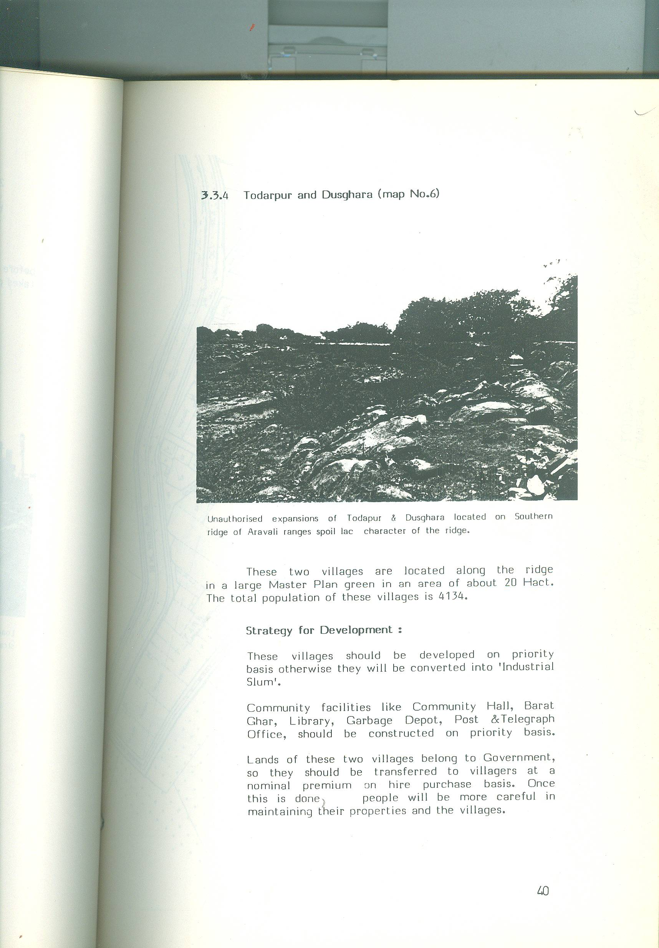

Unauthorised expansions of Todapur & Dusghara located on Southern ridge of Aravali ranges spoil lac character of the ridge.

These two villages are located along the ridge in large Master Plan green in an area of about 20 Hact. The total population of these villages is 4134.
Strategy for Development :
These villages should be developed on priority basis otherwise they will be converted into ‘ Industrial Slum’.
Community facilities like Community Hall, Barat Ghar, Library, Garbage Depot, Post & Telegraph Office, should be constructed on priority basic.
Lands of these two villages belong to Government, so they should be transferred to villagers at a nominal premium on hire purchase basis. Once this is done, people will be more careful in maintaining their properties and the villages.

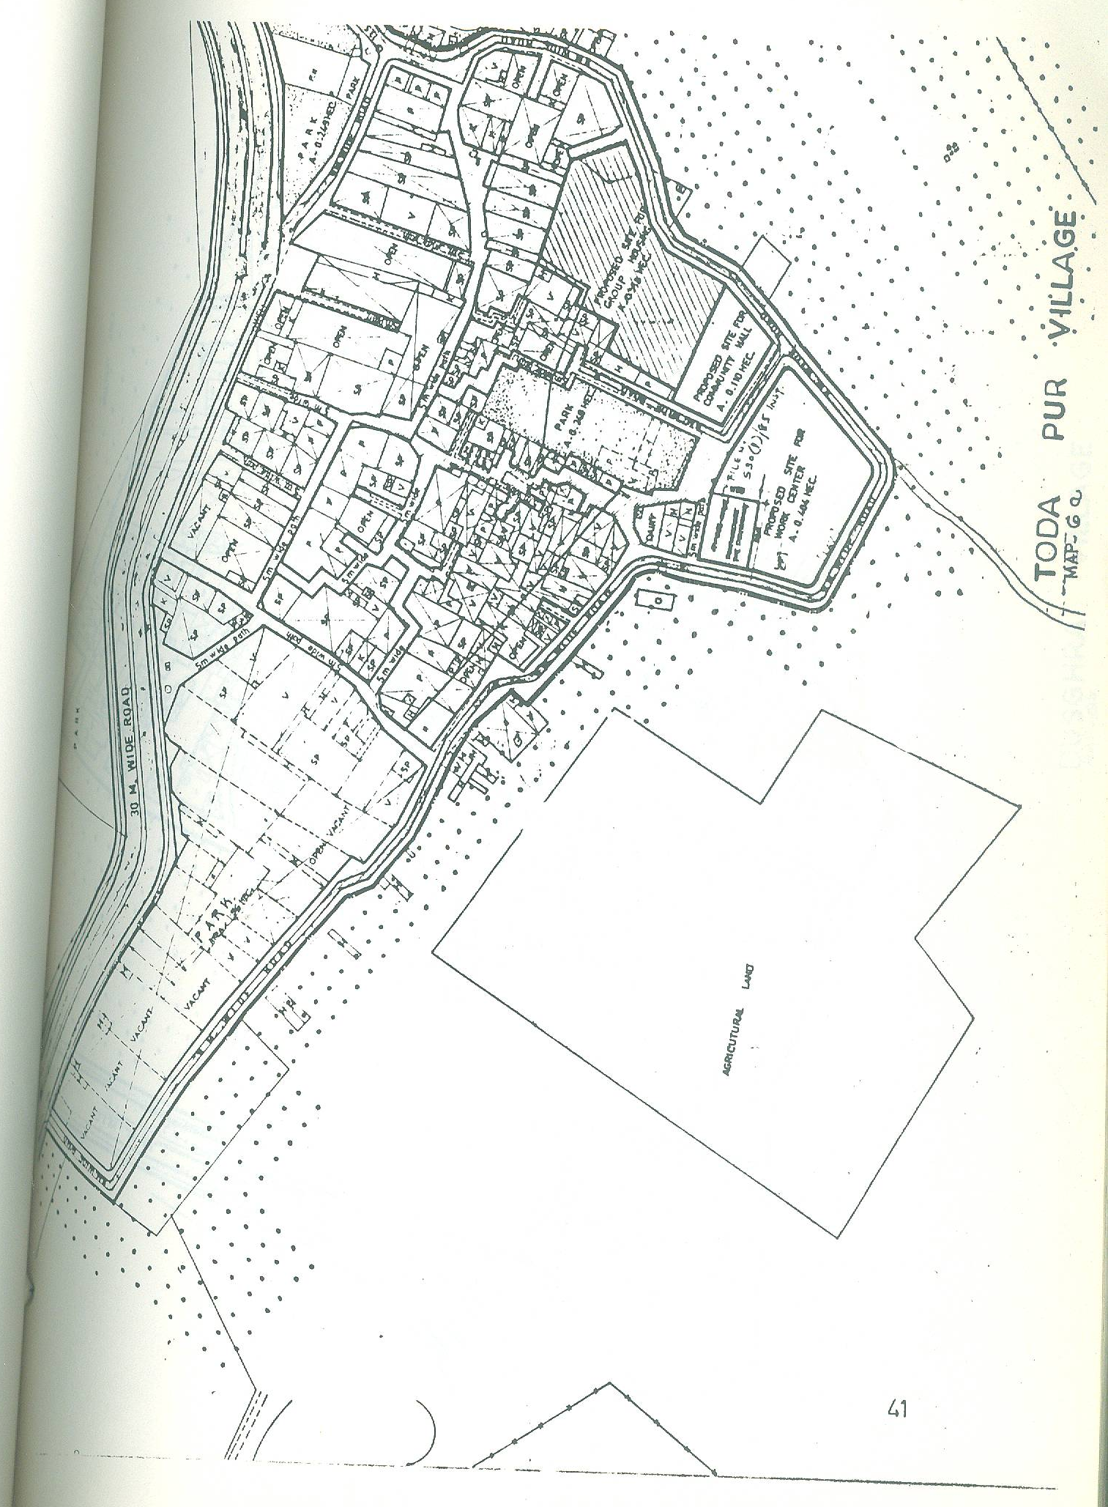
MAP : TODA PUR VILLAGE
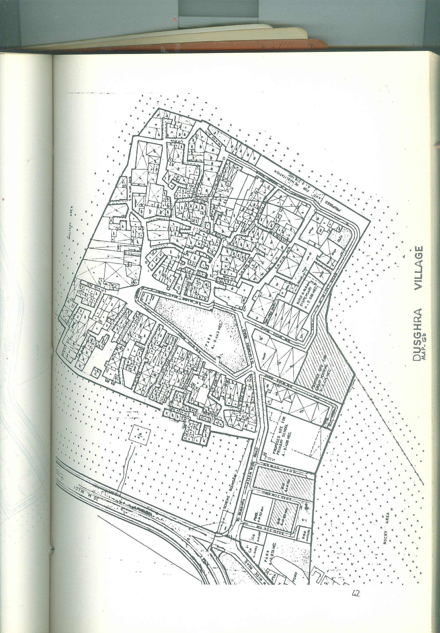
Map: DUSGHRA VILLAGE :

In the first instance, areas on the periphery should be developed into beautiful green belt to stop further encroachments.
All industries which have more than 4 workers and 1 H.P should be shifted to any of the adjoining pockets after its development for the purpose of industrial use.
Most of the industrial units are ready to shift but only to adjoining areas. In the vicinity, there is no developed industrial estate except Naraina, where there is no plot. As such it will be better if these industries are re-located in a pocket on the periphery, after marking a proper plan & development .

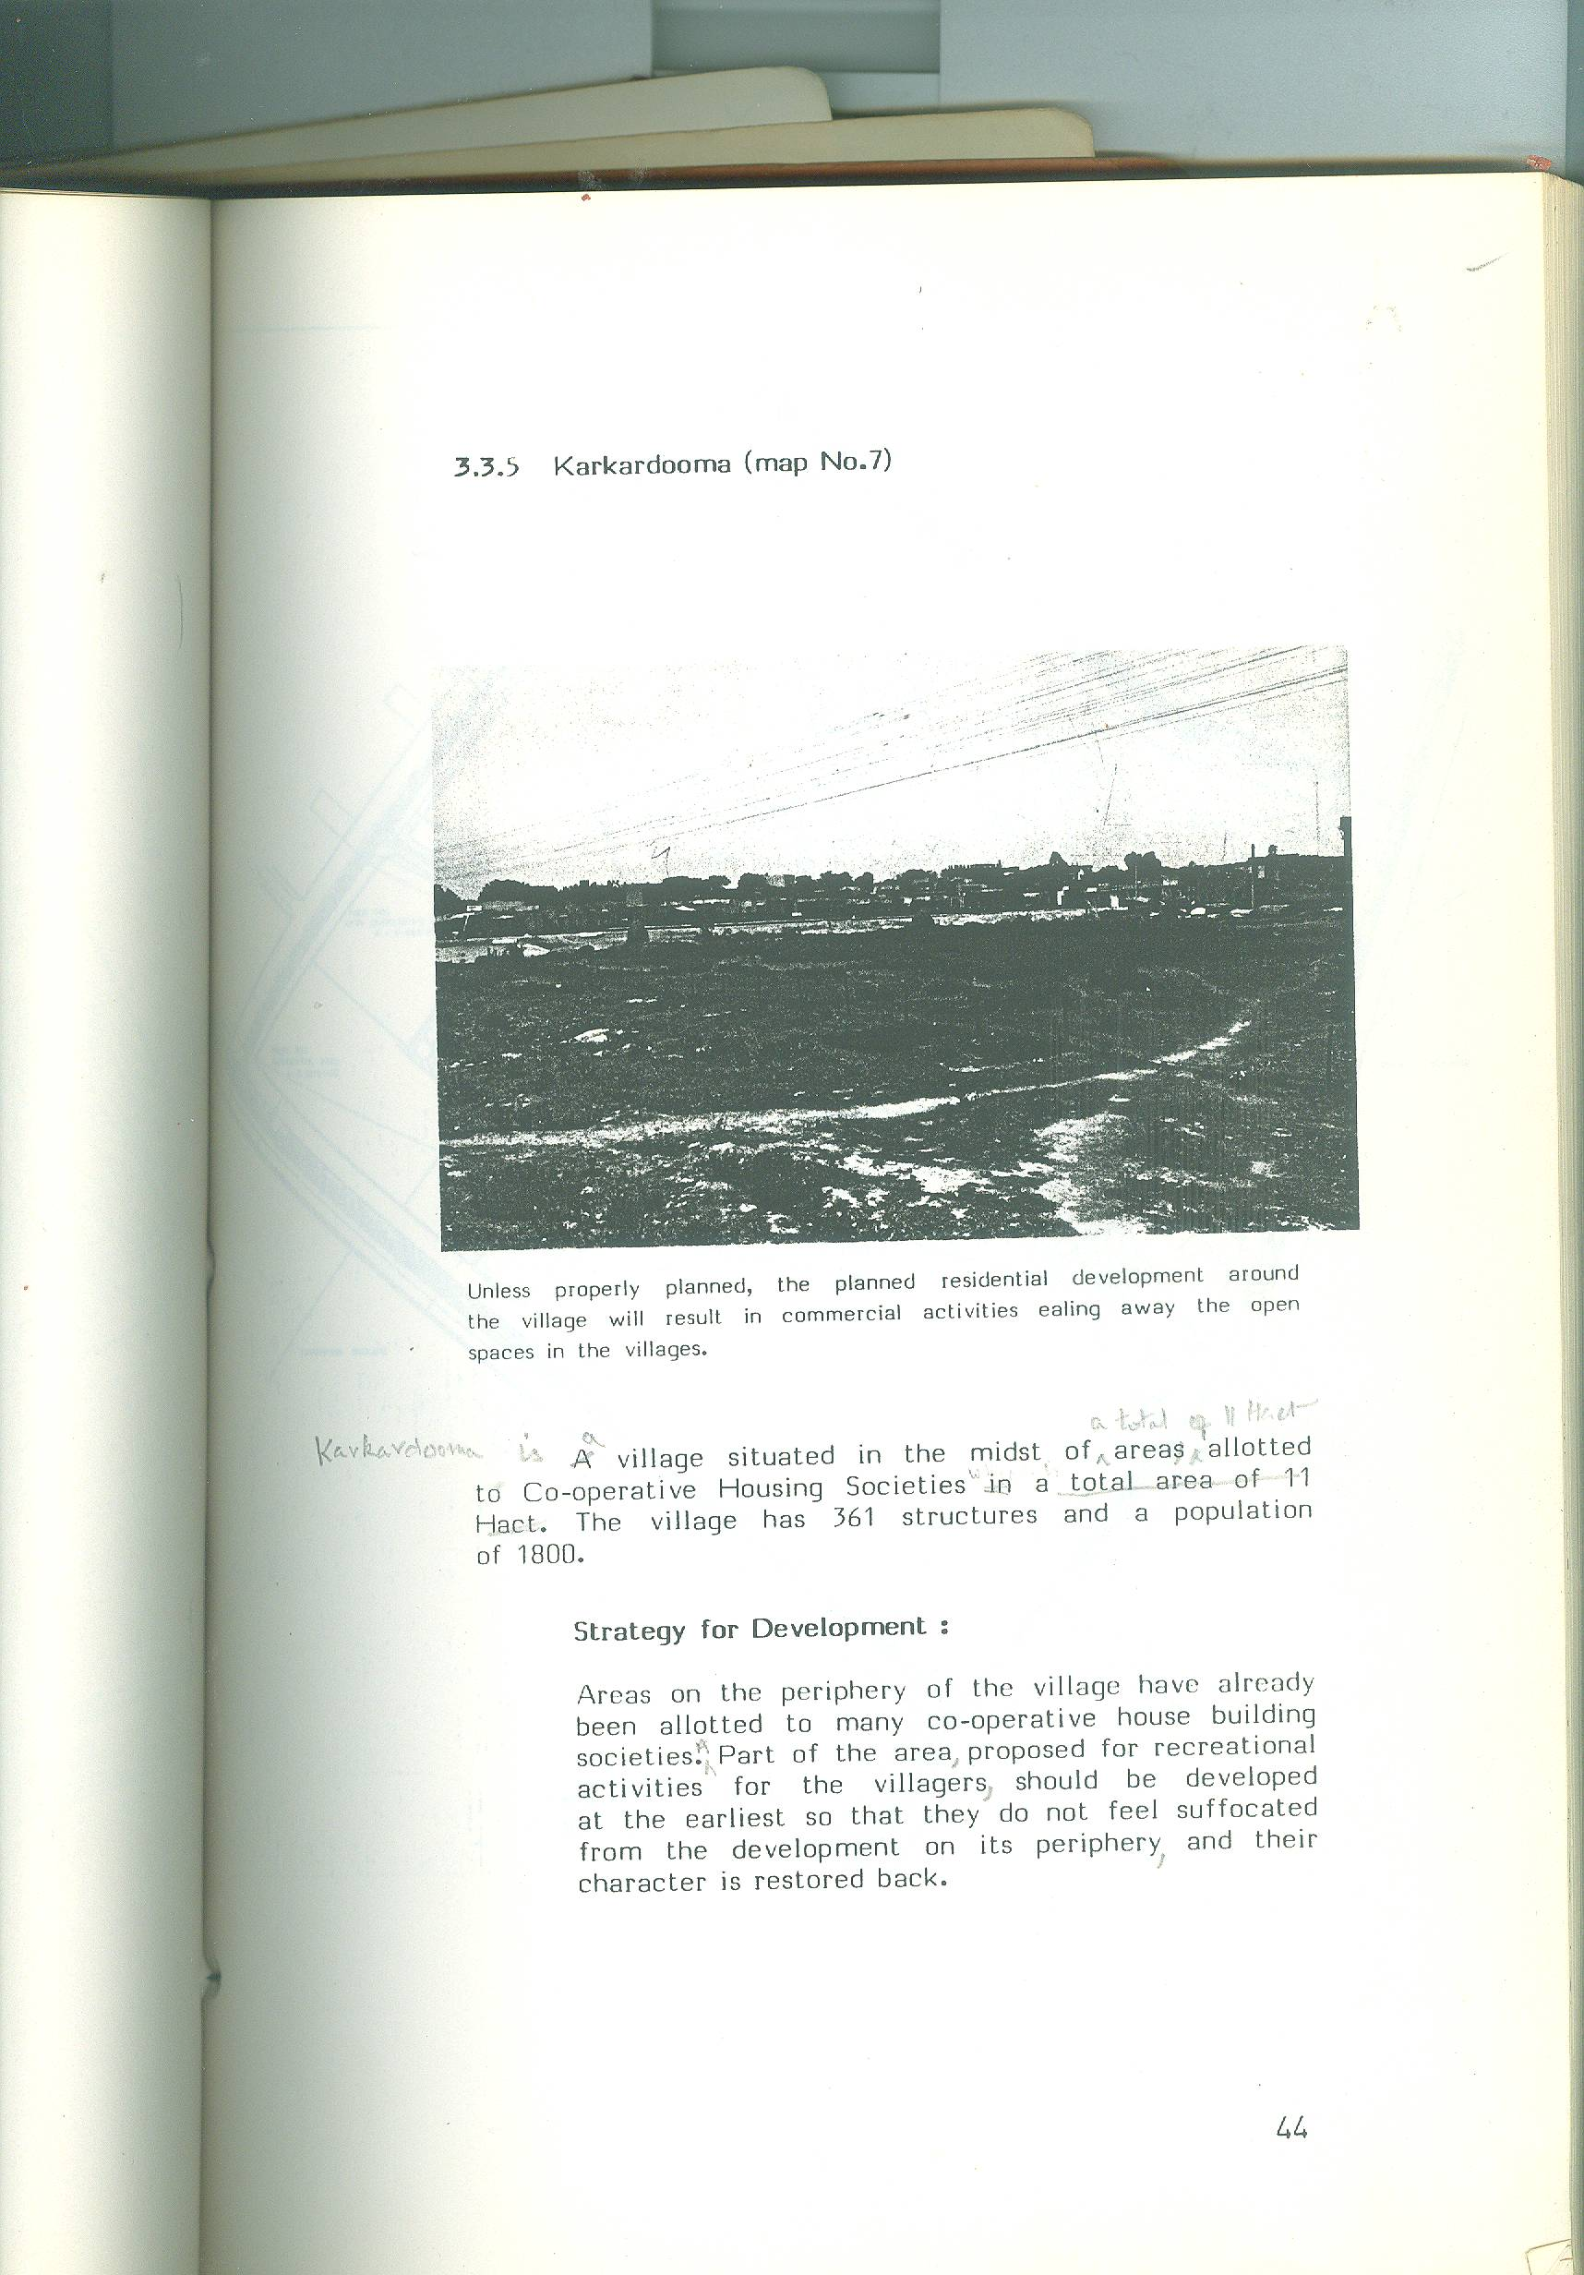
    - MAP : KARKARDOOMA (MAP NO. 7)

Unless properly planned, the residential development around the village will result in commercial activities ealing away the open spaces in the villages.
Karkardooma is a village situated in the midst of a total of 11 Hact area allotted to Co-operative Housing Societies. The village has 361 structures and a population of 1800.
Strategy for Development :
Areas on the periphery of the village have already been allotted to many co-operative house building societies. A part of the area, proposed for recreational activities for the villagers, should be developed at the earliest so that they do not feel suffocated from the earliest so that they do not feel suffocated from the development on its periphery, and their character is restored back.

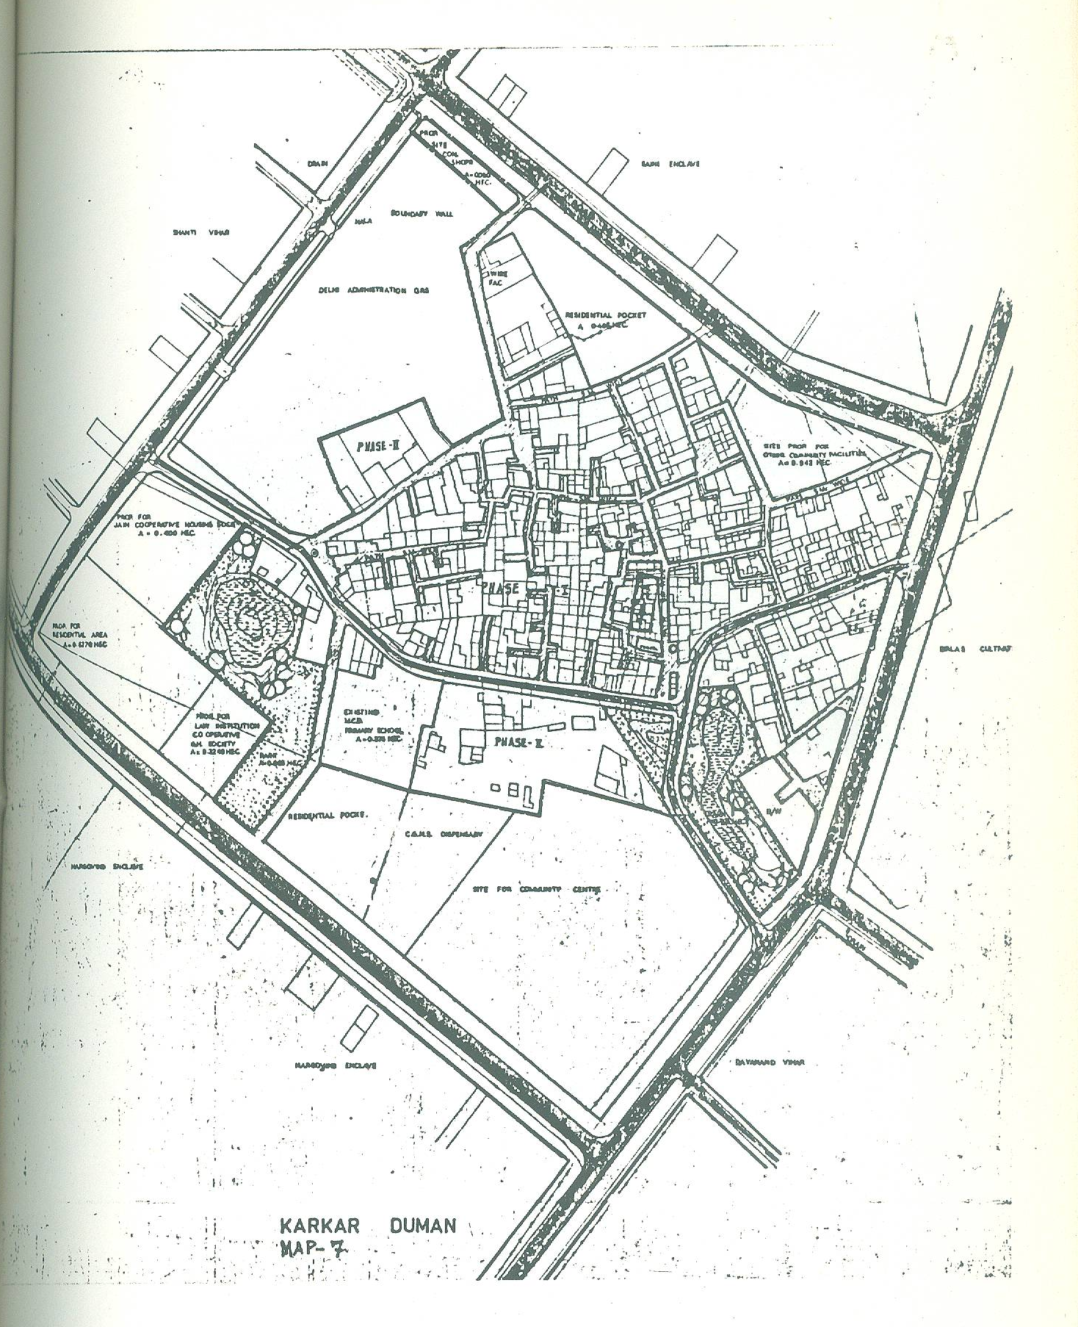
Map : KARKAR DUMAN MAP 7:

    - JWALA HERI (MAP NO. 8)
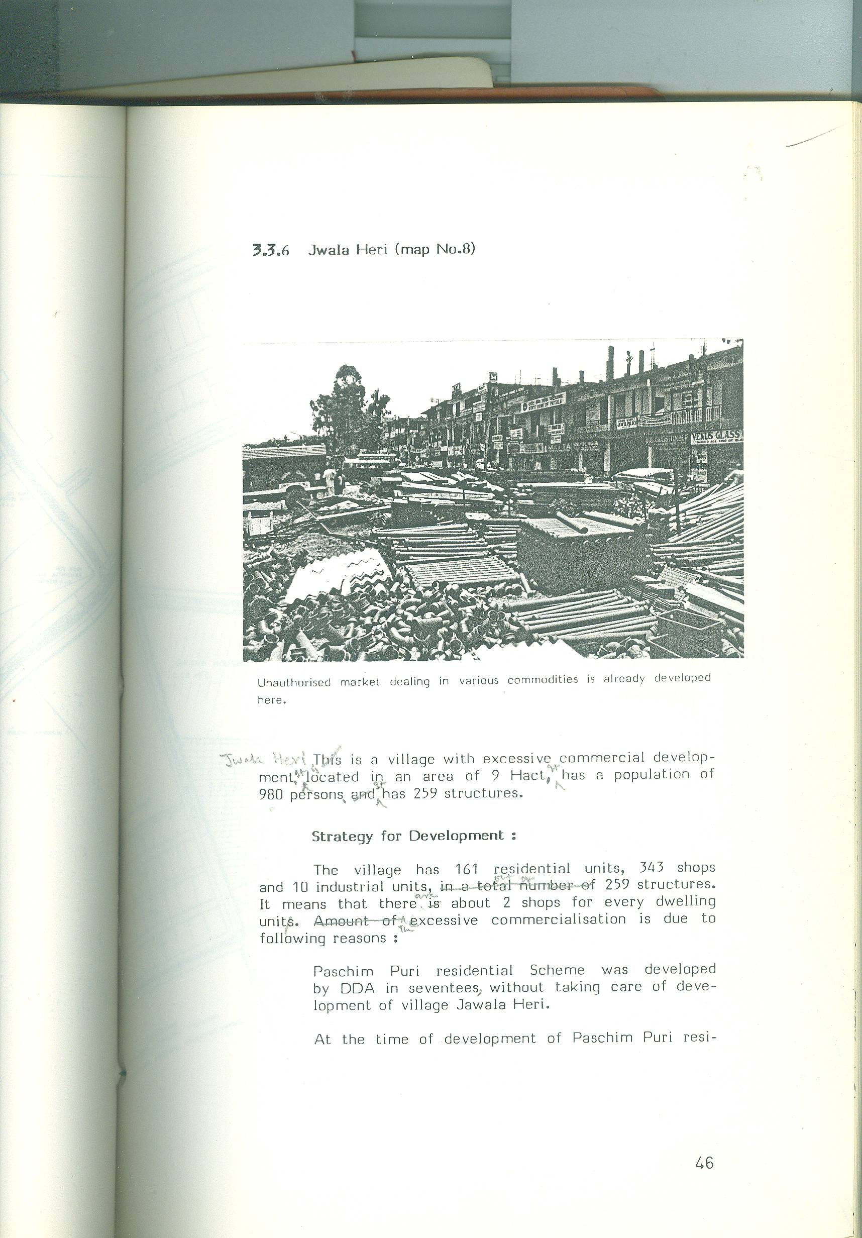
Unauthorised market dealing in various commodities is already developed here.

Jwala Heri is a village with excessive commercial development. It is located in an area of 9 Hact. It has a population of 980 persons. It has 259 structures.
Strategy for Development :
The village has 161 residential units, 343 shops and 10 industrial units, out of 259 structures. It means that there are about 2 shops for every dwelling unit. The excessive commercialization is due to following reasons:
Paschim Puri residential Scheme was developed by DDA in seventees, without taking care of development of village Jawala Heri.
At the time of development of Paschim Puri residential colony, no shopping facilities were available. The result was that hundreds of shops of building materials and of other necessaries were opened in an unauthorised way.

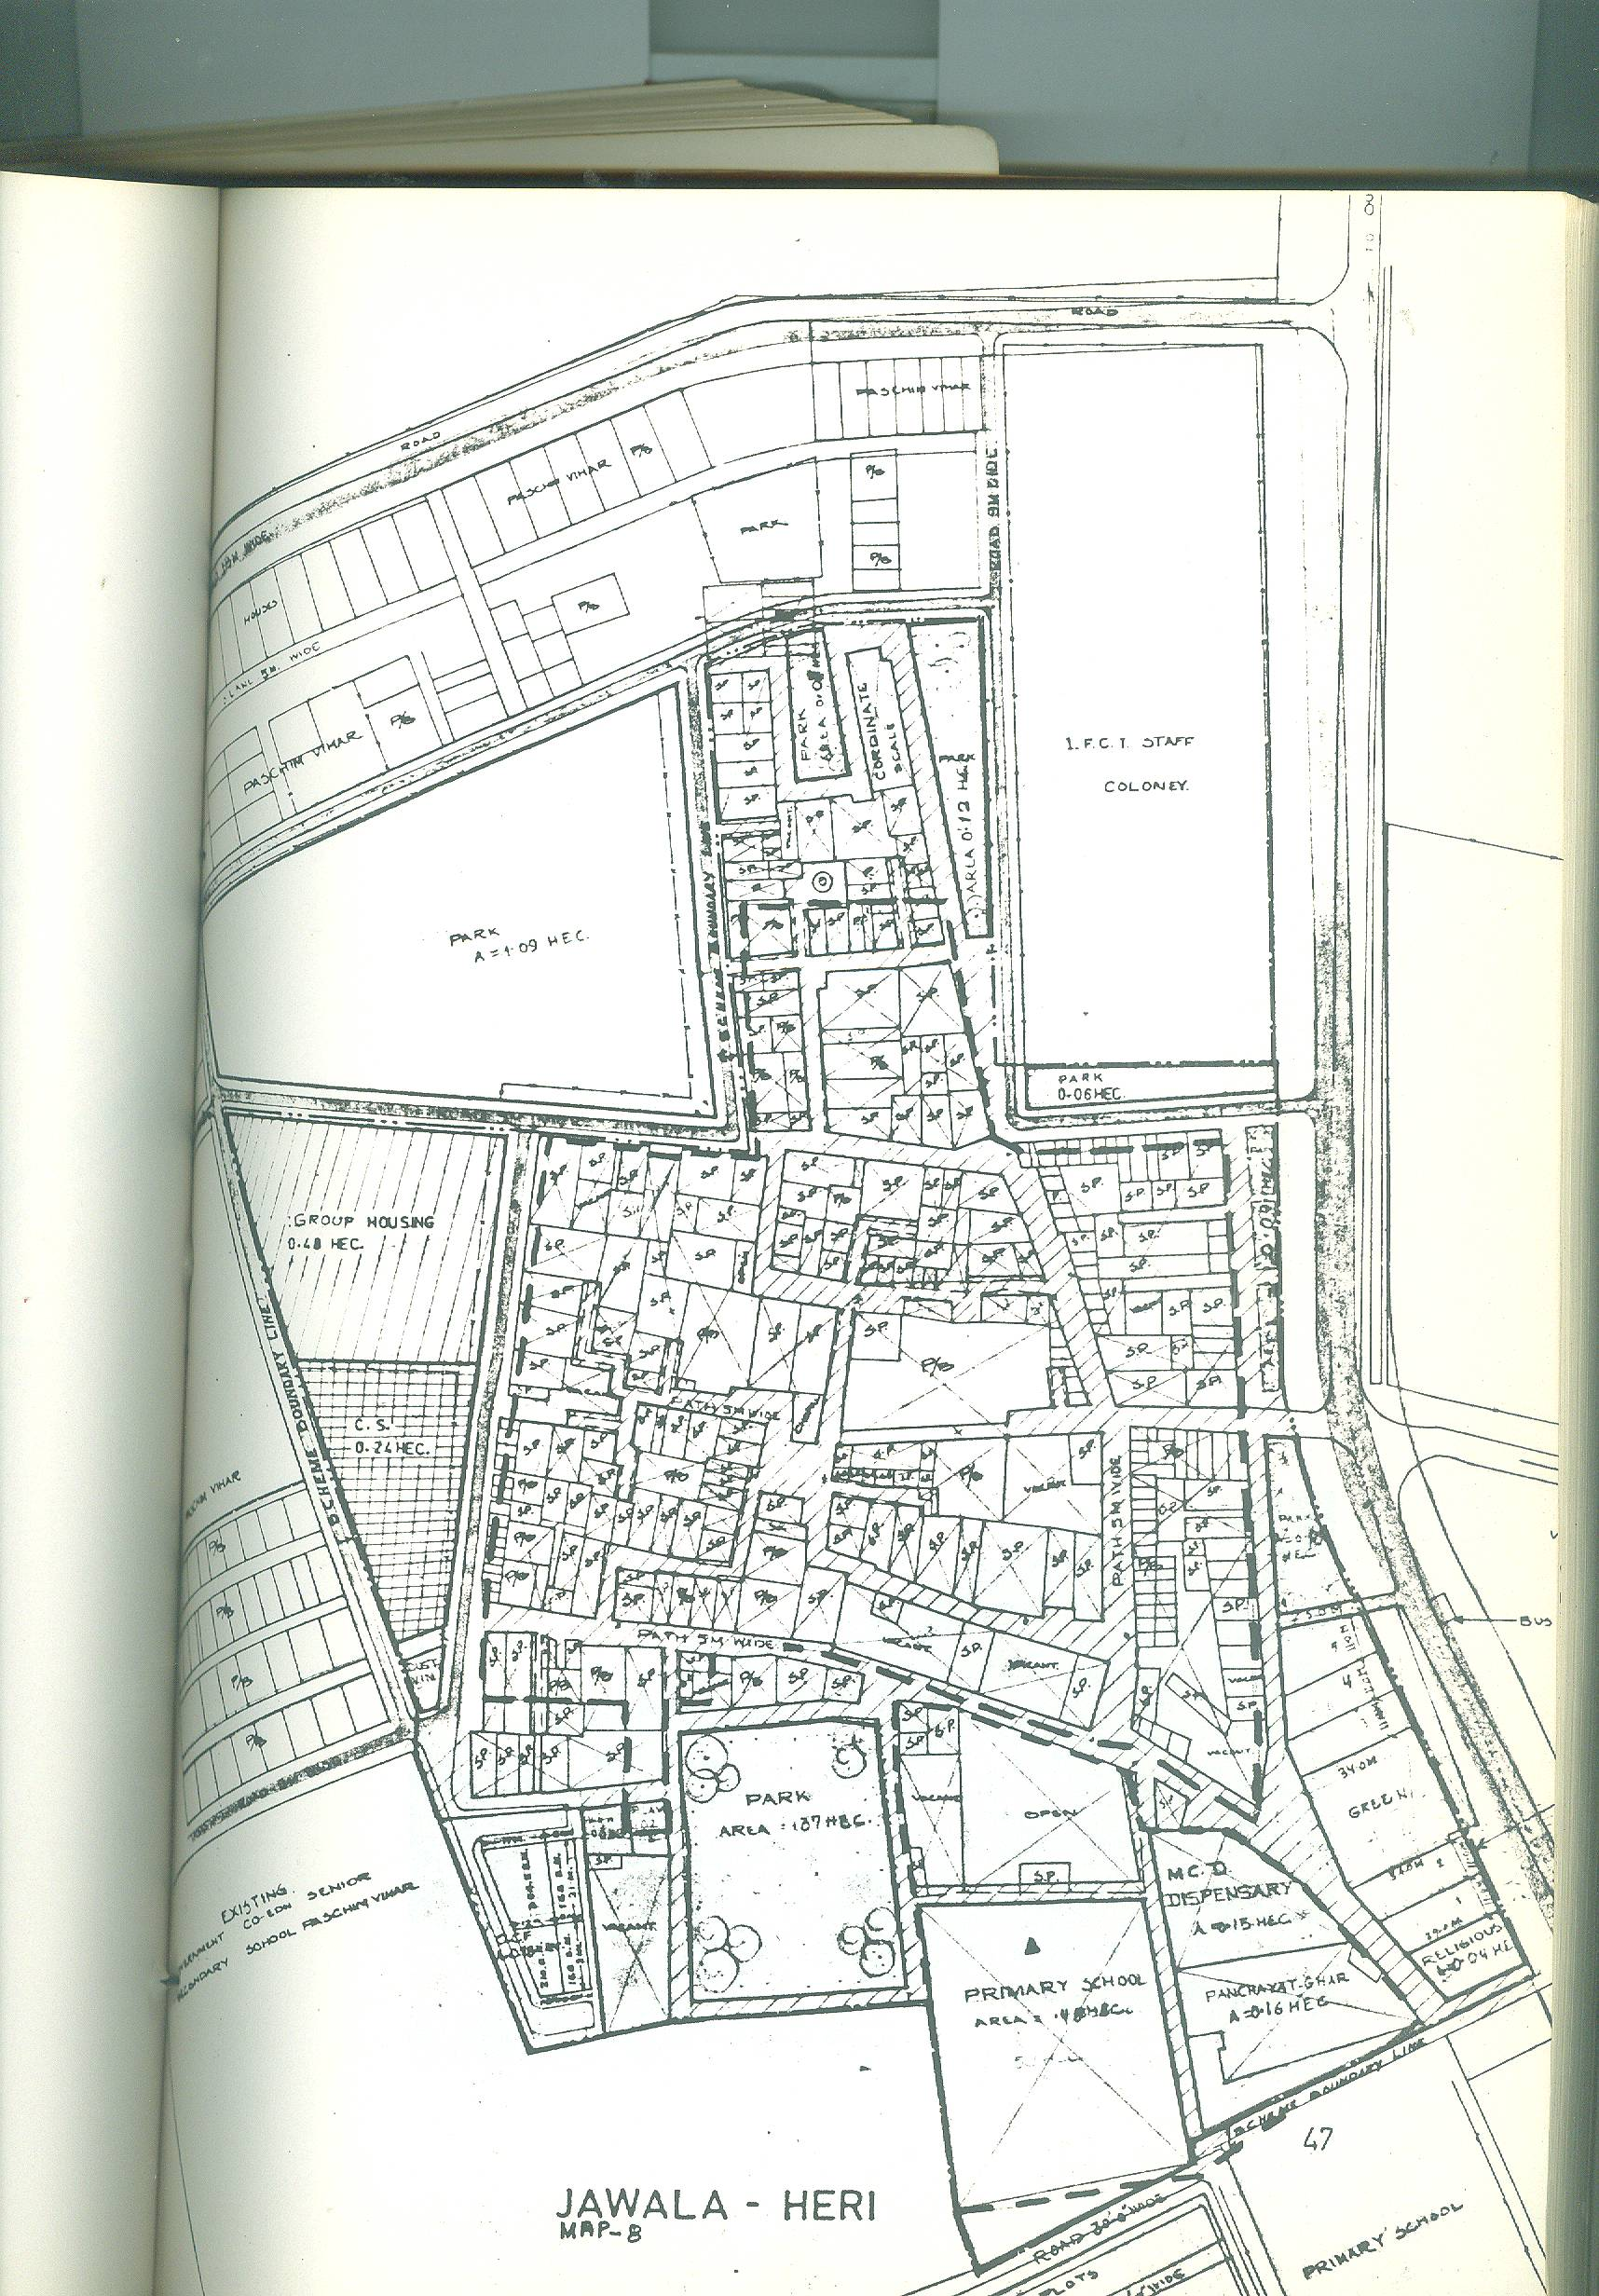
MAP. JAWALA-HERI :
Now the basic question is, “Can these shops be demolished? One of the views is, that shops cannot be demolished. They should not be demolished. Following strategy should be adopted.
Change the location of the community shopping centre which is proposed across the road on the place where the double storeyed market is in existence.
Development charges from the commercial use, as per details given in chapter No. 2, should be charged besides cost of the land if the market is on government land.
From this amount, the infrastructure of the village should be improved and developed.
Other small shops, which are in other parts of the village, should be spot zoned after charging development charges, as per details given in chapter No.2.

The unauthorised market is likely to sabotage the development if planned
shopping centre.

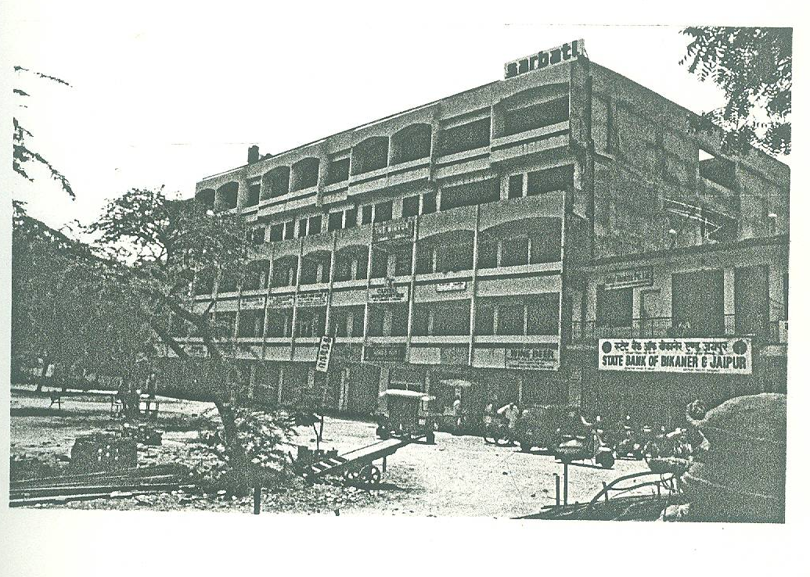

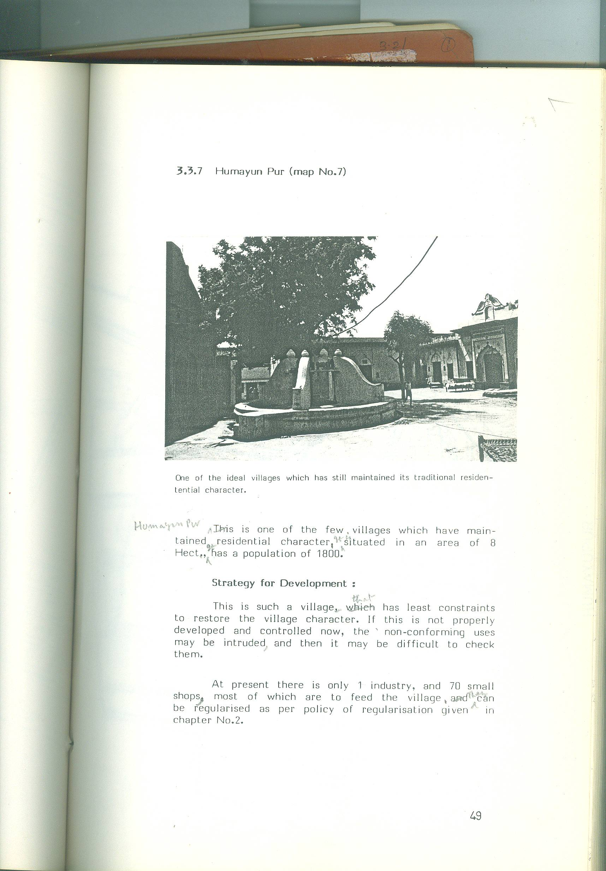
    - HUMAYUN PUR (MAP NO.7)

One of the ideal villages which has still maintained its traditional residential character.

Hamayun Pur is one of the few, villages which have maintained residential character. It is situated in an area of 8 Hect., It has a population of 1800.
Strategy for Development :

This is such a village that has least constraints to restore the village character. If this is not properly developed and controlled now, the non -conforming uses may be intruded, and then it may be difficult to check them.
At present there is only 1 industry, and 70 small shops, most of which are to feed the village. They can be regularized as per policy of regularization given in chapter No. 2.

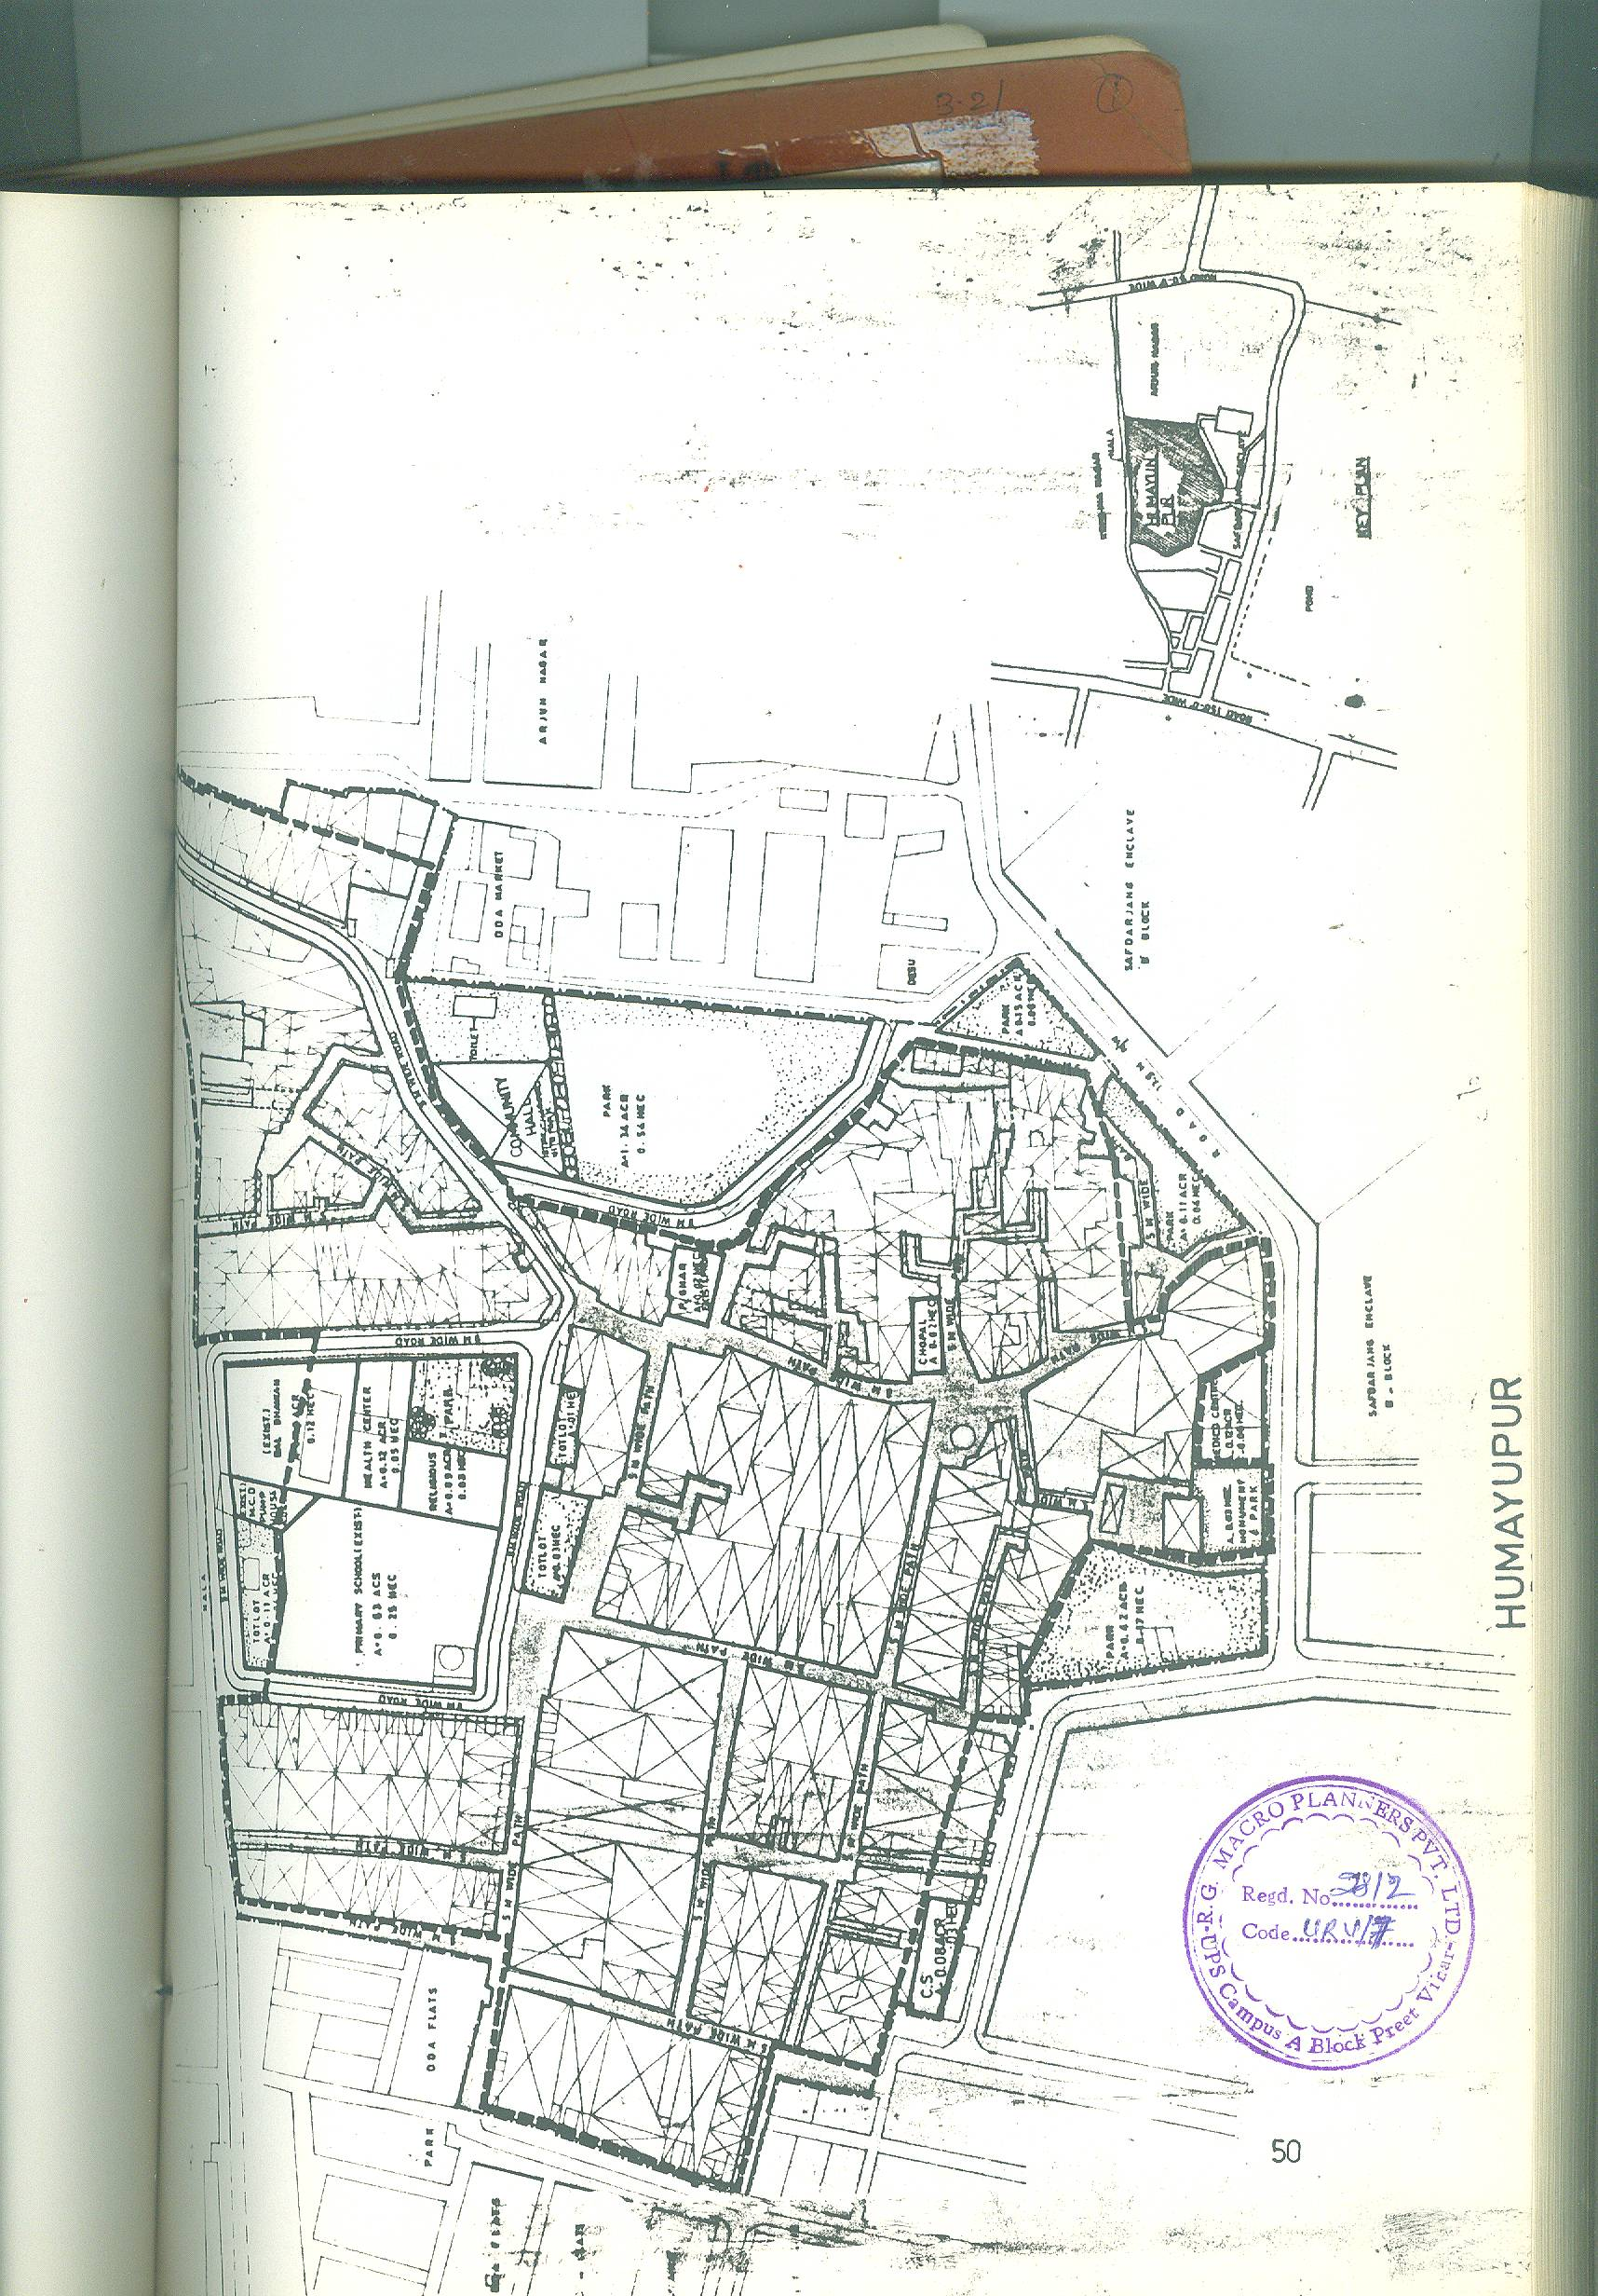
MAP : HUMAYU PURI :
    - BASAI DARA PUR (MAP NO. 10)

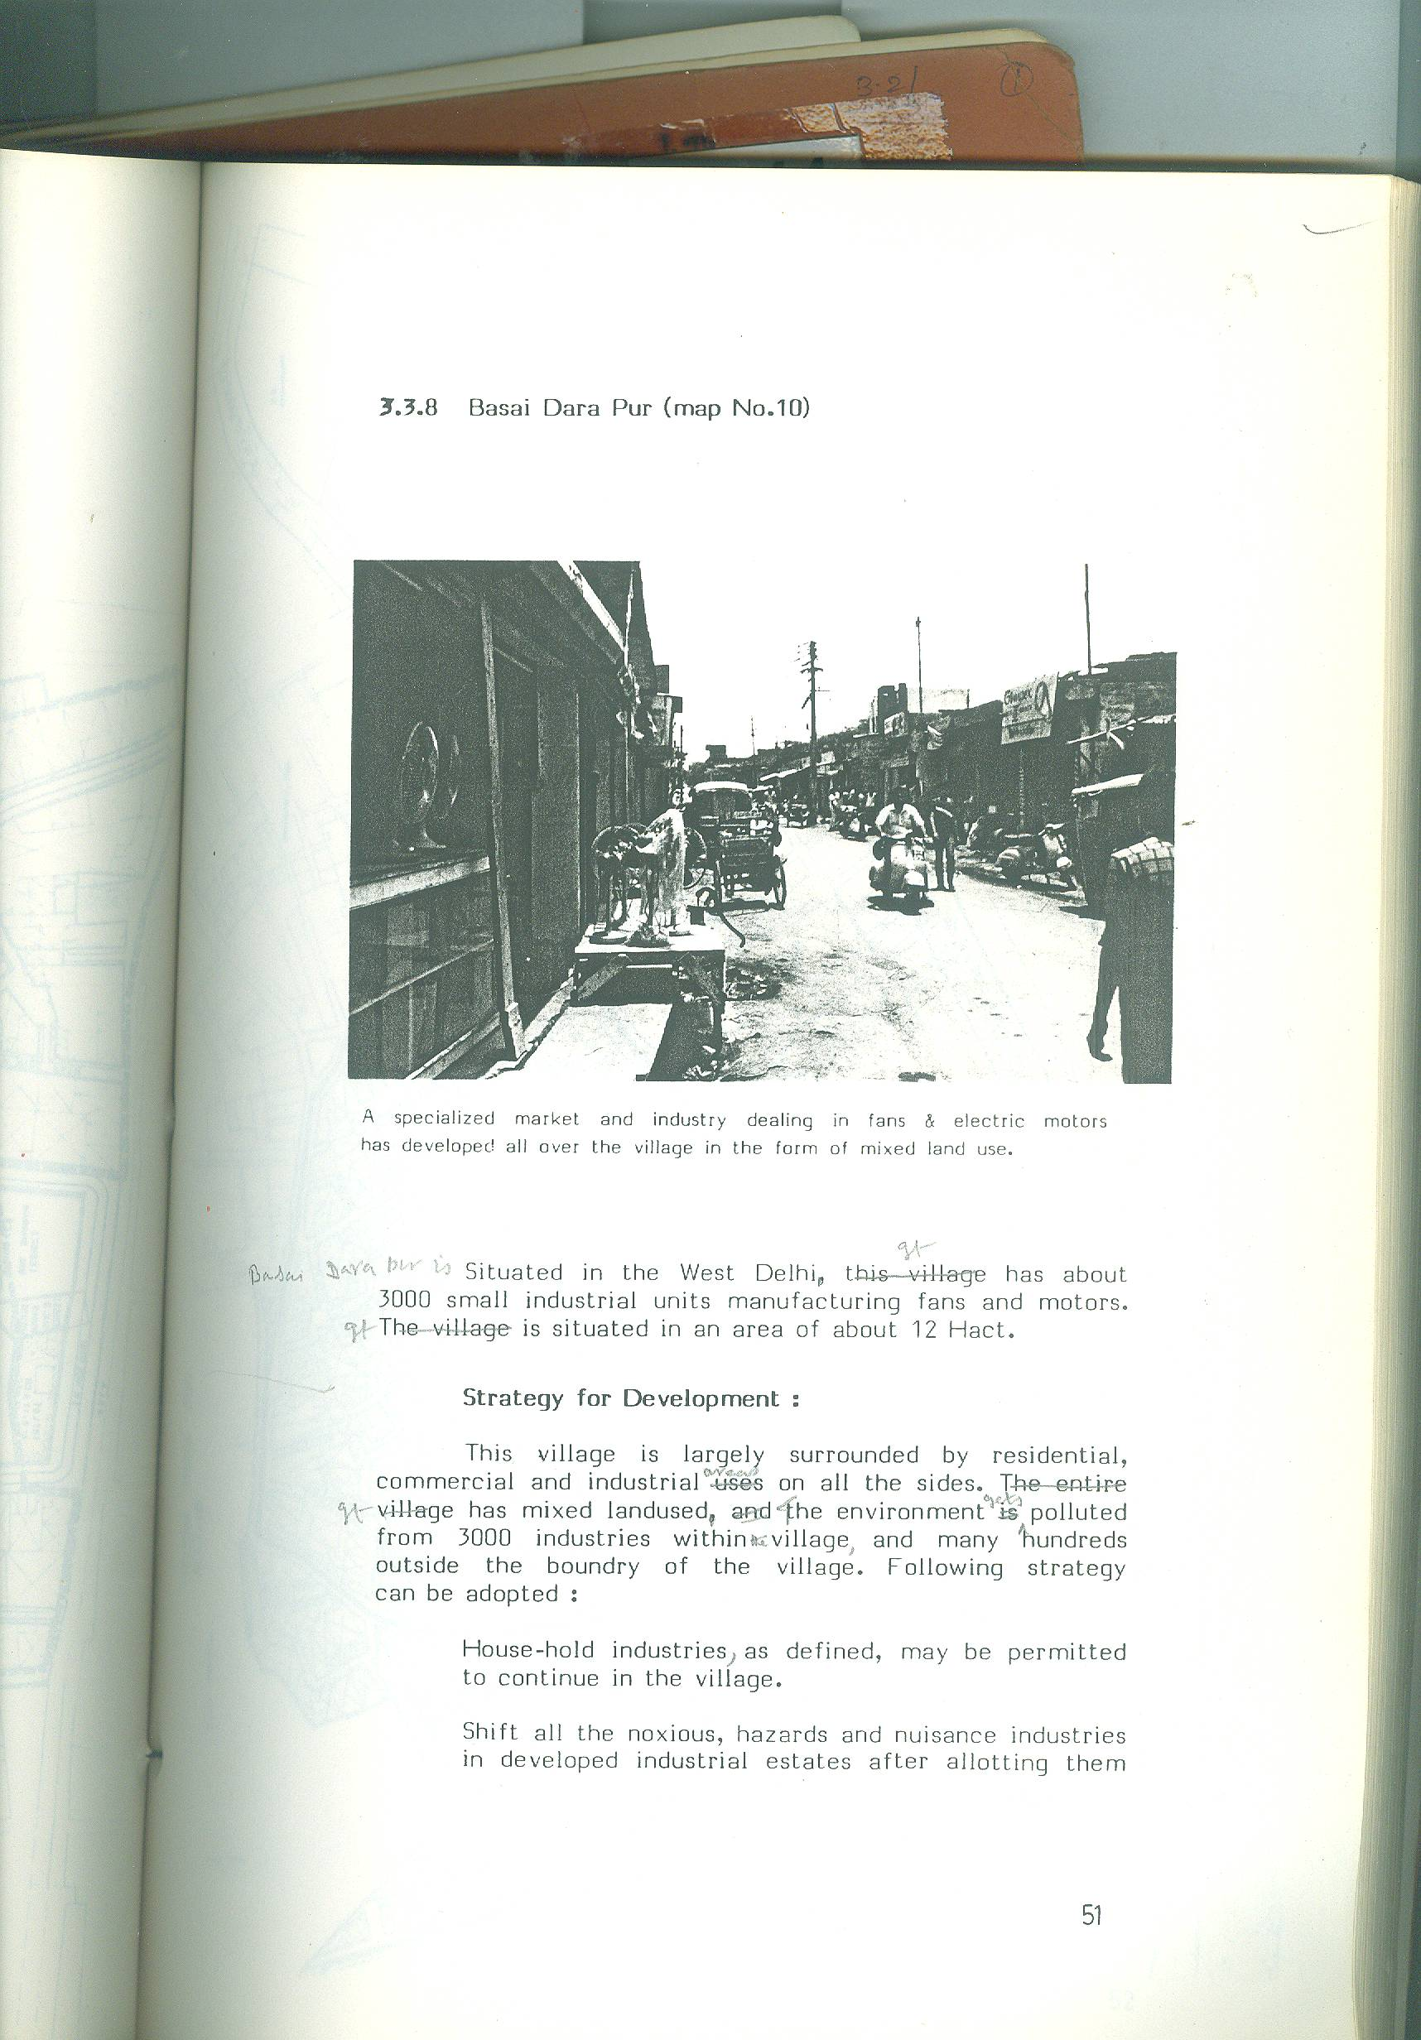
A specialized market and industry dealing in fans & electric motors has developed
all over the village in the form of mixed land use.
Basai Dara Pur is situated in the West Delhi. It has about 3000 small industrial units manufacturing fans and motors. It is situated in an area of about 12 Hact.
Strategy for Development :
This village is largely surrounded by residential, commercial and industrial areas on all the sides. It has mixed land use. The environment its polluted from 3000 industries within the village, and many hundreds outside the boundary of the village. Following strategy can be adopted:

House-hold industries, as defined, may be permitted to continue in the village.

Shift all the noxious, hazards and nuisance industries in developed industrial estates after allotting them alternative plots within a distance of 8 to 10 Km.

Industrial units, which do not fall in the above two categories, should also be shifted within a distance of 1-2 Km. from the village Basai Darapur, after developing a pocket of 5 to 6 hect.

Areas vacated by these industries should be permitted to be used for residential purpose and for community facilities.

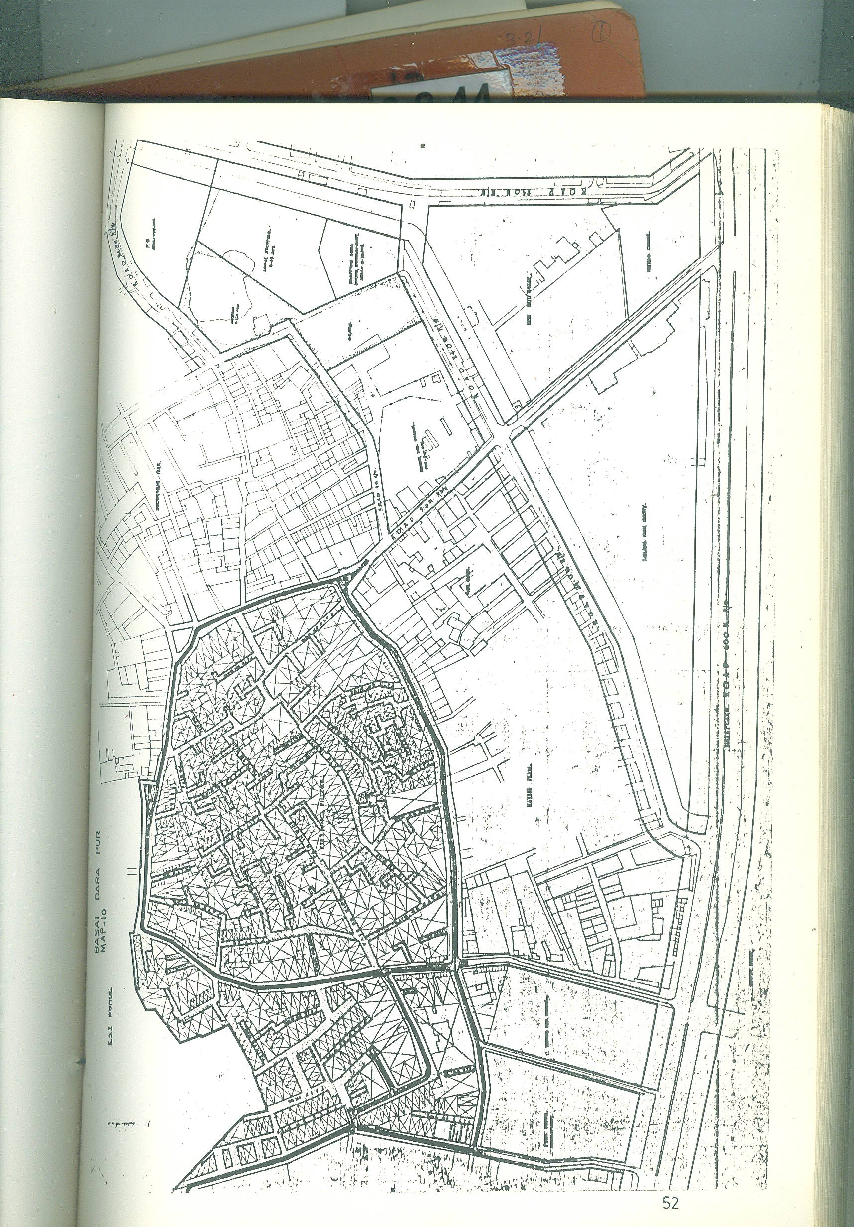
MAP : BASI DARA PUR

3.3.9 PITAM PURA (MAP NO. 11)

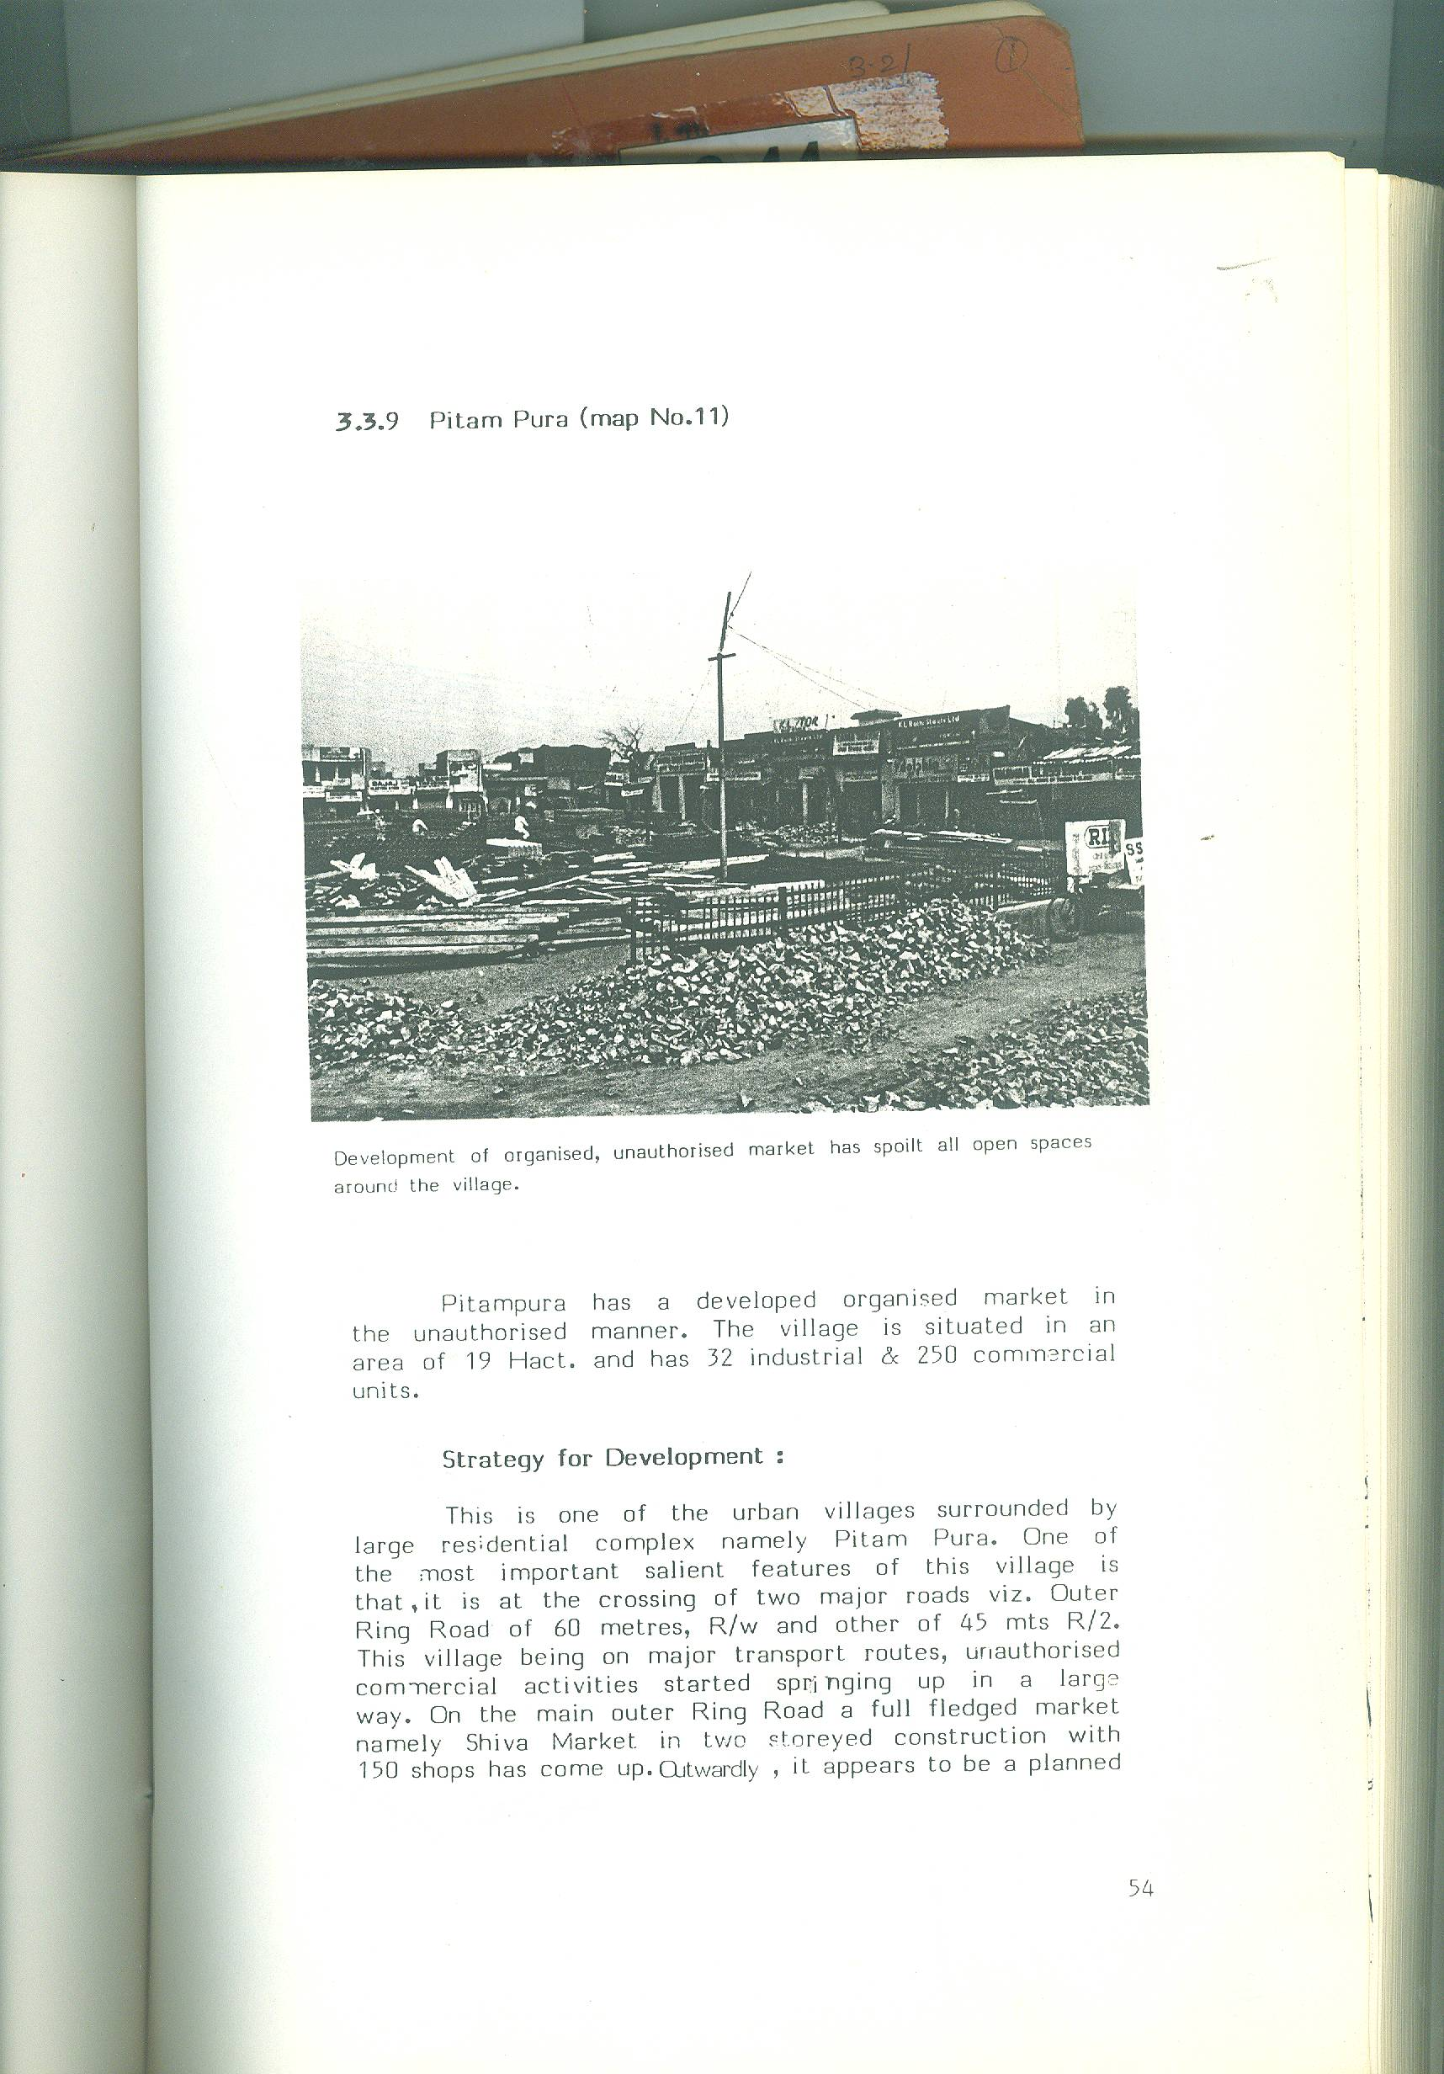

Development of organized, unauthorised market has spoilt all open spaces around the village.

Pitampura has a developed organized market in the unauthorised manner. The village is situated in an area of 19 Hact. And has 32 industrial & 250 commercial units.

Strategy for Development :

This is one of the urban village surrounded by large residential complex namely Pitam Pura. One of the most important salient features of this village is that, it is at the crossing of two major roads viz. outer Ring Road of 60 metres, R/w and other of 45 mts R/2. This village being on major transport routes, unauthorised commercial activities started springing up in a large way . On the main outer Ring Road a full-fledged market namely Shiva Market in two storeyed construction with 150 shops has come up. Outwardly, it appears to be a planned market but so far no physical or infrastructure Plan has been submitted to the concerned local authorities, The market is unauthorised.

Map : PITAM PURA AND EXTENTION :

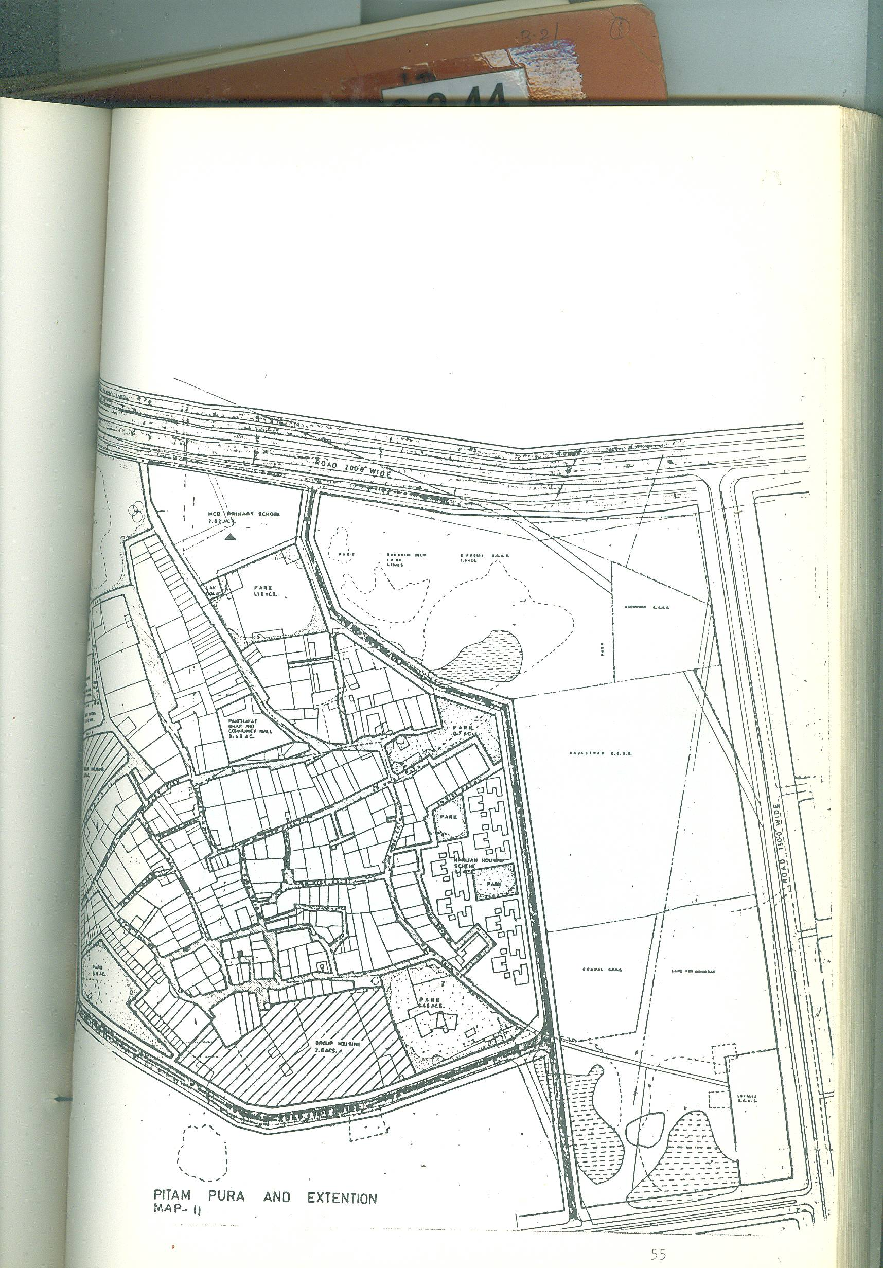

To restrict and control such situation, it is recommended that, in all the cases, before taking up development of any residential colony, a large numbers of shops related to building materials and of eatables should be constructed well in advance.

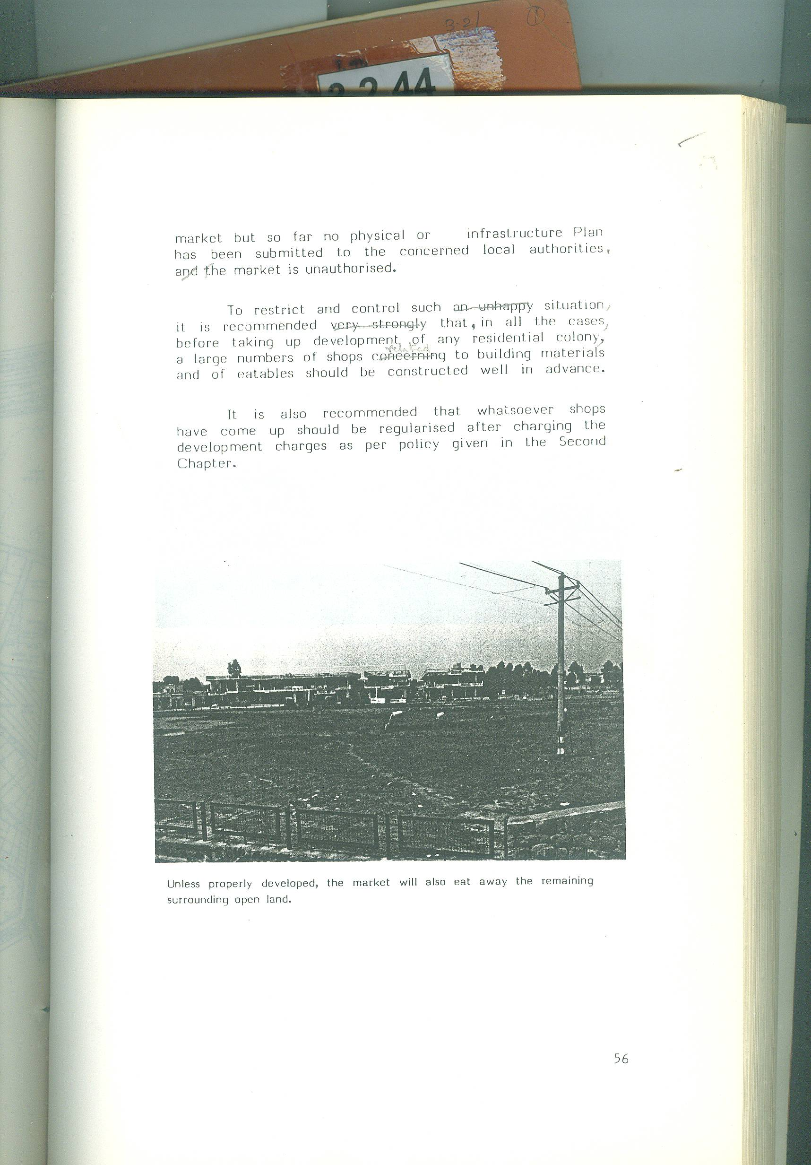
It is also recommended that whatsoever shops have come up should be regularized after charging the development charges as per policy given in the Second Chapter.

Unless properly developed, the market will also eat away the remaining surrounding open land.

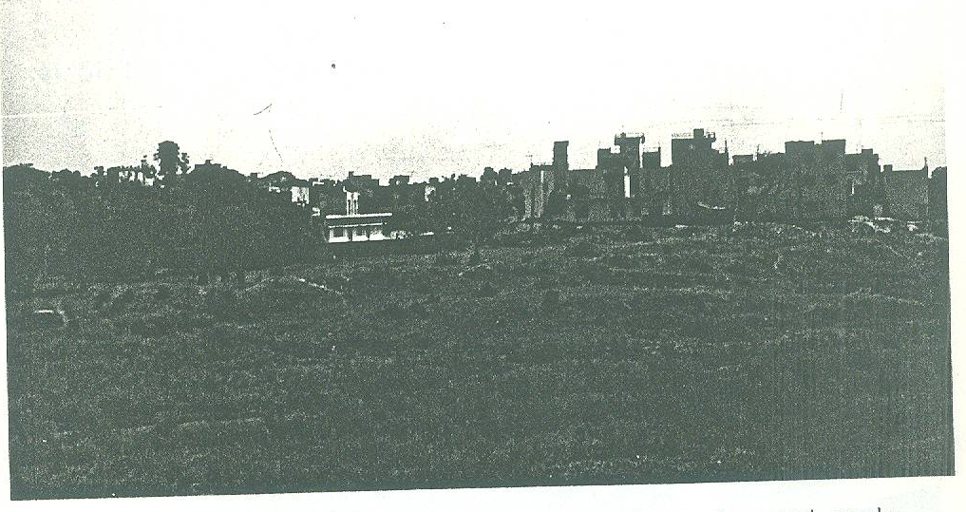
3.3.10 JIA SARI MAP

A village in South Delhi is already developed with modern and newly constructed buildings, and gives a look of planned colony.

Jai Sarai is in the midst of the IIT Delhi. About 60 % of the houses are occupied by staff members of the Institute. So far the village has no industry.

Gradually the village is being transformed as an annexe to the Indian Institute of Technology’s residential complex. There can be following three strategies.

Strategies for Development:

- Development the entire village as ‘Institutional Housing of Indian Institute of Technology, Delhi’, by persuading the villagers and rehabilitating them somewhere else with suitable alternate accommodation.

- Divide the village into two parts. In the first part, construct residential houses for the villagers, who at present live there, and in the second part develop the area for institutional housing for Indian institute of Technology.

- The village may be developed without any major structural change in it.

Out of the above three strategies, proposition at Sl. No. (b) is more suitable, but will take time.

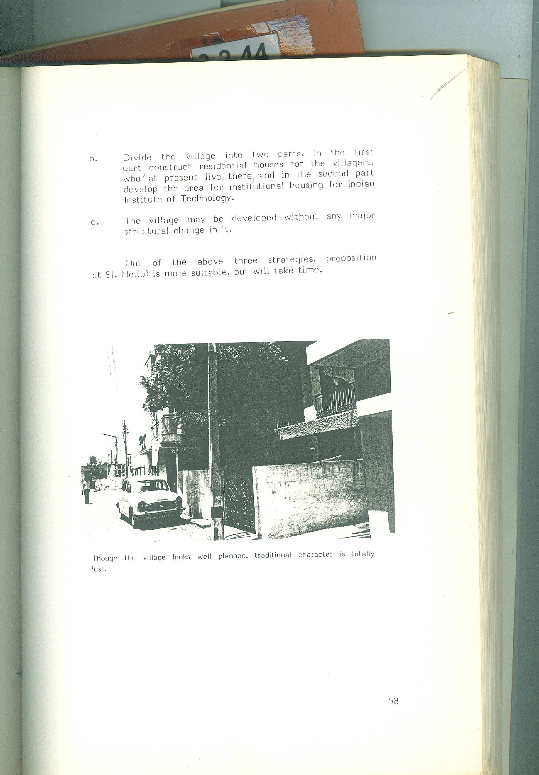
Though the village looks well planned, traditional character is totally lost.

  - Development Carried Out Upto 1980

Delhi Development Authority started planning and development of urban villages in 1965. During the first three years, development plans for most of the villages were prepared and approved by the Authority. Development works in the initial period was slow due to shortage of funds and lack of policies. During sixties, the policy was to develop the villages with the amount collected as development cess @ Rs.1/ sq.yd. from the beneficiaries to whom residential/industrial plots were allotted under the policy of “Large Scale Acquisition Development and Disposal of Land”. Under this system DDA could collect Rs.22 crore only by 1979, which was spent on the development of villages.

  - First Project Report for the Development of Urban Villages and Development Carried out during the 6th Five Year Plan.

In 1980, it was decided to prepare a Project Report, after conducting physical and socio economic surveys for the urban villages, so that these 111 urban villages could be developed as per the standards for community facilities, utilities and services. In 1980, Engineering department conducted various surveys of the villages giving the following information:-

30 villages had no water supply.

59 villages had no sewer lines.

96 villages did not have proper drainage system, toilets, urinals and dustbins.

96 villages did not have proper electrification, and

96 villages did not have proper roads, lanes, parks, open spaces and community halls.

Based on the deficiencies given above, a Project Report (appendix No.1) giving total project cost of Rs.23 crores was prepared and was approved by the Ministry of Urban Development through Lands & Building Department of Delhi Administration as per order dated 24.6.83 given in appendix No.2.

Fiscal Position of Development Works in Urban Villages upto 1985

Table-3 Release & Expenditure of Funds for urban villages upto 1985

Plan  Period | Year | Funds released in lacs of rupees |  |  | Expenditure in lacs of  rupees
Plan  Period | Year | D.D.A | M.C.D | TOTAL | D.D.A | M.C.D | TOTAL
Up to 31st March 1980 |  | *26.00 | - | 26.00 | Nil | - | Nil
6th Five Year Plan | 1980-81 | 180.00 | - | 180.00 | 268.70 | - | 268.70
6th Five Year Plan | 1981-82 | 166.00 | - | 166.00 | 422.64 | 25.55 | 448.19
6th Five Year Plan | 1982-83 | 490.00 | 160.00 | 650.00 | 530.33 | 63.46 | 593.79
6th Five Year Plan | 1983-84 | 575.00 | 50.00 | 625.00 | 349.43 | 152.92 | 502.35
6th Five Year Plan | 1984-85 | 412.50 | 100.00 | 512.50 | 385.55 | 103.91 | 489.46
Total 6th Five Year Plan | 1980-85 | 1823.50 | 310.00 | 2133.50 | 1956.65 | 345.84 | 2302.49
GRAND TOTAL | Upto  March’ 85 | 1849.50 | 310.00 | 2159.50 | 1956.65 | 345.84 | 2302.49
Source : Data supplied by Accounts branch of the DDA.

* Amount of Rs. 220 lacs was released by Delhi Administration in 79-80 from which 194 lacs was transferred to Dairy Colonies. In addition, substantial amount had been spent from village development cess till March 1980.

A total amount of Rs. 2302.49 lacs has been spent on the development of 94 urban villages upto March 1985. Department in EIUS of 10 urban villages have spent Rs.2 crores upto March 1985. Both the authorities i.e. DDA & MCD have spent Rs. 142.99 lakh excess of the outlay.

In the next chapter, the estimate of the amount required to complete the remaining development works in (96+10) 106 urban villages and for taking up the entire development of 53 villages is given.

- DEVELOPMENT WORKS IN 7TH AND 8TH FIVE YEAR PLANS

For the purpose of calculating the financial requirement for the development of urban villages, the following two aspects have been considered.

Amount required to complete the Development Works in 106 Urban Villages.

Amount required to Development 53 additional Urban villages which are likely to be urbanised by the end of the Century.

4.1 Amount Required to Complete the Development Works in 106 Urban Villages.
There are 111 urban villages, out of which two villages viz. Jherera and Mehram Nagar are located within the Cantonment Board; two villages viz. Usmanpur and Kharera have been deserted; and one village viz. Manglapuri has been rehabilitated near village Palam. Thus, for all practical purpose, there are only 106 urban villages which need to be developed.
In the preceding chapter, it was stated that 80% of the development works in these villages have been completed. Now only 20% of the works for which additional amount is required are to be completed.
Based on the plans prepared by DDA and the Municipal Corporation of Delhi, it has been calculated that area of 106 urban villages which is yet to be developed, is 1607.64 hect. x 20% = 321.928.
The Engineering Department of DDA supplied basic rates of development of various works viz., water supply, drainage, sewage etc. vide their letter of 26.2.85 placed at Appendix No. XIV. These rates are on the basis of December 1983 price level and are as under :-
Water supply at the rate of Rs. 0.58 lakh per hect.
Sewerage at the rate of Rs.0.97 lakh per hect.
Storm water drains at the rate of Rs. 0.51 lakh per hect.
Remodeling of chopal at the rate of Rs. 7,000/- per hect.

Development of parks at the rate of Rs. 61,000 per hect.
Lavatory blocks at the rate of Rs. 17,000 per hect.
Urinal blocks at the rate of Rs. 2,300 per hect.
Dust bins at the rate of Rs. 4,800 per hect.
Misc. expenditure at the rate of Rs. 23,000 per hect.
Total Rs. 4.57 lakh per hect.

The rate of development of Rs. 4.57 lakh per hect. has been further projected for another 5 years by taking 5% escalation every year and will be as under:-

Year In Rs. Lakh per hect.
December 1983 4.57
December 1984 4.80
December 1985 5.04
December 1986 5.29
December 1987 5.55
December 1988 5.83

For calculation of rate of development of 20% works of 106 villages, average of the last three years i.e. from December 1986 to December 1988 has been taken. This rate comes to Rs. 5.56 per hect.
Cost of development of works in 321.92 hect. will be 321.928 x 5.56 = Rs. 1790 lakh or say Rs. 18 crore.

An additional amount of Rs. 1790 lakh is required to complete development works of 106 urban villages. The requirement of additional funds then calculated in the first project report, is due to the following reasons:-
Escalation in price level.
Better specifications.
Village extensions have also been added.
10 villages, which were in slum areas, have also been added.
It is also made clear that part of the expenditure can be met from the resources from village extensions based on the formula of unauthorized regularized colonies (details given in chapter no. 2).
Total financial position will be as under :-
- Expenditure incurred upto March 1980 220.00 lakh.

- Expenditure incurred in the 6th five year plan
(against sanction of Rs. 2067.33 lakh) 2308.44 lakhs

- Additional amount required to complete
Development in 106 villages. 1790.00 lakhs

Total Rs. 4318.44 lakhs

With the investment of Rs. 4318.44 lakh, 106 urban villages having a total area of 1607.64 hect. will be developed at an average cost of development of Rs. 268.6 per sq. mtr.
  - Amount Required to Develop 53 Urban Villages which are likely to be Urbanised by the end of the Century.
A list of 53 villages, which are likely to be urbanised by the end of the century, has been prepared and is given in Appendix No. XVII. Total area of these villages is 433.39 hect. with approximate population of about 1 lakh.
Total cost of development of these 53 villages will be Rs. 2665.75 lakh (details given in Appendix No. XVI) and is explained as under :

- Cost of development has been calculated by taking an average rate of development of 6 years as given under:-

Year Amount in lakhs per Hect

December 1986 Rs. 5.29

December 1987 Rs. 5.55

December 1988 Rs. 5.83
December 1989 Rs. 6.12
December 1989 Rs. 6.12
December 1990 Rs. 6.43

December 1991 Rs. 6.75

December 1992 Rs. 7.08

Average of 6 years Rs. 6.15

Total cost of the project of development of (106+53) 159 urban villages in 7th and 8th Five Year Plan will be Rs. 1790 + Rs. 2665.75 = Rs. 4455.75 lakh. It is also proposed to divide the entire amount into two Five Year Plans with a break- up of Rs. 30 crore for 7th Five Year Plan and Rs. 14.75 crore for 8th Five Year Plan. Distribution of funds between DDA and MCD will be according to the number of villages and their sizes.

APPENDICES

APPENDIX – I

Project Report for Development of Urban Villages in Delhi – (1980-85).

Objectives:
A large number of village abadi and their revenue estates were covered in the 1981 urbanisable limit of Master Plan of Delhi. While preplanned colonies were developed in the surroundings, these villages remained neglected with meager amenities. It was, therefore, considered necessary to provide at least basic amenities to these villagers.

Background of the Case:
There are 357 villages in the Union territory of Delhi. Out of these 111 villages are within the urbanisable limits of 1981 as per Master Plan for Delhi. In general, villages in Delhi are governed either by the Delhi Land Reforms Act or by the provisions of the Punjab Land Revenue Act, as extended to Delhi, unless the village is declared as urban village by Delhi Administration under the 507-A of the Municipal Corporation of Delhi Act.

Status of Land :
Most of the villages are on private land except seven villages viz. Todapur, Dasghara, Sarai Kale Khan, Nangli Razapur, Arakpur Bagh Mochi, Mehram Nagar and Jharera which are no government land. Village Manglapuri, which was on Govt. land, has already been shifted near village Palam as this comes in the expansion of Palam Airport. Mehram Nagar and Jharera come in Cantt. Area.

Priorities for Development :
Although provision of all facilities in these 106 urban villages may not be possible in the next Financial Year. However, it may be possible to provide the same in the 6th Five Year Plan. The facilities, to be provided are as under:-

- Water supply in 37 villages;

- Sewerage Scheme in 67 villages,

- Environmental sanitation like surface drainage and public lavatories.

- Electrification ,

- Strengthening of approach roads and lanes/by lanes.

- Community Halls.

- Parks and open spaces:

Water Supply:- Water Supply is still to be provided in 37 villages. This will cost Rs. 1.1 crore, as per estimates of 1978, which may increase to Rs. 1.5 cores, as per prevailing cost of development.
Sewerage Scheme :- There are 67 villages which are to be provided with sewerage system. The sewerage facility will have to be provided before development works of roads/paths are taken up. The cost of provision of this sewerage system is approx. 6.1 crore as per 1978 estimates which may rise 7.5 crores as per prevailing estimates.
Environmental Sanitation : the cost of providing two sets of lavatory blocks with the provision of 24 w.c. seats and bathing facilities, is about Rs. 1.06 crores as per estimate of 1978 which may increase to 1.5 crore as per prevailing rate.
Electrification : Most of the villages have already been provided with this facility. However, an augmentation of the same would be necessary to bring them at par with the adjoining developed colonies. The cost of augmentation of this facility as per 1978 estimates, is approximately Rs. 76 lakhs which may now become 1 crore as per prevailing cost .

Strengthening of Approach Roads and Lanes/ Bye – lanes:-
Each villages should be connected with the mettled approach roads. The existing lanes/bye-lanes in these villages should be brick paved. As per 1978 estimate, the cost of augmenting circulation network is about Rs. 4.75 crores which may now becomes 6.5 crores as per prevailing rates.
Community Halls : The estimated cost of construction of community halls in these villages, as per the become Rs. 4 crores as per prevailing rates.
Parks & Open Spaces:- Since the surrounding agricultural/open land has already been acquired, from health point of view, it is essential to provide some parks and open spaces in and around these villages. The estimated cost for providing this facility has been worked out to Rs. 0.61 crores as per 1978 estimate, which may now become Rs. 1 crore as per prevailing cost of development.
As per the above, the total cost of development, as per prevailing rate, works out to Rs. 23 crores which can be met partly from the village development Cess, and partly from the revolving fund.
Families Benefitted :
As per 1971 census, there are about 3,17,886 persons living in these 111 urban villages, making the No. of total families to be approximately 63,577. The population may get increased to 4,00,000 persons, as per 1981 census, thereby increasing the number of families to 80,000. By the above said project, these families will be benefitted. Out of them, about 20,000 families would be of Scheduled Caste and landless labourers. Therefore, these families will also be benefitted with other families of the Urban Villages.
Employment Generation:
If this project is approved by the Planning Commission for the allocation of Rs. 23 crores, a large number of employment will be generated. For development works the ratio of materials and labour is approximately 50%:50%. Thus, about 11.5 crores would be spent on payment to labourers. Taking Rs. 10/- as payment per day to a labourer, about 1,15,000,00 man-days of direct employment would be generated. This direct employment generation would be, in addition to, indirect employment generation which would be required for providing/ procurement of materials. Thus, it would be seen that a lot of employment would be generated by this scheme.

Position of Funds :
As mentioned above, the cost of the total scheme will be to the tune of Rs. 23 crores. Out of this sum of Rs. 23 crores, Rs. 2.5 crores is likely to become available from the village development cess. The remaining Rs. 20.5 crores shall have to be provided by the Government of India in the form of grant.
The planning Commission has recommended allocation of Rs. 10 Crores for the 6th Five Year Plan, out of which Rs. 1.8 crores have been made available during 1980-81 as loan. Further, from the loans in 1976-80, a sum of Rs. 0.26 crore is available. Thus, the funds which would be ploughed are as follows:-
- Plan funds from Government of India/
Delhi Administration for 1980-85 .
Rs. 10.00 crores.
- Collection from village dev cess. Rs. 2.50 crores

- Additional Plan funds required
From Government of India/Delhi Admn.,as grant. Rs. 10.50 crores.

Thus, the total grant required from Govt. of India/- Delhi Administration, work out to 10+10.5 = Rs. 20.5 crores. Therefore, Planning Commission may be approached, through Delhi Administration for allocation of Rs. 20.5 crores as Plan Funds in the form of grant.

APPENDIX- II
No. N- 11014/1/82 –DDVI
Government of India
Ministry of Works & Housing
(Nirman Aur Awas Mantralaya)
New Delhi, dated the 24th June’ 83.
To
The Lt. Governor,
Raj Niwas,
Delhi.

Subject: Scheme for Development of Urban Villages of Delhi.

Sir,
I am director to convey the administrative approval of the Government of India to the Scheme of Providing basic amenities to 96 urban villages of Delhi prepared by the Delhi Development Authority at an estimated cost of Rs. 2067.33 lakhs (as per details given in the Annexure). The Scheme is to be implemented in a phased manner within the approved outlay of the Sixth Five Year Plan and spilling over to the next Plan. After deduction a sum of Rs. 250 lakhs to be raised by the DDA as Village Development Cess under the Scheme Rs. 2067.33 lakhs (as per details given in the Annexure). The Scheme is to be implemented in a phased manner within the approved outlay of the Sixth Five Year Plan and spilling over to the next Plan. After deduction a sum of Rs. 250 lakhs to be raised by the DDA as Village Development Cess under the Scheme ‘Large Scale Acquisition, Development and Disposal of Land in Delhi’, the balance amount, viz Rs. 1833 lakhs, would be provided by the Delhi Administration to implementing agencies (DDA and MCD) as grants. This approval is subject to the following conditions:-
- Amount will be spent by the implementing agencies on the provisions of basic amenities as per the annexure.

- The amounts released by Delhi Admn. during the years 1980-81, 1981-82 and 1982-83 in anticipation of the approval of the scheme will be adjusted against the total cost of the Scheme.

- The beneficiaries will have to pay for individual water supply, electricity and sewerage connections.

- The implementing authorities (DDA and MCD) will submit detailed estimates for individual components of this Scheme to the Delhi Administration who will release the funds to the implementing agencies after due technical scrutiny and sanction of the competent authority.

- The financial and physical progress of the implementation of the Scheme will be monitored by the Delhi Administration by obtaining quarterly progress reports from the MCD/DDA, copies of which will be sent by the Administration to the Ministry of Works & Housing.
2. The expenditure is debitable to the Major Head “284-B(8) Urban Development, sub – Heads “B-9 (1) (1) (1) Grant –in –Aid to DDA” AND “B-8(1) (1) (2) Grant –in –Aid to MCD’ of Delhi Administration.

Your faithfully,
Sd/-
(H.R. GOEL)
DY. SECRETARY TO THE GOVT. OF INDIA
TEL: 382636
The item-wise breakup of the Scheme is as under :
SI.No. Item of work Number of Villages Total estimated Cost (Rs. . in lakhs)
i. Water Supply 30 121.00
ii. Sewerage 59 616.00
iii. Drains, Lavatories,
Urinals, Dustbins, etc. 96 137.00
iv. Electrification 96 100.00
v. Roads and Lanes 96 543.00
vi. Parks & Open Spaces 96 144.00
vii. Community Halls etc. 96 347.20
Total 2008.20

Additional expenditure incurred during
Incurred during 1980-81 in the ten villages
Declared as Slums
59.13
2067.33

Amount which will become available
with the DDA from the villages development
cess under the scheme of
“Large Scale/ Acquisition, Development &
Disposal of Land of Delhi.
250.00
1817.33

Net amount to be given by the Central
Govt. as grants during the Sixth &
Seventh Five Year Plan periods. 1817.33

No. F2(6)83/UVC/D-40 to 44 Dated: 7.7.83

APPENDIX III

List of Urban Villages located in
‘Development Area’ of DDA.
- Asalatpur
- Azadpur
- Begumpur
- Badli
- Ber Sarai
- Basti Shalimar
- Basant Gaon
- Bharola
- Basai Darapur
- Bodella
- Dhirpur
- Garhi Jharia Maria
- Garhi Peeran
- Ghonda Patti
- Ghonda Neemka
- Zazipur
- Hauz Khas
- Hari Nagar Ashram
- Humayunpur
- Haiderpur
- Hasanpur
- Joga Bai
- Jawala Heri
- Jhilmil Tahirpur
- Kaitwara Nazul
- Kilokri
- Kotla Mubarakpur
- Khampur
- Khichripur
- Khirki
- Kalu Sarai
- Kotla
- Katwaria Sarai
- Kishan Garh
- Khayala
- Kakkar Duman
- Kachipur
- Khizrabad
- Khureji Khas
- Lado Sarai
- Masjid Moth
- Masih Garh
- Munirka
- Mehrauli
- Masoodpur
- Mangolpur Kalan
- Mangolpur Khurd
- Mauz Pur
- Madipur
- Mandavali Fazalpur
- Naharpur
- Naraina
- Nangal Raya
- Nangli Jalib
- Nangloi Sayed
- Okhla
- Peepal Thala
- Pitampura
- Possangipur
- Rampura
- Sarai Julliana
- Shahpur Jat
- Sheikh Sarai
- Shadipur
- Shakurpur
- Sahipur
- Shakarpur Khas
- Tamoor Nagar
- Tekhand
- Tatarpur
- Tughalakabad
- Wazirpur
- Madangir

2. Urban Villages proposed to be included in ‘Development Area’ of DDA.

- Arakpur Bagh Mochi
- Chirag Delhi
- Dasghera
- Hauz Rani
- Keshopur
- Khanpur
- Madanpu Khadar
- Mohammedpur
- Tihar
- Todapur
- Zamrudpur

3. Village shifted to ‘Agricultural’ Green Belt/ Rural Area.

- Manglapuri

APPENDIX - IV

No. Subject : Policy regarding grant of industrial .
78 licences to household industries
A 21.8.79 F1(139)/76-mp.

Precis

As per Zoning Regulations of Residential Use Zone in the Delhi Master Plan, “ Home Occupation” (Household Industries) when situated in the same dwelling as the one occupied by the professional man or women is permissible if allowed by competent authority after special appeal. (Page 48 of the Delhi Master Plan). This point was confirmed by the Ministry of Works & Housing vide their letter No. K - 13011/41/77/UDI(A) dated 6th October, 1978 Appendix ‘ B’ Page 104.
- Out of about 36,000 industrial units in Delhi nearly one- third are of the household category. It is, therefore, difficult and even time consuming if each case of house- hold industries considered under special appeal, especially as the main objective of issuing licences for such units is to provide livelihood to the poor. In fact, in the last 15 years only a few cases of this type have been considered and people are either taking licences directly from the M.C.D. or running the units unauthorisedly.

- Hitherto, the M.C.D. is granting industrial licences to household industrial units in residential area with modifications from time to time, with regard to maximum Horse Power, maximum number of persons engaged, type of industry to be permitted etc.

- In August, 1975 the M.C.D. listed 26 trades in the house- hold industries category with a restriction of ½ K.W. Power load and 4 workers of the same family (details at App. ‘S’ in Page 105). In June, 1976 the permissible list was increased to 37 and the power load raised to 1 kw. In November, 1977, 5 more trades were added to the permissible list and at present, 56 trades are listed (Details given in Appendix ‘T’ Page 106 &107).

- In a recent meeting held in the room of the Executive Councilor, a decision was taken to issue Licences to household industries on the following conditions:

- In the approved residential area in not more then 300 sq.ft. of floor space of the dwelling along with residence of the owner of the family.

- Number of works should not be more than four.

- Power load 1 Kv. Domestic power single phase load and 2 kv power with three phase load.

- The Units would not be considered for alternate allotment and licences would be given to them on a regular basis.

- As the number of cases to be decided are too many and industrial licence is to be issued by the MCD the delegated power to consider such cases under special appeal to regulate household industries with the above conditions.

- The matter is placed before the Authority for consideration.

RESOLUTION
Resolved that the proposal contained in para 6 of the précis for delegating the powers to the Commr., Municipal Corporation of Delhi to consider cases under ‘ Special Appeal’ to regulate household industries approved by the Executive Council, subject to the conditions mentioned therein be approved.
Resolved further that similar powers as resolved to be delegated above to the Commissioner, Municipal Corporation of Delhi, be also delegated to the President, N.D.M.C. in respect of the areas within the jurisdiction of the New Delhi Municipal Committee for traders, in the approval list suitable for New Delhi.

APPENDIX ‘T’ TO ITEM NO. 78

Issued vide letter No. Regn. 7(7)/77/D1/10458-59 dated 23.11.77 from the Directorate of Industries, Kashmere Gate, Delhi -110006.
List of Household industries approved at the Meeting of the Committee Constituted for Defining Household Industries held on 8th November, 1977 in the Office of Commissioner, Municipal Corporation of Delhi.
- Agarbati & Other Products
- Calico & Textile Printing
- Cane & Bamboo Products
- Clay Modelling
- Coir & other Fibre Products
- Zari Zardozi
- Hosiery
- Jewellery work
- Stone engraving
- Manufacture of

- Blanko cakes
- Brushes
- Crayons
- Ica Cream & Confectionery
- Jam, Jallies & Fruit Preserves
- Narrow Fabrics and lace work material.
- Musical Instruments including repairs
- Ornamental leather goods such as purses, hand bages.
- Small Electronics Components.

- Paper Stationery items including book binding.
- Framing of Pictures and looking glasses.
- Pith work, manufacturing of pith hate, garland and flowers.
- Tailoring
- Thread Balls and Cotton filling
- Umbrella assembly
- Wood carving & artistic wood wares
- Vermicelli and macaroni
- Assembly and repairing of Electronic items.
- Ivory carving
- Card board boxes
- Plastic and P.V.C. Products with one mounding machine of one K.W.
- Toys and Dolls
- Paper Machine
- Copper & Brass Art ware
- Lac Products
- Candles
- Cottage, Rope & Twine Marking
- Batik Work
- Carpentry
- Sports Goods
- Leather Footwear
- Assembly & repair of Electrical Cadgets.
- Dari & Carpet Weaving
- Wool Balling & Lachee making
- Khadi & Handloom
- Leather & Rexene made ups
- Perfumery and cosmetics
- Assembly/repair of sewing machines.
- Surgical Bandage Rolling, cutting
- Repair of watches and clocks
- Fountain pens and Ball Pens
DELHI MASTER PLAN -2001 ALSO SUGGESTS HOUSEHOLD INDUSTRIES UPTO S.NO.69
- Black smithy
- Village Poltery (without using Bhatti)
- Assembly and repair of electrical gadgets
- Block marking and Photo enlarging
- Biscuit, Pappy, Cakes and cookies making
- Buttan making. Fixing of button and hooks.
- Contact lense
- Canvas Bags and haldalls making
- Cotton/silk printing (by hand)
- Detergent (without Bhatti)
- Embroidery
- Gold and Silver Thread Kalabattatu
- Hats, Caps, turbans (including Embroidery)
- Ink marking for fountain pen
- Name Plate making
- Photo setting
- Photo state and cyclostyling
- Preparation of Vadi Papad etc.
- Processing of condineuts, spices, groundnuts and Dal etc.
- Pan Masala
- Rakhee making
- Stove Pin, Safety Pins and Aluminium Buttons (Hand Press)
- Silver Foil marking
- Saree Fall making
- Valvet, embroider Shies/shawls.
- Wooden/Card Board Jwellery Boxes (subjects to NOC from Fire Dept)
- Wool Knitting (with machine)
- Aluminium furniture
- Air conditioner’s parts
- Aluminium doors/ windows/fittings
- Assemble & repair of cycles
- Atta Chakki and spices & dal grinding
- Auto parts
- Belts and buckles
- Bulbs (battery)
- Bread and bakeries
- Cloth dying
- Cotton ginning
- Cotton & silk screen printing
- Cycle chain
- Cycle locks
- Dal Mills
- Diamond cutting & polishing work
- Electric fittings (switch, plug, pin etc.)
- Electroplating mina plating, engraving
- Elastic products
- Electric motor and parts
- Electric press assembling
- Engineering works
- Foundry (small job works)
- Ice – Cream
- Ice boxes and body of the coolers
- Iron grills and door making
- Jute products
- Key rings
- Knife marking
- Marbles stone items
- Metal looter cutting
- Motor winding works
- Oil Industry
- Power looms
- Photographs, printing (including sing – board painting )
- Printing press (provided not creating problem)
- Repair of small domestic appliances and gadgets (like room
heater, room coolers, hot plates etc.)
- Rubber stamps
- Sanitary goods
- Screws and nails
- Screen printing
- Scissors making
- Shoe – laces
- Soap making
- Spectacles and optical frames
- Steel furniture
- Steel lockers
- Steel springs
- Steel almirahs
- Stamp pads
- Surgical instruments and equipments
- Table lamps & shades
- Timber cutting
- Tin box marking
- Transformer covers
- T.V., radio, cassette recorders, etc.
- T.V./ radio/ transistor cabinets
- Typewriter parts manufacturing and assembling.
- Water meters repairing
- Water tanks welding works
- Wire knitting
- Wooden furniture works.

THE 132 INSUSTRIES LISTED ABOVE, AS GIVEN BY DELHI MASTER PLAN – 2001, SHALL BE PERMITTED AS LIGHT & SERVICE INSUSTRIES AS PER SPECIFICATIONS IN REPORT.

APPENDIX V

Copy of Resolution No. 1458 of the Standing Committee Meeting of the Corporation held on 1.4.65.

Item No.16 :- Interpretation of Building Bye- law No. 25 (2)(1-A)
(e) Set- backs.
Commissioner’s letter No. 1863/C&C dated 14.1.65.

(CIRCULATED HEREWITH)

Item No.16 :- Interpretation of Building Bye- law No. 25 (2)(1-A)
(e) Set- backs.
Commissioner’s letter No. 1863/C&C dated 14.1.65.

Since the amended bye – law have come into force, there is some dispute regarding interpretation of the proviso given at the end of Bye- laws No. 25 (3)(1-A)(e) – iii dealing with “Side set- backs. There was discussion in the Standing Committee on this issue and a Special Committee was appointed to go into the interpretation of this proviso and to put up its recommendation before the Standing Committee. My observations on this interpretation are also given below for consideration :-

(a). The proviso at the end of Bye- law 25(2)(1-A)(e) under “ Set- backs” is applicable to the entire clause of set – back.

The “Set – backs” is indicated in the amended bye – laws shall not apply to plots in the following areas:

- Erstwhile Delhi Municipal Committee Area i.e. former administrative Ward Nos. 1 to XX to Delhi Municipal Committee.

- Erstwhile Shahdara Municipal Committee.

- Colonies developed by the Ministry of Rehabilitation Prior to 1.9.1962.

- Colonies developed by the any other Government of Municipal Authority prior to 2.9.1962.

- Colonies sanctioned by any competent authority including Standing Committee of the Corporation Delhi Development Authority (former D.I.T. or D.D.P.A.) before 1st September 1962 and .

- Built up Abadis of villages falling within 1981 urbanisable limits of the Master Plan .
In the above mentioned area set-back lines as already approved and forced by a Competent Authority prior to 1.9.62 or existing set-back lines, as the case may be, shall continue to be followed .
(b). The proviso under rear set-back shall apply in all area including those stated in para (a) above. It means that the rear set-back with depths less than 60 ft. This is, however, subject to restrictions relating to light and air planes as provided under Bye-law 31 except in case of corner plots as far air plans is concerned.
(c) The relaxation granted earlier by the commissioner like permission to construct essential amenities in half of the rear set-back for plots upto 200 sq. yds. in the colonies developed by the Ministry of Rehabilitation and also construction in front half set-back in Karol Bagh and Patel Nagar (East, West and South Patel Nagar) and other areas, where such provision had been made in their layouts etc. shall continue to be allowed. Provided that in colonies developed by the Ministry of Rehabilitation in case of landings on plots on area of 100 sq. yed. or less, the front set-back shall be 10 Hect.
(d). In areas like Karol Bagh, Shakti Nagar, Kamla Nagar, Roop Nagar, Jawahar Nagar etc. where layouts were approved by the D.I.T. or any other competent authority and where either no setback is provided in the layouts or the same was not being insisted upon the practice as in force prior to 1.9.62 be followed.
(e) The then Commissioner had relaxed set-backs in the walled city some time back and set-backs used to be enforced as per “City Area Policy”. The City Area Policy” as approved by the Commissioner, is as stated below :-
(i) The building shall be set-back at front from the street on which a particular plot abuts by such a distance so as to make the ultimate width of trafficable road to 30 ft. and non-trafficable road to 15 ft.
(ii) In case of back-to-back plots set-backs of minimum 5 ft. and average 10 ft. shall be insisted upon, subject to maintaining rear airplane as per Bye-law No. 31. The concession granted in para (5) above will also be applicable in case of back-to-back construction. The city area policy is applicable to Walled City, Shahdara City, Paharganj, Subzimandi, Bhogal and Urban villages.
(iii) Where ground floor of a building exists with certain set-backs under proper sanction, construction on first and subsequent floors shall be allowed as per same set – back except where the building is effected by right-of-way of a road as stipulated in the Master Plan. In such cases right of way must be protected.

Item No. 16:- Resolution No. 1458 dated 1.4.65 be substituted as under :-
Resolution
No. 1455 Resolved that the recommendations of the Sub – committee and the observations of the Commissioner as contained in his letter No.1863/C&C dated 14.1.65 on the building bye-laws No. 25(3)(1-A) (e) Set – backs be approved.

APPENDIX V – A

City Area Policy

Municipal Corporation of Delhi Building Department

The City Area Policy is as follows:-

- Upto 50 sq. yds. Plots no building activity is allowed .

- Beyond 50 square yards.

- For road width below 15’ front set-back to be left so as make the street 15’ wide.
- For trafficable road i.e road width between 15’ and 30’ the front set-back shall be such so as to make road width as 30’ .
- Rear set-back shall be 5’ minimum and 10’ average provided the rear air plan is maintained by builder in his own plot.

- Where the building on ground floor is existing with certain set – back under proper sanction no set-back will be required on the floors above the ground floor provided the front and rear air planes are maintained and coverage are according to the building bye – laws.

- In back to back plots where the building is existing on four sides with open area in the centre, rear air plan is not insisted upon for construction of first floor provided the area of plot is not more than 200 sq. yds.

Jhuggi policy for permitting temporary construction of one year.

In such areas which comprise of hutments and jhuggies the existing policy is that we may permit reconstruction to start with for a period of only one year. Following are the points dealing with this policy.

- In such area which constitute type basties or areas comprising of jhuggies e.g. Than Singh Nagar, Old Tizabmil Bapa Nagar, etc. We may accept requests for reconstruction which may be permitted to start with for a period of only one year. Such permission may be renewed after the expiry of the year on request. The Builder however, will have to given an undertaking that such structures will be removed by him in a notice within a period of three months at his own cost and without any compensation.

- Such request of reconstruction can be entertained only for very small plots where normally Jhuggies or huts are constructed by poor people. The area of such small plots should be upto and less than 50 square yards.

- Such request shall be accompanied with a token fee of Rs. 10/- along with dimensioned sketches in triplicate which need not be prepared by a licenced architect but must be signed by the owner. Proof of ownership should also be submitted. The sketches should show normally the structure as it exists today or had originally existed and should also show the proposal of reconstruction in red colour which should not exceed or be different from the accommodation previously existing.

- Permission for reconstruction will be on the same foundation and where no foundation exists the alignment of existing jhuggies etc. will be followed. The sizes of room etc. shall not be widened. We may, however permit raising of roof subject to maximum height prescribed in paragraph below :-
The reconstruction shall not have better specifications than the following:-
- Mud mortar, brick masonary in wall with only cement pointing on both sides.
(ab) Temporary roof or stone slabs or tiles over wooden battens.
(ac) Height of the structures should not be more than 12 feet including plinth of 1.1/2 feet.
(ad) Only reconstruction of single storey will be permitted.
Such permissions shall be given only to structures which are in a ruinous condition and have already wholly or partially collapsed.
The above concession will apply when prior permission is taken.

Commissioner has extended the application of the Jhuggi policy for permitting temporary construction for one year which is in vogue in certain limited localities at present, extended to all urban villages subject to the condition that the area of the existing building does not exceed 50 sq. yds. and that all other conditions enumerated in the jhuggi policy approved by the Commissioner, are strictly observed.
Repairs Policy.
- Plastering and patch repairs;

- Re- roofing or renewal of roof including roof of intermediate floor at the same height or by raising the height of walls of room provided final height is not less than that provided under the building bye – laws ;

- Flooring and re-flooring;

- Opening and renewing windows, ventilators and doors not opening towards others’ property and without door leaves opening on public land on the ground floor.

- Making alteration to a building with re-erection to the extent of 50 per cent of any external wall abutting on a road or a street and subject to the maximum of two internal walls of a room being erected or making alteration to a framed building without involving the removal of re-erection of more than one – half of the parts in any such walls thereof as aforesaid;

- Replacing fallen bricks, stones, pillars, beams etc.

- Construction or reconstruction of sunshades not more than 2 ft. 6 inches in width and within one’s own land and not overhanging public street.

- Construction or reconstruction of parapet walls not exceeding 3 ft. in height and purdah walls upto a maximum height of 5 ft. 6 inches on any floor or floors.

- Construction or reconstruction of lofts in shops in built up commercial areas upto a coverage of 50 per cent, provided its height from floor level is not less than 7ft. and height between the ceiling and the loft is not more than 5 ft. 6 inches and that the loft is used for storage purposes only;
- Construction or reconstruction of saiban in front of shop provided it does not project beyond the boundary line of the plot on which the shop stands;

- Reconstruction of portions of buildings damaged by storm, rains, fire, earthquake or any other natural calamity to the same extent and specification as existed prior to the damage, provided the use conforms to the provisions of the Master Plan.

- Reconstruction of staircase of the same size and in the same position as previously; and

- Construction of uncovered staircase (with open risers) of not more than 2 ft. 6 inches in width in plots upto 100 sq. yds. in area, where no staircase already exists.

NOTE: No sanction shall be necessary for carrying out repairs as defined in this clause.

Sd/.
Assistant Engineer (B) Genl.

APPENDIX V B

No. Subject :- Building activities in urban villages.
212 (F. 14(15)63.WD)
18.6.68

- The Town Planner, M.C.D. has stated in his letter No. TP(R)1066/6412 dated 30.10.1967 that the decision taken by the DDA regarding the urban villages was examined at the Layout Committee meeting held on 30.11.67 specially with a view to take decision whether building plans for the plots included in the development plans could be considered or not. At present the MCD is sanctioning building plans of the plot falling in the built up abadi areas of these villages. The Committee felt that till such time the villages whose redevelopment plans have been prepared and approved by the DDA are declared as ‘development areas’ the land is de-notified and proper development work is completed no building plans could be considered for approval in the extended areas outside the built up ababi of the villages.

- In accordance with the Authority’s decision taken in its resolution No. 604 dated 16.8.1967 the necessary action has already been taken for declaring the villages, whose plans have been approved as ‘development area’ of the DDA. But the MCD is not going to sanction the building plans till proper development work is completed and as such it will create a difficulty for the villagers. The proper development of the villages is likely to take time since the estimates have yet to be prepared and approved and there after the work will be taken up .

- It will not be out of place to mention here that in the re- development plans of urban villages some areas already notified for acquisition under section 4 of the Land Acquisition Act have been included. Since these areas are contiguous to these villages and are required for the proper development of villages. The Secretary (Land and Building) however, considered that no building activities can be allowed in such areas (notified for acquisition and included in the plans) till the sane have actually been acquired; developed and leased out.

- The Standing Committee considered the matter at its meeting held on 21,22,23 May, 1968 (Item No. 45) and recommended that building activity be permitted in urban villages; the question whether development charges may be levied or not was postponed for further consideration.

- The matter is now placed before the Authority for according their approval to the recommendation of the Standing Committee as in para 4 above.

Resolution

Resolved that the recommendation of the Standing Committee as in paragraph 4 above be approved.

APPENDIX VI

List of Plots measuring 500 Sq. Mtrs. And above
as on December ‘ 84

1. | Azad Pur | 1 plot
2. | Arakpur Bagh Mochi | 1 plot
3. | Basai Dara Pur | 2 plots
4. | Budhela | 8 plots
5. | Bharotta | 2 plots
6. | Badly | 73 plots
7. | Basant Gaon | 1 plots
8. | Chilla | 2 plots
9. | Dusgrah | 4 plots
10. | Dhir Pur | 3 plots
11. | Dallu Pura | 66 plots
12. | Gazi Pur | 40 plots
13. | Ghroda Neemka | 1 plot
14. | Ghonda | 3 plots
15. | Hauz Khas | 7 plots
16. | Hunayun Pur | 2 plots
17. | Hari Nagar Ashram | 4 plots
18. | Haider Pur | 30 plots
19. | Hassan Pur | 17 plots
20. | Hawala Heri | 4 plots
21. | Khayala | 7 plots
22. | Kesho Pur | 2 plots
23. | Khichri Pur | 15 plots
24. | Karkardooma | 36 plots
25. | Khera | 3 plots
26. | Kilokri | 2 plots
27. | Kalu Sari Begum Pur | 7 plots
28. | Khizra Bad | 5 plots
29. | Khan Pur | 5 plots
30. | Kishan Garh | 61 plots
31. | Lado Sarai | 20 plots
32. | Madipur | 3 plots
33. | Munirka | 7 plots
34. | Masood Pur | 4 plots
35. | Mehrauli | 20 plots
36. | Madan Pur Khadar | 25 plots
37. | Msajid Moth | 1 plots
38. | Mohammad Pur | 2 plots
39. | Mauz Pur | 3 plots
40. | Mandavali Fazalpur | 18 plots
41. | Mangol Pur Kalan | 25 plots
42. | Mangol Purkhurd | 15 plots
43. | Nangloi Sayed | 7 plots
44. | Nangloi Jalib | 5 plots
45. | Naraina | 7 plots
46. | Nangli Raja Pur and Kale Khan Sarai | 5 plots
47. | Nahar Pur | 32 plots
48. | Nangal Raya | 4 plots
49. | Pira Garhi | 6 plots
50. | Pritam Pura | 5 plots
51. | Peepal Thala | 1 plot
52. | Sahi Pur | 3 plots
53. | Shakur Pur | 3 plots
54. | Shadi Pur | 1 plots
55. | Toda Pur | 9 plots
56. | Tuglakabad | 38 plots
57. | Tekhand | 7 plots
 | TOTAL : | 687 PLOTS

APPENDIX VII

Concept of Lal dora as defined by Delhi
Administration : Delhi
(Revenue Department)

Memorandum

- During the past few months the question of issue of certificate of ‘Lal Dora’ vis-a-vis the “Extended Abadi” area of a village has been raised several times in various forms. Besides, there has been a persistent demand from certain quarters that ‘Lal Dora’ Certificate should be issued for the “Extended Abadi” area also.

- It is clarified that ‘Lal Dora’ is the Abadi Deh as determined by the settlement of 1908-09 and such abadi Deh is given one No. in the Revenue Record. It is not assessed to land Revenue and the same cannot be revised till another settlement takes place. There is no term like ‘Extended Lal Dora’, in any of the provision of the Revenue Laws. The concept of Extended Abadi is, however, found in the provisions of Consolidation of Holding Law which envisaged that the ‘Extended Abadi’ shall be used for common purposes and common need of the villages. The area within extended abadi commonly known as ‘Phirni’ cannot be used for Industrial purposes. Such area continues to be assessed to land revenue and subject to all restrictions as to transfers and use imposed in the Delhi Land Reform Act.

- In the year 1959, Delhi Municipal Corporation Delhi passed a Resolution permitting the setting up of Cottage Industry within ‘Lal Dora’ and allowing power connection upto 20 H.P. in relaxation of its bye-laws in the area falling within Lal Dora (Old abadi). However, the concession was misused in as-much-as these facilities were even provided in the area of the extended abadi. This resulted in haphazard and unplanned growth of industries in the rural centre causing pollution and destructions of the Rural environments. In the year 1981 clarifications were issued to all the agencies about the concept of ‘Lal Dora’ (Old Abadi) and ‘Extended Abadi’ i.e ‘Phirni’ there-upon the agencies concerned stopped giving electric and water connection, granting other facilities of licencing, Supply of Raw Material, Cement etc. for industrial use in the Extended abadi. As a consequence of this, the people living within the Extended abadi have been experiencing hardship as they are denied Water and Electricity even for domestic purpose within Extended abadi.

In order to mitigate the genuine hardship of the rural population within the extended Abadi and also to check haphazard and unplanned growth of industry within the rural area, the Delhi Administration, Delhi after careful examination of the whole question decided as under :-

- To avoid delay, such certificates shall be issued by the authorities specified below:-

- For electric/Water Pannchayat Pardhan/Area connection for domestic Municipal Councilor/ purposes Metropolitan Councilor

- For other purposes S.D.M./R.A. concerned.

- The SDM/RA on an application, would issue certificate of ‘Lal Dora’ or ‘extended – Abadi’ as the case may be, on the basis of entries in the revenue record.

- The application would specify the purpose for obtaining such certificates and the issuing authority would indicate the same in the certificate. Such application should be disposed off within 15 days from the date of its receipt.

- In so far as Lal Dora ‘Old Village Abadi’ is concerned all concession covered by Resolution of 1959 passed by the Delhi Municipal Corporation would continue to be given as hitherto on the basis of the certificate issued by the revenue authorities i.e. SDM/RA.

- However, in the case of extended abadi ‘Phirni’ Electric and Water connection for domestic purposes and power upto 3 H.P would be given for setting up of traditional/village cottage industry shall be given by the above authorities but such connection should be confined to the original residents of the village and their descendants only. In other words the non-residents of the village shall not be eligible for the grant of these connections.

- Power connections not exceeding 20 H.P. may be given to a bonfide resident of the same village subject to the prior approval of the Administrator of Delhi in terms of provisions of Section 23 of Delhi Land Reforms Act, 1954.

- Notwithstanding anything contained in any law or any agreement, deed or instrument no person shall have the right to transfer by sale or by gift or by any mode of transfer any land for which power/water connections is granted under Clause (e) & (f) above. In the event of contravention of said condition the transferee or the person taking or obtaining possession of such land shall be liable to be ejected summarily under the relevant provisions of Delhi Land Reforms Act, 1954 and the supply of electricity and water shall be discontinued by the concerned authorities.

- No Power connection, licence, permission or relaxation shall be given in relation to any industry emitting obnoxious smell and which is otherwise hazardous to health.

All concerned authorities/agencies are advised to abide by and follow the above decisions in the matter of issuing the certificate of a ‘Lal Dora’ (Old Abadi) or Extended Abadi (Phirni) as the case may be and for grant of Electricity and Water connections or for giving any licence/concession/permission/registration for any Industrial present in the Rural area of Union Territory of Delhi and to take such legal and administrative steps as may be necessary to implement the above decision.

Sd/-
(R.S.Sethi)
Secretary (Revenue)
Delhi Administration: Delhi

No.F.11/20/83- SK/ Rev./
Dated: the 11th July’83.

Further Clarifications about Lal Dora
and Consolidation of Holdings

In the Union Territory of Delhi, the land which is covered by revenue enactment is of two categories; namely:-
Village site (abadi)
Agricultural land

2. In the Union Territory of Delhi, the last Settlement took place during the year 1908-1909. The land earmarked for village abadi and that connected with agriculture was duly demarcated during the course of the said settlement. In the village abadi, that part of the land was included which was used for house ‘Ghar Gitwar’, cattle-pens, storing manure, stacking straw and other wastes attached to the site. Such abadi site was shown in the village map in red ink which was ‘Lal Lakir’ or in common parlance as “Lal Dara”. The land falling within village abadi (Lal Dora) is not addressed to land revenue. The land outside the village abadi (Lal –Dora) is meant for purposes connected with agriculture and subject to land revenue.

- The majority of population of our country resides in the villages and is pre-dominantly dependent upon agriculture for their livelihood. According to the revenue law, a settlement remains in operation for a period of 30 to 40 years and after a span of every 30 to 40 years, a new settlement may be ordered. For various reasons, another settlement has not been practicable. The partition of the country took place in 1947. A large number of refugees migrated from Pakistan and settled down in Punjab and Delhi. Secondly, with the passage of time and due to increase in population agriculturist-families bifurcated and agricultural land fragmented. This brought in many difficulties in the way of cultivation and the holdings became uneconomical. Keeping these factors in view, the Punjab enacted a law providing compulsory consolidation of holdings and for prevention of fragmentation of agricultural land. The same Act was extended in 1951 to the Union Territory of Delhi under Delhi Laws Act. Under the provisions of the Act., the work of Consolidation of Holdings was initiated in some of the villages from 1951 and completed in 1954. Thereafter, Delhi Land Reforms Act 1954 was enacted and came into force in Delhi. The East Punjab Holdings (Consolidation & Prevention of Fragmentation) Act 1948 which stood extended to Delhi, was also amended to provide for extension of village abadi while undertaking Consolidation of Holdings. The objects of extension of village abadi are as under:-

- extension of village abadi, and

- providing income for the Panchayat of the village concerned
for the benefit of the village community.

As per provisions of rules framed under the said Consolidation Act, common purposes were specified as under:-

“Pasture lands, cremation or burial grounds, Khaliyan, land for standing cattle, fisheries, tanks, skin flaying centre, public latrines, fuel plantation, water channels tanning place, well for drinking purpose, sewage tank, market, mela ground, rural dispensary, veterinary center, village theatre, gurudwara, temple mosque or church, drains, community orchards, community center, young farmers club, etc.”

- Thereafter Delhi Administration undertook further programme of Consolidation of Holdings in 70 villages in 1970. This programme was also included in the Third-Five Year Plan of Delhi for which necessary funds were also provided. To start with, the posts of one Settlement Officer, Two Consolidation Officers, Four Asstt. Consolidation Officers, Ten Kanungos and Fifty Patwaris were created. In the last 12 years, leaving four villages, the consolidation in all the villages covered by this programme was completed. The Govt. of India has been effecting reduction in staff from time to time. During the year 1982-83, the Govt. of India sanctioned continuance of post of the Settlement Officer, one Consolidation Officer, one Asstt. Consolidation Officer, three Kanungos and Five Patwaris only and further directed the Administration to complete the programme in remaining four village by 31.3.83.

5. The intricacies of work of Consolidation of Holdings and its importance to the national economy has up-till now not been fully and properly appreciated in so far as U.T. of Delhi is concerned. It has been regarded as a short-term and occasional work, achieving almost finality once the consolidation proceedings have been completed in respect of particular village. It is not being considered as one long continuous process which it should be particularly in Delhi, where on account of rapid urbanization, phenomenal increase in population, the rural abadi areas needs to be reviewed. Consequently to provide urgent facilities to the remaining village community so that they are not completely suffocated. For ensuring proper rehabilitation of increasing village population, provision has to be made by way of Phirni or extended Lal dora - a task which could legally be achieved through the process of consolidation of holding alone. For implementation of the 20- Point programme, provision has also to be made for house sites to accommodate harijans and landless laborers. It is here that scheme acquire national importance.

- In short, rural development, providing basic amenities and facilities to the rural population, making available housing for the increasing population in the rural areas and arranging house-sites to harijans/landless laborers and other weaker sections which forms integral part of Prime Minister’s 20-point programme, come within the domain of responsibility of Delhi Administration which is duty bound to implement this programme. To fulfill these obligations and to discharge this responsibility, it is necessary to keep a village abadi area under constant review to meet the rising needs of the rural population and to make provisions for additional housing sites both for increasing rural population as well as for allotment to harijans and landless laborers, community facilities and other common purposes, through Consolidation of Holding Programme.

- During the period from 1951 to 1954, the object of Consolidation of Holding was limited to consolidation of holding of agricultural land because there was no provision for providing land for extension of village abadi at that time. This provision was made by amending the law in 1963. For this reason, no extension of abadi site took place in the course of consolidation, done during the period from 1951 to 1954. Such villages are 102.

- Thereafter, the consolidation which was undertaken from 1970, necessary provision for extension of abadi and other community services was made. As a result, the value of land in village/villages in which the consolidation was done in the period 1970 onwards rose considerably as compared to the land value of the villages in which the consolidation was taken in the year 1951-54. In the villages, where consolidation of holding has been done after 1970, the land was reserved for additional housing sites, pathways, phirni, school, hospital, community services etc. In the villages where consolidation of holdings has not been done or undertaken 30 years ago, their condition is pitiable. In such villages, the village abadi was settled in the year 1908-1909. For the last more than 70 years, the increase in population has been phenomenal but the line of village abadi has not been extended. These twin conditions population residing within the Lal-dora has been suffocating. In small houses more than 15 to 20 people and the animals are living together leading to health–hazards and breaking out of disease in the epidemic form. According to 1908-1909 settlement, all land outside the lal –dora is categorized as agricultural and it cannot be put to any other use. Under the provisions of Delhi Land Reforms Act-1954, the use of land outside lal-dora for purposes other than connected with agriculture is not only prohibited but is penal. In brief, on one hand land within lal dora has become grossly insufficient to meet the rising needs of the increasing population and on the other, the land outside lal- dora cannot be put to any use other than the agriculture. In this squeezing situation, suffocation of population is but natural. These appalling conditions give rise to resentment.

APPENDIX – VIII

Levy of Development Charges
Delhi Development Authority

Copy of resolution No. 80 passed at an ordinary meeting of the Delhi Development Authority held on 29.4.1969.

No. Subject: Building Activity in Urban villages Levy
80 of Development Charges.
A.29.4.69 F 14(15) 63 – W & D.

1. Reference is invited to the Authority’s resolution No. 212, dated 18.6.1968 in which it was decided that building activity be permitted in urban villages and the question whether development charges may be levied or not was postponed for further consideration.
2. Certain urban villages have been declared as ‘development areas’ of the Authority and it has also been decided by the Authority in their Resolution No.27 dated 24.1.1969 that in villages declared as ‘development areas’, development work should be done by the Delhi Development Authority through its own agency upto the extent of Rs. 50,000.00 per village in the first instance according to the priorities already laid down. This will include latrines, pavements of streets and storm water drains, etc.
3. Certain building plans of villages declared as ‘development areas’ of the Authority have been submitted for approval. The Secretary (L&B) while issuing a no objection certificate from the acquisition point of view has also attached following conditions:-
i) Development charges in full are recovered in advance.
ii) The plot for which No Objection Certificate is obtained, is purchased before the date of notification for the General Plan Development Scheme of Delhi.

- It has not yet been decided at what rate the development charges are to be recovered.

- In the meantime, an undertaking is being taken from the applicants to pay the development charges/betterment charges as and when decided by the Authority.

- The matter was put up before the Standing Committee at its continued meetings held on 6th, 11th and 18th March, 1969 (item No. 152) but was postponed.

- The Standing Committee considered the matter at its continued meetings held on 16th, 17th, and 18th, April,1969 (Item No.187) and recommended that no development charges may be levied at present for sanctioning building plans in urban villages. A comprehensive note may, however be prepared by the Secretary (L&B), Delhi Administration indicating how those not belonging to the village could be dealt with for purposes of these development charges.

- The matter is now placed before the Authority for according their approval to the recommendations of the Standing Committee as in para 7 above.

Resolution

Resolved that the recommendations of the Standing Committee as in paragraph 7 above be approved with the modification that no development charges be levied for sanctioning building plans on residential plots provided they are situated in old ‘Lal Dora’ areas/old abadis.

Attested
Sd/-
Secretary,
Delhi Development Authority,
New Delhi.

APPENDIX IX

Standards of Community Facilities Adopted In Regularised Unauthorised Colonies, as Approved by Technical Committee And High Powered Implementation Body.

S.No | Items | As proposed in the Master Plan |  | Desirable standards for unauthorized colonies | Remarks
S.No | Items | New areas with Old density 200 pp | Old city with density 200 pp | Desirable standards for unauthorized colonies
1 | 2 | 3 | 4 | 5 | 6
1. | Pre-primary school | 0.1Hc to 0.2 Hc |  | Dropped
2. | Primary School | 0.6 “ to 0.8 “ | 0.3 Hc. | 0.30 Hc. To 0.6 Hc./500
3. | High School | 1.6 “ | 0.6 “ | 0.6 “ to 1.0 “ /7500
4. | Playgrounds and other spaces | 0.8 “/ 1000Pop. | 0.112 Hc/1000Pop | 0.04 “ to 0.08 “/1000 Pop | Min. Size 167 aq.mt.
5. | Local/convenient shopping | 0.04” Convenient /local per 1000 Pop.  - |  | As Per Master Plan 0.04 Hc./1000Pop.Convenient/local
6. | Streets & Roads (community hall Police Post) | 9 mt. to 13.5 mt. One for 15000 Pop. | 5mt. to 13.5mt.  ---- | 6mt. to 13.5mt/Lanes and 3mt. to 5mt./pedestrian only  One plot for 15000 Pop. Of 400 sq.mt.(Multipurpose Buildings) | 1 Min.of 167sq.mt.  2 Religious plot if required
7. | (Health Centre Post Office) | 0.4 Hc. For 22000 Pop 240sq. mt. for 22000 Pop.
8. | Electric Sub – station | 13.5 Mt.x24 mt. | 12mt.x12mt. | 13.5mt .x24mt.
N.B: Extract taken from Annexure No. 20 Page No. 69 from Project Report on Policies and Regularization of Unauthorised Colonies prepared by City Planning Wing, Delhi Development Authority.

APPENDIX X
Sample Industrialised Villages

S.No. | Villages | Population | Industrial Units
 |  |  | Numbers | Percentage
1. | Basai Darapur | 12151 | 1500 | 48.08%
2. | Basti Shalimar | 2507 | 350 | 11.22%
3. | Haiderpur | 7850 | 300 | 9.62%
4. | Peeran Garhi | 1827 | 322 | 10.32%
5. | Dhreepur | 12000 | 173 | 5.55%
6. | Wazirpur | 9095 | 150 | 4.81%
7. | Khyala | 4690 | 175 | 5.60%
8. | Rampura | 5678 | 150 | 4.80%
TOTAL : |  | 355798 | 3120 | 100.00%

Sample Commercialized Villages

S.No. | Villages | Population | Shops
 |  |  | Number | Percentage
1. | Pitampura | 1398 | 283 | 19.18%
2. | Munirka | 10000 | 273 | 18.50%
3. | Jwalaheri | 976 | 233 | 15.79%
4. | Possangipur | 687 | 185 | 12.55%
5. | Masjid Moth | 5000 | 153 | 10.38%
6. | Wazirpur | 9095 | 134 | 0.09%
7. | Asalatpur | 617 | 131 | 8.89%
8. | Khanpur | 1583 | 083 | 0.62%
TOTAL : |  |  | 1475 | 100.00%

APPENDIX NO.XI

POSITION OF SOCIO ECONOMIC CONDITIONS IN 52 VILLAGES AS ON JANUARY 1985
S SL .No. | NAMEOF VILLAGES | P ROPERITES | H OUSEHOLDS | SC/ST. POPULATION | POPULATION | TOTAL AREA IN HECTRICITY
1. | 2 | 3 | 4 | 5 | 6 | 7
1 | ASALAT PUR | 125 | 105 | 246 | 617 | 13.21
2 | ARAKPUR BAGH MOCHI | 449 | 383 | 537 | 841 | 3.89H
3. | BHAROLA | 236 | 213 | 125 | 1404 | -
4. | BUDELLA | 348 | 225 | 271 | 1578 | -
5. | BEGAM PUR | 308 | 311 | 735 | 1973 | 17.00
6. | BASTI SHALIMAR | 558 | 448 | --- | 2507 | 15.20
7. | BASANT GAON | 308 | 412 | 861 | 2573 | 24.00
8. | BASAI DARA PUR | 1048 | 2735 | 1196 | 12151 | 25.23
9. | DUSOARHA | 486 | 439 | 256 | 2240 | 12.2H
100 | GARHI PEERAN | 458 | 342 | 509 | 1827 | 47.58
11. | GAZI PUR | 220 | 276 | 218 | 2029 | 21.00
12. | HASANPUR | 023 | 022 | - | 177 | 1.90
13 | HAUZ KHAS | 159 | 129 | 143 | 626 | 2.8
14 | HUMAYUN PUR | 321 | 320 | - | 2133 | 23.10
15 | HAUZ RANI | 503 | 387 | - | 2399 | 16.7
16 | JWALA HERI | 259 | 161 | 86 | 976 | 20.8
17 | JHILMIL TAHIR PUR | 264 | 279 | - | 1419 | 7.36
18 | KACCHI PUR | 036 | 041 | - | 200 | 1.79
19 | KOTLA (SHHDRA) | 066 | 054 | 020 | 321 | 6.33
20 | KALU SARAI | 073 | 092 | 043 | 453 | 10.87
21 | KHICHRI PUR | 187 | 140 | 055 | 1114 | 13.02
22 | KISHAN GARH | 253 | 176 | 176 | 1231 | 53.42
23 | KHIZRA BAD | 272 | 207 | 125 | 1295 | 5.36H
24 | KHAN PUR | 350 | 299 | - | 1583 | -
25 | KHIRKI | 276 | 264 | - | 1630 | -
26 | KHUREJI KHAS | 220 | 276 | 84/3 | 2029 | 5.51
27 | KARKARDOOMA | 361 | 388 | 202 | 2269 | -
28 | KATWARIA SARAI | 257 | 680 | 840 | 3340 | -
29 | LADO SARAI | 847 | 985 | 1662 | 4905 | 39.13H
30 | MASIHGARH | 056 | 068 | 486 | 486 | -
31 | MASOOD PUR | 206 | 124 | 60 | 889 | 13.23
32 | MUNIRKA | 1000 | 2250 | 1125 | 1000 | -
33 | MASJID MOTH | 750 | 825 | 1500 | 5000 | -
34 | MADAN PUR KHADAR | 703 | 567 | - | 4266 | 39.32
35 | MADI PUR | 874 | 1011 | - | 5740 | 20.DH
36 | MEHRAULI | 2139 | 1833 | 224 | 10634 | -
37 | NAGLI JALIB | 151 | 156 | 130 | 961 | 5.28H
38 | NAGLOI SYED | 175 | 175 | 435 | 1500 | -
39 | NAGLOI JAJ | 685 | 563 | 797 | 3266 | -
40 | OKHLA | 396 | 188 | 021 | 2301 | 6.26
41 | POSANGI PUR | 250 | 117 | 121 | 687 | -
42 | PEETAMPURA | 271 | 187 | 170 | 1398 | -
43 | PEEPAL THALA | 298 | 332 | 610 | 2061 | -
44 | RAMPURA | 747 | 995 | 110 | 5678 | 14.7H
45 | SAHI PUR | 265 | 152 | 069 | 760 | 6.46
46 | SARAI JULLINA | 182 | 352 | 128 | 1737 | 8.16H
47 | SEIKH SARAI | 300 | 200 | - | 8000 | 11.32H
48 | TATAR PUR | 145 | 278 | 102 | 1483 | 4.64
49 | TEKHAND | 271 | 230 | 456 | 1650 | 16.7H
50 | TODA PUR | 212 | 482 | 215 | 1883 | 8.9H
51 | TUGLAKABAD | 577 | 476 | 825 | 3688 | -
52 | WAZIRPUR | 606 | 1818 | - | 9095 | -
 |  | 20538 | 22138 | 15934 | 139103 | 55150
Part –II
ELECTRI CITY | WATER SUPPLY | SEWAGE | METALLED | BRICK PAVED | KACCHA | SIDE DRAINS
8 | 9 | 10 | 11 | 12 | 13 | 14
YES | YES | YES | YES | YES | - | YES
YES | YES | YES | YES | YES | - | POOR
YES | YES | YES | YES | YES | YES | YES
YES | YES | YES | YES | YES | - | YES
YES | YES | YES | YES | YES | - | YES
YES | YES | YES | - | YES | - | YES
YES | YES | YES | YES | YES | YES | YES
YES | YES | YES | YES | YES | - | YES
YES | YES | NO | YES | YES | - | -
YES | YES | U/C | YES | YES | - | YES
YES | YES | NO | YES | YES | - | NO
YES | U/C | NO | YES | - | - | NO
YES | YES | YES | YES | YES | - | YES
YES | YES | YES | YES | YES | - | YES
YES | YES | YES | YES | YES | - | -
YES | YES | YES | YES | YES | - | YES
YES | NO | NO | YES | YES | YES | -
YES | U/C | --- | YES | YES | - | -
YES | U/C | - | YES | - | - | YES
YES | YES | YES | YES | YES | - | YES
YES | NO | - | YES | - | - | YES
YES | YES | YES | - | - | YES | -
YES | YES | LAID | - | YES | YES | YES
YES | YES | YES | YES | YES | - | YES
YES | YES | YES | YES | YES | - | YES
YES | YES | NO | 50% | YES | - | YES
YES | - | - | - | YES | - | -
YES | YES | YES | YES | YES | - | YES
YES | YES | YES | YES | YES | - | YES
YES | YES | YES | - | YES | - | YES
YES | YES | YES | - | YES | - | YES
YES | YES | YES | YES | YES | - | YES
YES | YES | YES | YES | YES | - | YES
YES | YES | YES | YES | YES | YES | -
YES | YES | YES | YES | YES | - | YES
YES | YES | YES | YES | YES | - | YES
YES | YES | YES | YES | YES | - | YES
YES | - | YES | YES | YES | YES | NO
YES | YES | YES | - | YES | YES | YES
YES | YES | YES | YES | YES | - | YES
YES | YES | YES | YES | YES | - | YES
YES | YES | YES | - | YES | - | YES
YES | YES | YES | YES | YES | - | YES
YES | YES | YES | YES | YES | YES | YES
YES | YES | YES | YES | YES | - | YES
YES | YES | YES | - | YES | - | YES
YES | YES | YES | - | - | - | YES
YES | YES | YES | YES | YES | - | YES
YES | YES | YES | YES | YES | - | YES
YES | YES | YES | - | YES | YES | YES
YES | - | YES | - | YES | YES | YES
YES | YES | YES | YES | YES | YES | YES
 | YES-44 UC-3 | YES-41 UC-2 | YES-39 UC-1 | YES-47 | YES-12 | YES-41

Part – III
SCHOOLS |  | PARKS | LAV. BLOCKS | DUSTNIN/DHALAO | COMM.HALL | DISPENSARY
P.S | H  H.SS.
15 | 16 | 17 | 18 | 19 | 20 | 21
1 | 1 | NO | - | - | 1CH | -
- | - | YES | 2U/C | 2 | 1CH | -
1 | - | YES | 2 | YES | 1CH | -
1 | - | YES | YES | YES | 2CH | -
1 | 1 | - | 2 | 1 | 1CH | YES
1 | 1 | - | 2U/C | - | 1CH | -
1 | 1 | YES | - | 5 | 1CH | -
1 | 1 | YES | 3 | 1 | 3CH | YES
1 | 1 | YES | 2 | YES | 1CH | -
1 | - | YES | 2 | 1 | - | -
1 | - | - | YES | 1 | 1CH | -
1 | - | - | - | - | - | -
1 | - | YES | 1 | 2 | - | -
1 | - | YES | 3 | YES | 2CH | YES
3 | 1 | YES | YES | YES | 2CH | -
1 | 1M.S | YES | 1 | - | 2CH | YES
1 | - | - | - | - | 1CH | -
- | - | - | - | - | 1CH | -
1 | - | - | - | - | - | -
1 | - | YES | - | 1 | 1CH | -
1 | 1 | - | YES | - | 1CH | -
1 | - | - | - | - | 1CH | -
1 | - | YES | YES | - | 2CH | YES
1 | 1H.S | YES | YES | YES | 2CH | -
1 | - | - | 1 | YES | - | -
1 | - | - | YES | - | 1CH | -
1 | - | YES | - | - | 1CH | -
1 | - | YES | - | - | 1CH | -
1 | 1MS | YES | 2 | 1 | 1CH | -
1 | - | - | - | 1 | - | -
1 | - | - | - | - | - | -
2 | - | YES | YES | - | 1CH | -
1 | 1.H.S | YES | 2 | 1 | - | -
2 | 1HS | - | - | - | - | YES
1 | 1HS | YES | 3 | 3 | 3CH | -
4 | 3M.S | YES | 5 | 4 | - | YES
- | - | YES | - | - | 1CH | YES
1 | - | YES | - | YES | 1CH | -
2 | - | - | - | - | 1CH | -
1 | 1 | YES | - | 1 | 1CH | -
1 | 1MS | YES | 1 | 1 | - | -
1 | - | YES | - | - | 1CH | -
1 | - | - | 2 | - | 2CH | -
1 | 1MS | YES | YES | YE S | 4CH | -
1 | - | - | YES | 3 | 1CH | -
1 | - | YES | 1 | YES | 2CH | -
1 | 1MS | - | 1 | - | 1CH | -
1 | 1HSS | YES | 1 | YES | 1CH | -
2 | - | - | - | 1 | 2CH | YES
1 | - | YES | 3 | 2 | 2CH | -
2 | 1MS | YES | - | 1 | 3CH | YES
2 | 1MS | - | YES | YES | 3CH | -
60 | HS 15 MS 9 | YES 31 | YES 33 UC -4 | YES 45 | CH-61 BG 1 | YES 14

APPENDIX XII

List of Villages being proposed for urbanization

- Madanpur Khadar Complex

- Ali
- Molarband
- Jaitpur
- Mithepur
- Tajpur

- Kishangarh Complex

- Rangpuri

- Papankalan Complex

- Nangloi Jat
- Ranhola
- Nilothi
- Hasthal
- Nawada Majra Hasthal
- Bindapur
- Matola
- Dabri
- Kakrola
- Nasirpur
- Bagrola
- Amber Hai
- Palam
- Mundka
- Tilastpur
- Sahaya Sari
- Nangal Deva
- Shahbad Mohammedpur
- Pochanpur

- Kingsway Camp Scheme
- Gopalpur

- North of wazirabad

- Gokulpur
- Subhapur
- Sadatpur Gujran
- Mustafabad Dayalpur
- Beharipur
- Khajuri Khas
- Tukhmirpur
- Joharipur
- Karawal Nagar
- Sherpur
- Garhi Mendu

- South of Hindon Cut

- Kondli
- Gharoli
- Dallupura

- Beyond Rohini Complex

- Kirari Suleman Nagar
- Sahibabad Daulatpur
- Puth Kalan
- Begumpur
- Pehladpur Banger
- Daulatpur
- Nithari
- Mubarakpur Dabas

- Others

- Chilla
- Deoli
- Tigri
- Saidal Jab
- Neb Sarai

APPENDIX XIII

Sub:- Percentage of structures which have came up as village extensions, as on December, 1984.
A visual survey of unauthorized Extension of Urban Village have been got conducted and the report is as under :-
There are 111 villages which fall in the urban sable limit of 1981 of the Master Plan.
The detailed information regarding percentage of unauthorized constructions which have come up on the periphery of 68 Urban Villages is categorized as under:-
- Percentage of unauthorized extension up to 10%.

- South Zone

- Hauz Rani
- Masihgarh
ii) West Zone
- Dusgarha
- Garhi Kiran
- Jawala Heri
- Tatar Pur
- Todapur
iii) East Zone
- Kotla
- Khichri Pur

- Percentage of Unauthorized extensions up to 20%.

- South Zone
- Ber Sarai
- Basant Gaon
- Garhi Jharia Maria
- Khirki
- Khizrabad
- Masjid Moth
- Okhla
- Zamrood Pur

- West Zone
- Budella
- Basai Dara pur
- Madi Pur
- Nangli Jalib
- Naraina
- Kham Pur
- Kesho Pur
- Khyala
- Tihar
- Shadi Pur

- North zone
- Dhirpur
- Mangol Pur Khurd
- Pitampura
- Rampura
- Shakur Pur
- Sahipur
- Wazir Pur
- Nahar Pur

- East Zone

- Ghonda Patti
- Ghonda Neemka (Ghonda)
- Karkar Dooma
- Jhilmil Tahir Pur
- Hasan Pur

- Percentage of unauthorized extension up to 30%.

- South Zone
- Chirag Delhi
- Hauz khas
- Hari Nagar Ashram
- Humayunpur
- Kotla Mubarakpur
- Kalu Sarai
- Munirka
- Masood Pur
- Mahmood Pur
- Madanpur Khadar
- Sarai Juliana
- Shahpur Jat
- Sheikh sarai
- Tekhand
- Katwaria Sarai

- West Zone

- Asalat Pur

- North zone
- Basti Shalimar
- East Zone

- Gazi pur

- Percentage of unauthorized extension upto 40% .

- South Zone
- Arakpur Bagh Mochi
- Khanpur
- Lado Sarai

- North Zone

- Badli

- Percentage of unauthorized extension up to 50%.

- South Zone
- Kishan Garh
- Mehrauli

- East Zone
- Khurehi Khas

APPENDIX XIV

Development Charges for Urban Villages
Delhi Development Authority
Engineers
Chief Engineer – II(WZ)
No. CE- II/12(1)82-Pt.File/646
Dt. 26.2.85
To
Sh. H.S. Sikka
Dy. Director,
DDA, New Delhi.

Sub:- Development Charges for urban village per acre.
Please refer to your officer letter no. 2076/DD/CP dt.13.12.84 on the above noted subject. A copy of EE/UVD-II letter No. DB41(2-BG) UVD.II/ DDA/84/2877 dt.12.2.84 along with its enclosures is attached herewith for favor of information Please.

Encl: As above.
Sd/
(T.M.Abragham)
E.A. to CE- II

Office of the Executive Engineer
Urban Village Division No. II: DDA.
No.DB4(2-BG)UVD-II/DDA/84/2877
Dated: 12.2.84
To
The Technical Officer to CE-II(WZ),
Delhi Development Authority,
Vikas Kuteer,
New Delhi.
Sub : Development Charges for urban villages.
Kindly refer to your letter No. CE-II/12(1)82/313 dated 24.1.85, with subsequent reminders dated 7.2.85 and 8.2.85. In this connection, enclosed please find herewith the development charges per acre of land for Urban villages. The development charges have been worked out on the basis of actual expenditure incurred in last 5 years and anticipated expenditure, for completion of various Sub-heads and do not include deptt. Charges, Admn. Charges and interest charges, etc.
This is for your kind information and further action please.
Sd/-
(B.S.Dhaliwal)
Executive Engineer: UVD-II
Encl: One No.
Copy to :-
- The SEDV/DDA for information please.
- All AEs/UVD-II for information please.

Sd/-
Executive Engineer-UVD-II

Sub:- Development Charges for Urban Villages.

Unit: per acre

1. Water Supply Rs. 0.24 lac/acre
2. Sewerage Rs. 0.40 lac/acre
3. Road& Paths Rs. 0.52 lac/acre
4. S.W. drains Rs. 0.21 lac/acre
5. Remodelling of chaupals Rs. 0.03 lac/acre
6. Development of parks Rs. 0.25 lac/acre
7. Lav. Blocks Rs. 0.07 lac/acre
8. Urinals Rs. 0.01 lac/acre
9. Dustbins Rs. 0.02 lac/acre
10. Misc. Rs. 0.10 lac/acre
Rs. 1.85 lac/acre

Sd/-
Executive Engineer
UVD-II/DDA

N.B.: The total development cost thus comes to about Rs. 1.85 lakhs/acre

APPENDIX XV
Land Use Analysis of Urban Villages
Sl. No. | Name of Village | Area of Scheme in Ha. & % age. | Area under res. | Schools | Open Space & Parks
1 | 2 | 3 | 4 | 5 | 6
1. | Zakir Nagar, Batla House & Jogabai Complex | 15.87  100% | 6.58  41.50% | 1.10  6.92% | 1.89  11.91%
2. | Kilokri | 6.9  100% | 2.74  39.75% | 0.28  40.05% | 0.50  7.36%
3. | Sheikh Sarai | 8.18  100% | 13.56  68.00% | 0.41  1.80% | -
4. | Tamoor Nagar & Extension | 5.50  100% | 2.61  47.5% | - | 0.61  11.09%
5. | Kalu Sarai | 5.20  100% | 3.03  58.64% | 0.58  11.15 | 0.04  0.77%
6. | Khizrabad | 5.36  100% | 2.32  41.79% | 0.82  15.28 | 0.777  15.95%
7. | Masih Garh | 1.73  100% | 1.17  67.73% | 0.12  7.55% | 0.03  1.90%
8. | Sarai Julliana | 5.31  100% | 3.53  66.47% | 0.38  7.17% | 0.25  4.70%
9. | Tekhand | 16.77  100% | 9.38  55.9 | 0.77  5.59% | 0.55  3.28%
10. | Arakpur Bagh Mochi | 3.89  100% | 2.18  56.05% | 0.26  6.68% | 0.20  5.14%
11. | Madanpur Khadar | 35.11  100% | 26.78  76.27% | 0.65  1.86% | 3.05  8.68%
12. | Khanpur | 11.09  100% | 7.73  71.95% | 0.50  4.5% | 0.13  1.17%
13. | Basant Gaon | 15.70  100% | 5.79  36.88% | 1.70  10.80% | 1.26  11.85%
14. | Hauz Khas | 2.39  100% | 1.344  56.24% | 0.178  7.45% | 0.277  11.58%
15. | Khirki | 7.27  100% | 3.36  46.22% | 0.54  7.43% | 0.23  3.16%
16. | Katwaria Sarai | 12.58  100% | 7.19  57.15% | 0.30  2.38% | 1.27  10.09%
17. | Kishan Garh | 53.42  100% | 16.37  30.64% | 7.58  8.33% | 4.45  16.10%
18. | Lado Sarai | 39.13  100% | 18.09  46.24% | 3.18  8.13% | 2.98  7.61%
19. | Masjid Moth | 13.13  100% | 7.78  59.25% | 1.15  2.44% | 0.72  5.48%
20. | Okhla | 6.26  100% | 3.84  61.34% | 0.44  7.03% | 0.11  1.75%
21. | Tughlakabad | 45.62  100% | 26.61  58.33% | 2.54  3.84% | 3.29  7.21%
22. | Masoodpur | 13.23  100% | 7.11  53% | 1.21  9.15% | 1.76  13.30%
23. | Munirka | 27.75  100% | 15.51  55.89% | 2.42  8.72 | 3.32  11.96%
24. | Begumpur | 4.90  100% | 1.67  34.08% | 0.12  2.23% | 0.31  6.33%
25. | Asalatpur | 5.97  100% | 2.70  45.23% | - | 0.79  13.23%
26. | Tatarpur | 4.06  100% | 2.43  59.90% | - | 0.32  7.87%
27. | Nangloi Syed | 10.443  100% | 4.775  54.72% | - | 0.719  6.888%
28. | Madipur | 20.0  100% | 13.88  69.40% | - | 1.51  7.55%
29. | Rampura | 14.08  100% | 8.501  60.37% | 2.43  16.81% | 0.659  4.69%
30. | Pussangipur | 6.4  100% | 4.22  65.95% | - | -
31. | Nangli Jalib | 5.28  100% | 2.03  38.40% | - | 0.90  17.00%
32. | Shalimar Bagh | 9.01  100% | 4.637  51.98% | 2.10  23.30% | 0.16  1.80%
33. | Ambedkar Nag. Govind Mohalla vil. Hyderpur and Extension | 21.59  100% | 10.32  47.80% | 2.53 | 1.37  6.35%
34. | Nangal Raya and Extn. | 21.58  100% | 13.15 | 1.61 | 1.76
35. | Hasanpur | 1.90  100% | 1.3  64.5% | 0.09  5.0% | 0.22  11.5%
36. | Garhi Peeran | 19.25  100% | 6.786  35.25% | 0.64  3.1% | 4.247  22.06%
37. | Peepal Thala and Bharola | 16.5  100% | 9.06  54.90% | 2.21 | 1.20  13.35%
38. | Todapur | 8.09  100% | 4.964  61.36% | - | 0.498  6.15%
39. | Dusghera | 12.23  100% | 6.918  56.54% | 0.409  3.34% | 0.869  7.10%
40. | Karkardooma | 11.066 | 4.646 | 0.57 | 1.39
41. | Jawala Heri | 9.09  100% | 5.04  55.45% | 0.48  5.28% | 0.72  7.92%
42. | Hamayunpur | 8.01  100% | 4.97  62.05% | 0.25  3.12% | 0.89  11.11%
43. | Basai Darapur | 11.635  100% | 8.425  72.41% | - | -
44. | Pitam Pura | 18.676  100% | 9.885  52.95% | 0.816  4.36% | 2.71  14.51%
45. | Azadpur | 11.72  100% | 6.65  56.75% | 1.13 | 1.02  8.70%
46. | Jai Sarai | 2.57  100% | 0.69 | 0.25 | 0.73
Part II
Open Space & Parks | Shopping | Other Com. Facilities | Circulation
6 | 7 | 8 | 9
1.89  11.91% | 0.41  2.58% | 0.57(3.59%)  E.S.S./O.C.F.—0.11 C.Hal/Health Centre- 0.12 O.C.F-34. | 5.32  33.52%
0.50  7.36% | - | 1.59 (27.10%)  Work Centre – 0.96  Dispensary -0.12  O.C.F. -0.32  Religious -0.19 | 1.78  25.79%
- | - | 0.46(1.96%)  Barat Ghar -0.70  Chopal -0.16  Religious | 2.31  28.24%
0.61  11.09% | 0.02  0.4% | 0.22(4%)  Nursery School – 0.10  E.S.S.-0.02  Public Toilets – 0.01  Comm.Hall- 0.07  O.C.F.- 0.02 | 2.04  37.1%
0.04  0.77% | 0.07  1.35% | 0.11 (1.74%) Religious – 0.03 Chopal – 0.01 Police Post -0.04  Sub- post Office -0.03 | 1.37  26.35%
0.777  15.95% | - | 0.15(2.79%)  Comm. Hall -0.07  Lion Medical Centre – 0.08 | 1.29  24.07%
0.03  1.90% | - | 0.01  Religious- 0.01 | 0.40  22.81%
0.25  4.70% | - | 0.19 (4.70%) Multi- Purpose Comm. Hall – 0.21 Copal (2 Nos) -0.01  Temples- 0.03 | 0.90  16.95%
0.55  3.28% | 0.29  1.73% | 1.37 (8.17%)  Police Post -0.28 Multi-purpose Comm. Hall – 0.18 Dispensary -0.07  O.C.F. – 0.80  Religious 0.04 | 4.40  26.24
0.20  5.14% | 0.21  5.40% | 0.11(2.83%)  Industrial cum-work centre – 0.11 | 0.93  23.90%
3.05  8.68% | 0.19  0.54% | 1.40 (3.99%) Multi – purpose Comm. Hall – 0.09 dispensary- 0.05 Chopal-0.09 Police Post – 0.15 Hospitals- 1.00 Religious -0.02 | 3.04  8.66%
0.13  1.17% | 0.36  3.25% | 0.55(4.96%) Dispensary – 0.06 Religious -0.02 Chopal – 0.89 Social Welfare Unit – 0.02 Multi – purpose Comm. Hall – 0.05 Indl. Training -0.36 | 1.57  14.16%
1.26  11.85% | - | 3.04 (0.26%) Police Post – 0.16 Dharam Shala- 0.03 Religious -0.07 | 2.71  20.68%
0.277  11.58% | - | 0.111 (4.65%) Temple – 0.016 Mosque – 0.015 Graveyard – 0.019  O.C.F. – 0.041 Lav.- 0.002 | 0.480  20.08%
0.23  3.16% | 0.12  1.65% | 1.11 (15.95%) O.C.F – 0.15 Multipurpose Comm. Hall – 0.04 Health Center – 0.11  Police Post -0.17 religious -0.64 | 1.91  26.27%
1.27  10.09% | 0.05  0.40% | 0.32 (2.54%) Comm. Hall – 0.09 Panchayat Ghar – 0.09 Chopal – 0.01 Work Centre – 0.13 | 3.18  25.27%
4.45  16.10% | 8.60 Hospital (2)-3.74 P.Station -0.54 Dispensary-0.41 Post Office- 0.61 O.C.F – 0.83 Goshala- 1.35 | 7.48(14.00%) | 7.60  14.23%
2.98  7.61% | 0.65  1.66% | 7.06 (18.04%) College – 2.91 Com.Hall- 0.12 Chopal- 0.04 O.C.F 0.55 E.S.S- 0.42 Institu. -1.60 Temple – 0.13 | 7.17  18.32%
0.72  5.48% | 0.15  1.15% | 0.85 (6.47%) Comm.Hall – 0.02 Nehru Bal Samiti – 0.45 Samaj Shiksha Centre – 0.05 Religious -0.26 DAV Public School -0.07 | 2.48  18.89%
0.11  1.75% | 0.06  0.96% | 0.41 (6.55%) Com. Hall – 0.04 Dispensary – 0.05 Welfare Centre- 0.01 Chopal- 0.01 D.T.C. Stand – 0.12 Milk Booth -0.03 Religious – 0.15 | 1.35  21.57%
3.29  7.21% | 0.44  0.96% | 3.14 (6.88%) Panchayat Ghar – 0.20 Chopal (3 Nos.) - -0.04 Healt Centre – 0.30 Post Office – 0.01 Mandir -2Nos -0.19 Comm. Hall – 0.22 Indl. Training/ Work Centre – 0.73 O.C.F -1.24 Religious | 9.60  21.05%
1.76  13.30% | 0.12  0.9% | 0.32 (2.34%) Com. Hal- 0.23 O.C.F. – 0.09 | 2.71  20.4%
3.32  11.96% | 0.97  3.49% | 0.93(3.35%) Com.hall -0.03 Work Center -0.26 Health Center – 0.06 Religious – 0.21 Publice School – 0.06 Bank (Exist) – 0.03 Police Station – 0.17 Monument – 0.11 | 4.60  16.59%
0.31  6.33% | 0.39  7.06% | 1.36 (27.97%) Comm. Hall – 0.28 Religious -1.02 Dispensary -0.06 | 1.05  21.43%
0.79  13.23% | 0.22  3.69% | 0.89 (14.90%) Work Centre – 0.28 O.C.F. – 0.24 Multi Purpose Comm. Hall – 0.13 Police Post -0.20 Religious – 0.04 | 1.37  22.95%
0.32  7.87% | 0.26  6.40% | 0.09 (2.20%) Temple & Chopal | 0.96  23.63%
0.719  6.888% | 0.220  2.106% | 0.781 (7.478%)O.C.F.-0.22 Comm. Hall – 0.10 Work Center – 0.22 Multi Purpose Comm. Hall- 0.15 Lav. (2 Nos.) + Dhalao- 0.91 Religious -0.09 Hospital -1.09 | 2.768  26.505%
1.51  7.55% | 0.20  1.00% | 0.37(1.85%) O.C.F. -0.37 | 4.04  20.20%
0.659  4.69% | - | 0.023 (0.60%)  Religious-0.023 | 2.468  17.53%
- | - | 0.71 (22.96%) Post Office – 0.054 Panchayat Ghar – 0.100 Dispensary – 0.052 work Center -0.180 Police Post – 0.134 O.C.F.- 0.190 | 1.47  11.9%
0.90  17.00% | 0.16  3.10% | 0.43 (8.10%) Comm. Center - -0.08 Public Lav. (2) – 0.03 Milk Booth- 0.01 Polic Post – 0.29 E.S.S.-0.02 | 1.76  33.40%
0.16  1.80% | - | 0.038(3.87%) Work Center -0.220 Temple -0.138 | 1.717  19.05%
1.37  6.35% | 0.32  1.48% | Over Head Tank -0.14 Religious -0.18 Work Center – 0.26 Com.Hall -0.25 O.C.F -0.69 | 5.53  25.62%
1.76 | 0.33 | Com. Hall- 0.05  Religious – 0.23 | 4.45
0.22  11.5% | - | 0.1(5.0%) | 0.267  14.0%
4.247  22.06% | 0.235  1.22% | 1.27 (6.60%) O.C.F. – 0.524 Panchayat Ghar – 0.060 Chopal – 0.040 Religious (2) – 0.162 Work Center – 0.464 | 6.072  31.82%
1.20  13.35% | 1.57  7.25% | 1.57 Religious -0.05 Post Office – 0.05 Police Post – 0.10 Work Center – 0.41 | 2.48  15.0%
0.498  6.15% | - | 0.514 (6.36%) Comm. Hall – 0.110 Work Center – 0.404 | 2.114  26.13%
0.869  7.10% | 0.116  0.95% | 0.236 (1.93%) Comm. Hall – 0.121 Dispensary – 0.088  Temple – 0.027 | 3.688  30.14%
1.39 | - | 0.24 | 3.92
0.72  7.92% | 0.30  3.30% | 0.61 (6.71%) O.C.F. – 0.18 Panchayat Ghar – 0.16 Dispensary – 0.15 Police Post – 0.06  Religious – 0.04 Publice Lav. -0.02 | 1.94  21.34%
0.89  11.11% | 0.03  0.37% | 0.40 (5%) Comm. Hall – 0.04 Chopal – 0.02 Panchayat Ghar – 0.02 Health Center – 0.05 Medico Center – 0.05 Bal Bhavan – 0.12 Monument – 0.06 Pump House – 0.04 | 1.47  18.35%
- | - | 0.054 (0.44%) | 3.159  27.15%
2.71  14.51% | - | 0.537 (2.88%) Police Post -0.100 Post Office – 0.105 Health Centre – 0.145 Panchayat Ghar- 0.181 | 4.726  25.30%
1.02  8.70% | - | 0.30 | 2.62  22.35%
0.73 | - | 0.60 | 0.60

APPENDIX XVI
S.N | NAME OF THE VILLAGE | AREA IN HECT. | WATER SUPPLY @RS. 0.58 LAC/HEC. | SEWERAGE @ RS. 0.97 LAC/HEC. | ROAD & PATHS @ RS. 1.25 | S.W. DRAINS RS. 0.51 LAC/HEC | REMODELLING OF CHOPALS @RS.0.07 | DEV. OF PARKS @ RS.0.61 LAC/HEC | LAV BLOCK @ RS.0.17 LAC/HEC | URINALS @ RS.0.023 LAC/HEC. | DUSTBIN @ RS.0.048 LAC/HEC | COST OF COMMON HALL IN EACH VILLAGE | MISC. RS. 0.23 LAC/EC. | TOTAL
1. | Daulatpur | 6.25 | 3.62 | 6.06 | 7.81 | 3.19 | 0.44 | 3.81 | 1.06 | 0.14 | 0.30 | 6.25 | 1.43 | 34.11
2. | Ali | 6.72 | 3.98 | 6.63 | 8.62 | 3.48 | 0.49 | 4.14 | 1.16 | 0.16 | 0.33 | 6.25 | 1.65 | 36.89
3. | Molarband | 20.20 | 11.97 | 19.95 | 25.94 | 10.47 | 01.49 | 12.47 | 03.49 | 0.49 | 0.99 | 6.25 | 4.98 | 98.49
4. | Mithepur | 6.12 | 3.62 | 6.04 | 7.86 | 3.17 | 0.45 | 3.78 | 1.05 | 0.15 | 0.30 | 6.25 | 1.51 | 34.18
5. | Tajpur | 2.60 | 1.54 | 2.56 | 3.33 | 1.34 | 0.19 | 1.60 | 0.44 | 0.06 | 0.12 | 6.25 | 0.64 | 18.65
6. | Rangpuri & Malikpur | 11.20 | 6.63 | 11.06 | 14.38 | 5.80 | 0.82 | 6.92 | 1.93 | 0.27 | 0.55 | 6.25 | 2.76 | 57.36
7. | Nithari | 13.00 | 7.54 | 12.61 | 16.25 | 6.63 | 0.91 | 7.93 | 2.21 | 0.30
8. | Nangloi Jat | 27.54 | 12.76 | 21.28 | 27.66 | 11.17 | 1.56 | 13.30 | 3.72 | 0.53 | 0.10 | 6.25 | 5.32 | 104.64
9. | Ranhola | 4.80 | 2.84 | 4.74 | 6.16 | 2.47 | 0.35 | 2.96 | 0.83 | 0.11 | 0.23 | 6.25 | 1.18 | 28.12
10. | Nilothi | 1.82 | 1.07 | 1.79 | 2.33 | 0.94 | 0.13 | 1.12 | 0.31 | 0.04 | 0.08 | 6.25 | 0.44 | 14.40
11. | Hastsal | 19.20 | 11.38 | 18.96 | 24.65 | 9.95 | 1.42 | 11.85 | 3.31 | 0.47 | 0.94 | 6.25 | 4.74 | 93.92
12. | Niwada Mazra Hastsal | 4.59 | 2.72 | 4.53 | 5.89 | 2.38 | 0.34 | 2.83 | 0.79 | 0.11 | 0.22 | 6.25 | 1.13 | 27.19
13. | Bindapur | 2.40 | 1.42 | 2.37 | 3.08 | 1.24 | 0.17 | 1.48 | 0.41 | 0.05 | 0.11 | 6.25 | 0.59 | 17.17
14. | Matola | 8.10 | 4.80 | 8.00 | 10.40 | 4.20 | 0.60 | 5.00 | 1.40 | 0.20 | 0.40 | 6.25 | 2.00 | 43.25
15. | Dabri | 7.20 | 4.24 | 7.07 | 0.19 | 3.71 | 0.53 | 4.42 | 1.23 | 0.17 | 0.35 | 6.25 | 1.76 | 38.92
16. | Jaitpur | 2.00 | 1.08 | 1.81 | 2.36 | 0.95 | 0.13 | 1.13 | 0.31 | 0.04 | 0.09 | 6.25 | 0.45 | 14.60
17. | Kakrola | 10.20 | 6.04 | 10.07 | 13.09 | 5.28 | 0.75 | 6.29 | 1.76 | 0.25 | 0.50 | 6.25 | 2.51 | 52.79
18. | Nasirpur | 6.00 | 3.48 | 5.82 | 7.50 | 3.06 | 0.42 | 3.66 | 1.02 | 0.14 | 0.29 | 6.25 | 1.38 | 33.02
19. | Bagdola | 5.04 | 3.98 | 4.98 | 6.47 | 2.61 | 0.37 | 3.11 | 0.87 | 0.12 | 0.24 | 6.25 | 1.24 | 29.24
20. | Ambar Hai | 2.94 | 1.74 | 2.90 | 3.77 | 1.52 | 0.21 | 1.81 | 0.50 | 0.07 | 0.14 | 6.25 | 0.72 | 19.63
21. | Palam | 15.20 | 9.00 | 15.01 | 19.50 | 7.88 | 1.12 | 9.38 | 2.62 | 0.37 | 0.75 | 6.25 | 3.75 | 75.65
22. | Mundka | 19.80 | 11.73 | 13.56 | 25.42 | 10.26 | 1.44 | 12.22 | 3.42 | 0.48 | 0.97 | 6.25 | 4.89 | 90.66
23. | Tilastpur | 4.80 | 2.83 | 4.74 | 6.16 | 2.48 | 0.35 | 2.96 | 0.82 | 0.11 | 0.23 | 6.25 | 1.18 | 28.11
24. | Sahaya Sari | 1.14 | 0.67 | 1.12 | 1.46 | 0.59 | 0.08 | 0.70 | 0.19 | 0.02 | 0.05 | 6.25 | 0.28 | 11.41
25. | Nangal Deva | 20.00 | 11.85 | 19.76 | 25.68 | 10.37 | 1.48 | 12.35 | 3.45 | 0.49 | 0.98 | 6.25 | 4.94 | 97.60
26. | Shahbad Mohammedpur | 12.00 | 7.11 | 11.85 | 15.41 | 6.22 | 0.88 | 7.41 | 2.07 | 0.29 | 0.59 | 6.25 | 2.96 | 61.04
27. | Pochan Pur | 4.14 | 2.45 | 4.08 | 5.31 | 2.14 | 0.30 | 2.55 | 0.71 | 0.10 | 0.20 | 6.25 | 1.02 | 25.11
28. | Gopal Pur | 1.10 | 0.65 | 1.08 | 1.40 | 0.56 | 0.08 | 0.67 | 0.18 | 0.02 | 0.05 | 6.25 | 0.27 | 11.03
29. | Gokul Pur | 8.00 | 4.74 | 7.90 | 10.27 | 4.14 | 0.59 | 4.94 | 1.38 | 0.19 | 0.39 | 6.25 | 1.97 | 42.75
30. | Suba Pur | 6.00 | 3.55 | 5.92 | 7.70 | 3.11 | 0.04 | 3.70 | 1.03 | 0.14 | 0.29 | 6.25 | 1.48 | 33.61

S.N | NAME OF THE VILLAGE | AREA IN HECT. | WATER SUPPLY @RS. 0.58 LAC/HEC. | SEWERAGE @ RS. 0.97 LAC/HEC. | ROAD & PATHS @ RS. 1.25 | S.W. DRAINS RS. 0.51 LAC/HEC | REMODELLING OF CHOPALS @RS.0.07 | DEV. OF PARKS @ RS.0.61 LAC/HEC | LAV BLOCK @ RS.0.17 LAC/HEC | URINALS @ RS.0.023 LAC/HEC. | DUSTBIN @ RS.0.048 LAC/HEC | COST OF COMMON HALL IN EACH VILLAGE | MISC. RS. 0.23 LAC/EC. | TOTAL
31. | Sadatpur Gujran | 3.30 | 1.95 | 3.26 | 4.25 | 1.71 | 0.24 | 2.03 | 0.57 | 0.08 | 0.16 | 6.25 | 0.81 | 22.10
32. | Mustafabad Dayalpur | 7.02 | 4.16 | 6.93 | 9.01 | 3.64 | 0.52 | 4.33 | 1.21 | 0.17 | 0.34 | 6.25 | 1.73 | 38.29
33. | Behari Pur | 4.62 | 2.73 | 4.56 | 5.93 | 2.93 | 0.34 | 2.85 | 0.79 | 0.11 | 0.22 | 6.25 | 1.41 | 27.31
34. | Khajuri Khas | 7.20 | 4.26 | 7.11 | 9.24 | 1.63 | 0.53 | 4.44 | 1.24 | 0.17 | 0.35 | 6.25 | 1.77 | 37.01
35. | Mubarakpur Dabas | 10.50 | 6.09 | 10.18 | 13.12 | 5.35 | 0.73 | 6.40 | 1.78 | 0.24 | 0.50 | 6.25 | 2.41 | 53.05
36. | Tukhmir Pur | 3.50 | 2.07 | 3.45 | 4.49 | 1.81 | 0.25 | 2.16 | 0.06 | 0.08 | 0.17 | 6.25 | 0.86 | 22.19
37. | Johri Pur | 13.00 | 7.70 | 12.84 | 16.69 | 6.74 | 0.96 | 8.02 | 2.24 | 0.32 | 0.64 | 6.25 | 3.21 | 65.61
38. | Karawal Nagar | 9.00 | 5.33 | 8.90 | 11.55 | 4.66 | 0.66 | 5.55 | 1.55 | 0.22 | 0.44 | 6.25 | 2.22 | 47.37
39. | Sher PUr | 6.00 | 3.55 | 5.92 | 7.70 | 3.11 | 0.44 | 3.70 | 1.03 | 0.14 | 0.29 | 6.25 | 1.48 | 33.61
40. | Garhi Mendu | 8.00 | 4.74 | 7.90 | 10.27 | 4.14 | 0.59 | 4.94 | 1.38 | 0.19 | 0.39 | 6.25 | 1.97 | 42..70
41. | Kondli | 10.00 | 5.92 | 9.88 | 12.84 | 5.18 | 0.74 | 6.17 | 1.72 | 0.24 | 0.49 | 6.25 | 2.47 | 33.61
42. | Gharoli | 6.00 | 3.55 | 5.92 | 7.70 | 3.11 | 0.44 | 3.70 | 1.03 | 0.14 | 0.29 | 6.25 | 1.48 | 42.70
43. | Dallupura | 10.00 | 5.92 | 9.88 | 12.89 | 5.18 | 0.74 | 6.17 | 1.72 | 0.24 | 0.49 | 6.25 | 2.47 | 51.90
44. | Chilla | 3.40 | 2.01 | 3.36 | 4.36 | 1.76 | 0.25 | 2.10 | 0.58 | 0.08 | 0.16 | 6.25 | 0.84 | 21.75
45. | Deoli | 10.20 | 6.04 | 10.08 | 13.10 | 5.29 | 0.75 | 6.30 | 1.76 | 0.25 | 0.50 | 6.25 | 2.52 | 52.89
46. | Tigri | 2.00 | 1.16 | 1.94 | 2.50 | 1.02 | 0.14 | 1.22 | 0.34 | 0.04 | 0.09 | 6.25 | 0.46 | 15.17
47. | Saidal Jab | 5.61 | 3.32 | 5.54 | 7.20 | 2.90 | 0.41 | 3.46 | 0.96 | 0.13 | 0.27 | 6.25 | 1.38 | 31.82
48. | Neb Sarai | 6.50 | 3.85 | 6.42 | 8.34 | 3.37 | 0.48 | 4.01 | 1.12 | 0.16 | 0.32 | 6.25 | 1.60 | 34.80
49. | Kirari Suleman Pur | 5.20 | 3.08 | 5.13 | 6.67 | 2.69 | 0.38 | 3.21 | 0.89 | 0.12 | 0.25 | 6.25 | 1.28 | 29.95
50. | Sahibabad Daulatpur | 13.00 | 7.54 | 12.61 | 16.25 | 6.63 | 0.91 | 7.93 | 2.21 | 0.30 | 0.62 | 6.25 | 3.00 | 64.25
51. | Puth Kalan | 14.00 | 8.29 | 13.83 | 17.98 | 7.26 | 1.03 | 8.64 | 2.42 | 0.34 | 0.69 | 6.25 | 3.45 | 70.18
52. | Begum PUr | 6.24 | 3.39 | 6.16 | 8.01 | 3.23 | 0.46 | 3.85 | 1.07 | 0.15 | 0.30 | 6.25 | 1.54 | 34.71
53. | Pehlad Pur Banger | 9.00 | 5.33 | 8.89 | 11.55 | 4.66 | 0.66 | 5.55 | 1.55 | 0.22 | 0.44 | 6.25 | 2.22 | 47.33
 | Total | 433.39 | 252.24 | 414.9 | 546 | 219 | 31.23 | 262.9 | 73.42 | 10.21 | 20.77 | 6.25 | 104.3 | 2266.80

